For Immediate Release January 10, 2020
BRANDY CLARK’S YOUR LIFE IS A RECORD OUT MARCH 6 ON WARNER RECORDS
FIRST SINGLE “WHO YOU THOUGHT I WAS” OUT TODAY
TOUR DATES CONFIRMED
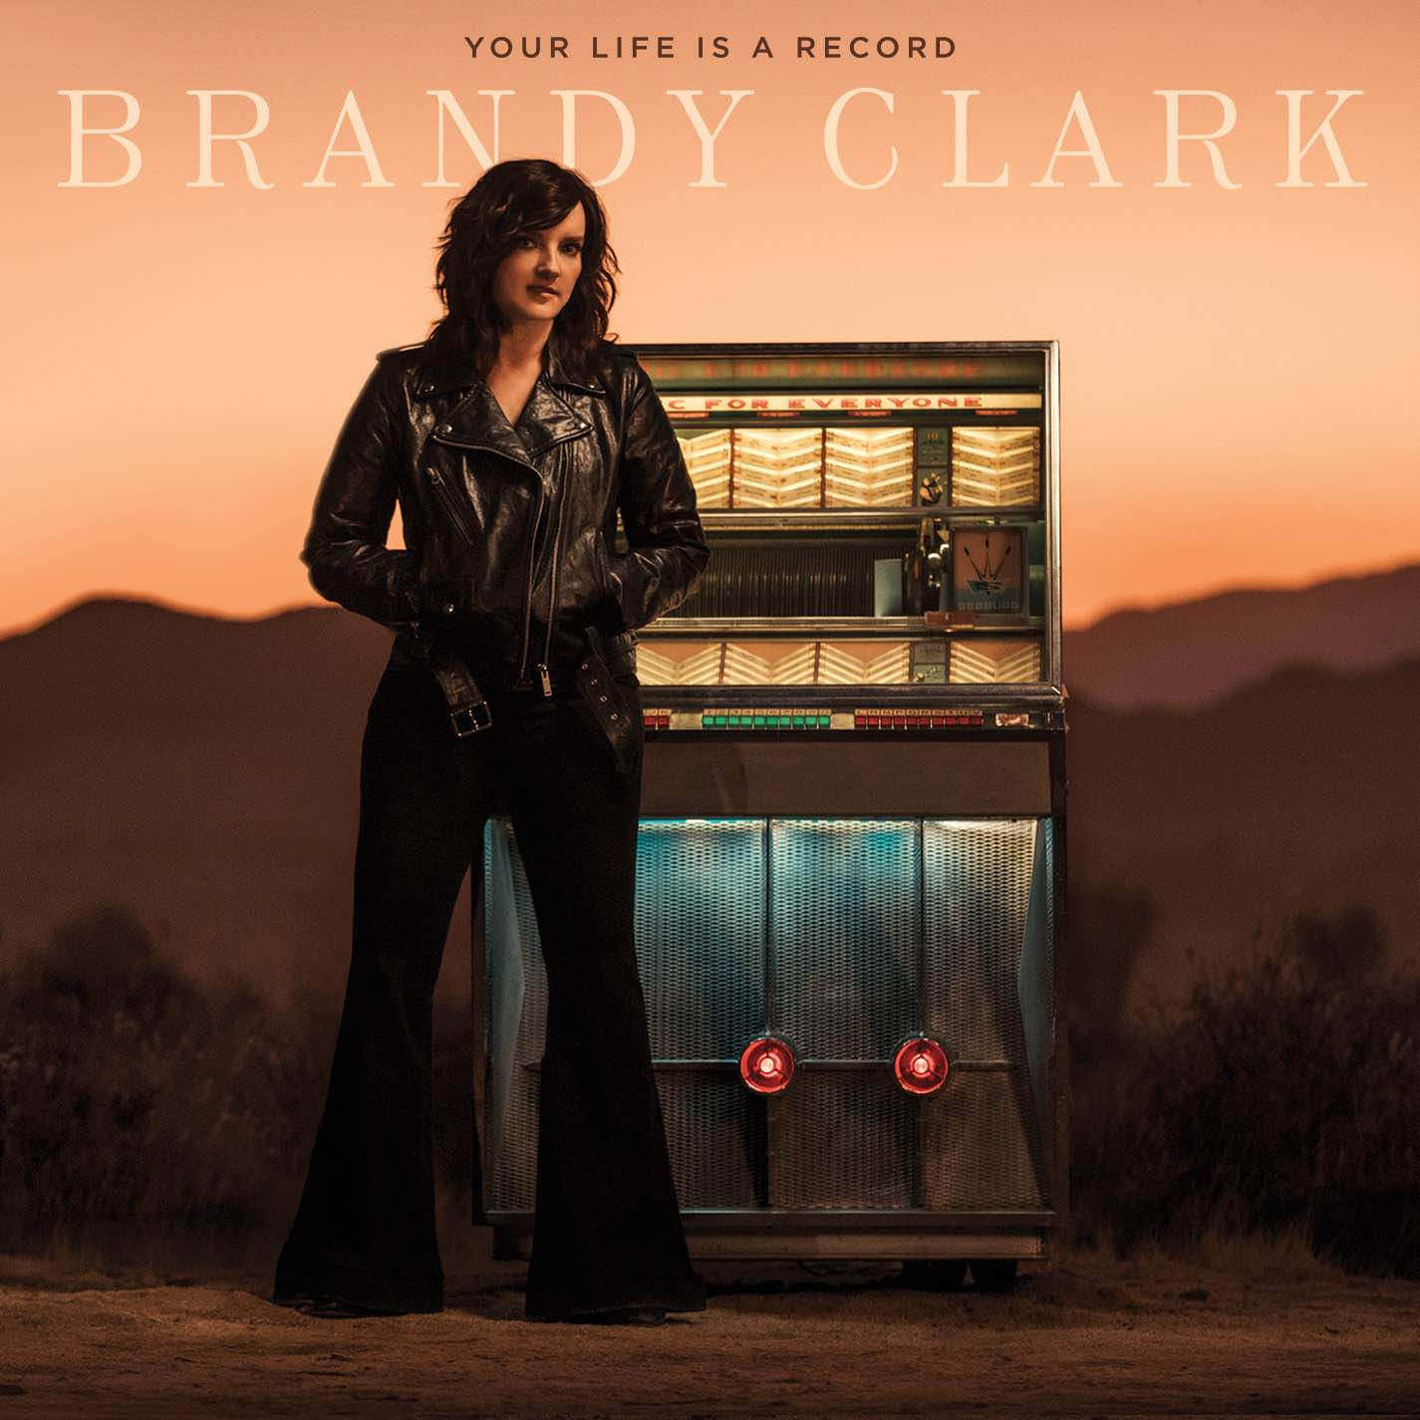
Grammy-nominated and CMA Award-winning singer, songwriter and musician Brandy Clark will release her highly anticipated new album, Your Life is a Record, March 6 on Warner Records (pre-order). In advance of the release, the first single, “Who You Thought I Was,” is out today—listen/share HERE.
Of the song, Clark shares, “The seed of the song came from something that John Prine said a couple of years ago at the Americana Awards. He walked out onstage at the Ryman and everyone stood up and clapped for what felt like five minutes. When everyone sat down, he said with a little laugh, ‘Well, I’m John Prine, but I’d like to go back to being who you thought I was.’ Man…that hit me. The songwriter in me instantly knew it was a song and the heart in me knew it was how I had felt in my own life many times. I mean who of us hasn’t let somebody down or wanted to be the version of ourselves that someone who loved us thought we were?”
Already receiving advance notice, NPR Music’s Ann Powers proclaims, “NPR Music’s Ann Powers declares, “Breakthroughs don’t always have to come for brand new artists,” and continues, “[Your Life is a Record] sounds like an instant classic. It sounds vintage, it evokes classic ‘60s country albums, but it also sounds completely contemporary,” while Rolling Stone recently included it as one of their “70 Most Anticipated Albums of 2020.”
Produced by award winning producer Jay Joyce, the 11-track album was recorded largely as an intimate acoustic four-piece—featuring Clark, Joyce, Giles Reaves and Jedd Hughes—with subsequent Memphis strings and horns layered in with arrangements by Lester Snell. Created after the dissolution of a long-term relationship, the album features Clark’s most personal songwriting to date along with special guest appearances from Randy Newman (“Bigger Boat”) and guitarist John Osborne (“Bad Car”).
In celebration of the release, Clark will tour extensively throughout 2020 including a series of winter tour dates with Tanya Tucker on the CMT Next Women of Nashville Tour. The run features stops at Philadelphia’s World Café Live, New York’s Town Hall, Memphis’ Graceland Soundstage among many others. Additionally, beginning in March, Clark will embark on her headlining “Who You Thought I Was Tour,” which includes special album release shows at Nashville’s 3rd & Lindsley on March 29, Los Angeles’ Lodge Room on April 7 and Chicago’s The Space on May 8. Tickets go on-sale next Friday, January 17 at 10:00am local time. See below for complete details.
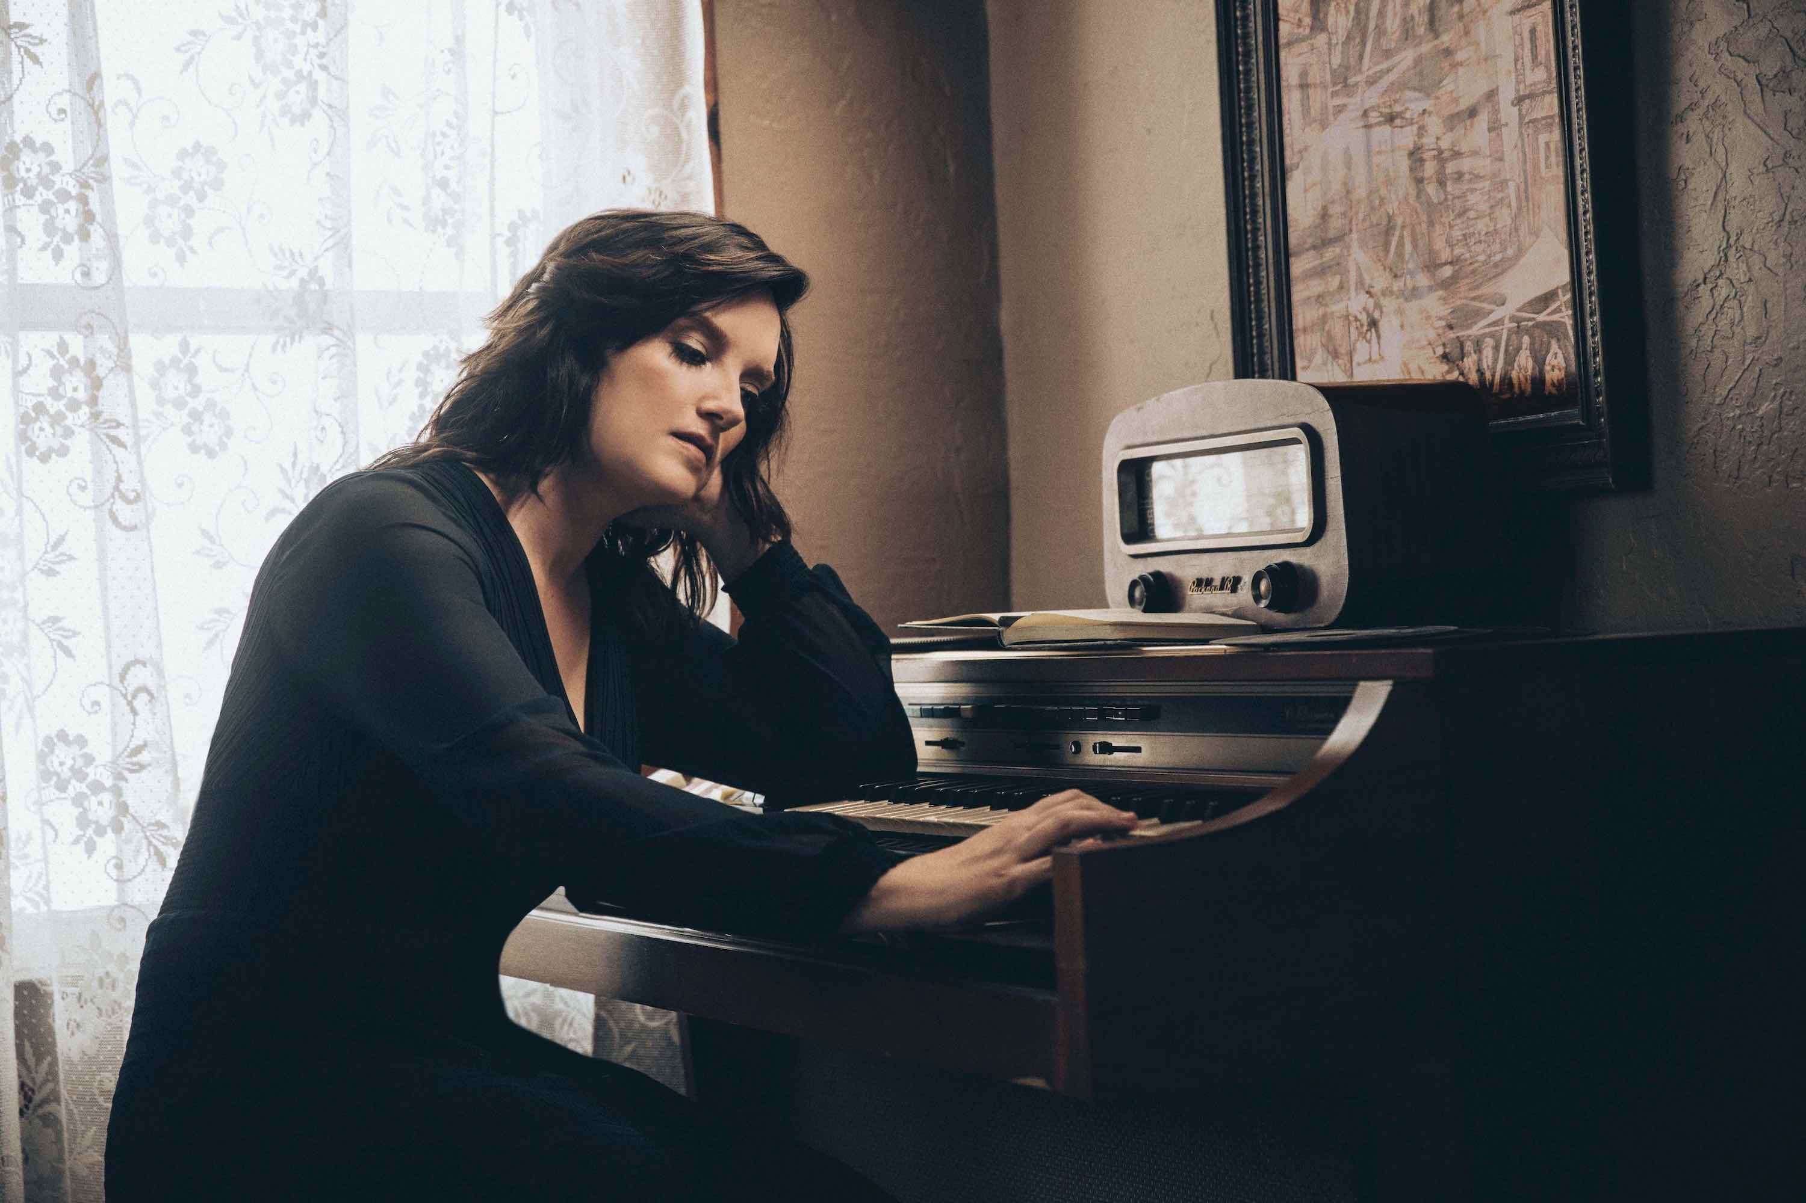
photo credit: Chris Phelps
A six-time Grammy nominee and CMA Awards “Song of the Year” recipient, Clark is one of her generation’s most respected and celebrated songwriters and musicians. Her songs include Kacey Musgraves’ “Follow Your Arrow,” Miranda Lambert’s “Mama’s Broken Heart,” The Band Perry’s “Better Dig Two” and Hailey Whitter’s “Ten Year Town,” which was just named #2 on Rolling Stone’s “25 Best Country and Americana Songs of 2019” round up. Her two solo albums—2013’s 12 Stories and 2016’s Big Day in a Small Town—each garnered immense critical acclaim landing on “Best of the Year” lists at New York Magazine, Billboard, NPR Music Entertainment Weekly, Rolling Stone, Stereogum, etc. NPR Music’s Ann Powers calls her, “a storyteller of the highest caliber,” while Rolling Stone’s Will Hermes declares, “a country visionary…the consolation of a beautiful voice delivering a well-built song, cold truth rising from it like fog off dry ice.”
YOUR LIFE IS A RECORD TRACK LIST
1. I’ll Be the Sad Song
2. Long Walk
3. Love is a Fire
4. Pawn Shop
5. Who You Thought I Was
6. Apologies
7. Bigger Boat (feat. Randy Newman)
8. Bad Car (Feat. John Osborne)
9. Who Broke Whose Heart
10. Can We Be Strangers
11. The Past is the Past
BRANDY CLARK CONFIRMED TOUR DATES
January 25—Oslo, Norway—Interstate 20
January 27—Copenhagen, Denmark—Ideal Bar, Vega – Musikkens Hus
January 29—Amsterdam, Netherlands—Paradiso
January 31—Gateshead, U.K.—The Sage Gateshead, Hall 1
February 1—Glasgow, U.K.—St. Luke’s
February 5—Vienna, VA—The Barns at Wolf Trap*
February 6—Philadelphia, PA—World Café Live*
February 7—New York, NY —Town Hall*
February 20—Memphis, TN—Graceland Soundstage*
February 21—Springfield, MO—Gillioz Theatre*
February 22—Wichita, KS—Templelive Wichita
February 24—Columbia, MO—The Blue Note
February 25—Lincoln, NE—Bourbon Theatre
February 27—Sioux Fallas, ND—The District
February 28—Fargo, ND—Fargo Theatre
February 29—Hinckley, MN—Grand Casino Hinckley
March 28—St. Louis, MO—Off Broadway†
March 29—Nashville, TN—3rd and Lindsley†
March 31—Houston, TX—White Oak†
April 1—Austin, TX—The Parish†
April 7—Los Angeles, CA—Lodge Room†
April 8—San Francisco, CA—Great American Music Hall†
April 10—Portland, OR—Alberta Rose Theatre†
April 11—Seattle, WA—Showbox Theatre†
April 13—Salt Lake City, UT—The State Room†
April 14—Denver, CO—Globe Hall†
April 16—Omaha, NE—The Waiting Room†
April 17—Minneapolis, MN—Fineline†
April 18—Des Moines, IA—Woolys†
April 20—Ann Arbor, MI—The Ark†
April 21—Cleveland, OH—Beachland†
April 22—Pittsburgh, PA—The Rex†
April 24—Uncasville, CT—Wolf Den†
April 27—Boston, MA—Brighton Music Hall†
May 1—Alexandria, VA—Birchmere†
May 2—Charlotte, NC—McGlohon†
May 4—Atlanta, GA—Terminal West†
May 5—Birmingham, AL—Saturn†
May 7—Louisville, KY—Headliners†
May 8—Chicago, IL—The Space†
May 9—Indianapolis, IN—Vogue†
May 11—Madison, WI—Majestic Theatre†
May 13—Kansas City, MO—Saloon @ Knuckleheads†
May 14—Oklahoma City, OK—Tower Theatre†
*with Tanya Tucker as part of the CMT Next Women of Country Tour
†“Who You Thought I Was Tour”
BOLD on-sale Friday, January 17 at 10:00am local time
www.brandyclarkmusic.com
For more information, please contact Asha Goodman 615.320.7753,
Catherine Snead 615.320.7753 or Carla Sacks 212.741.1000 at Sacks & Co., asha.goodman@sacksco.com, catherine.snead@sacksco.com or carla@sacksco.com.

