BRANDY CLARK PERFORMS “LIKE MINE” ON
THE ELLEN DEGENERES SHOW
NEW DELUXE ALBUM OUT THIS FRIDAY IN CELEBRATION OF YOUR LIFE IS A RECORD ANNIVERSARY
SPECIAL LIVESTREAM CONCERT CONFIRMED FOR MARCH 6
NOMINATED FOR TWO AWARDS AT 63RD GRAMMY AWARDS, OUTSTANDING MUSIC ARTIST AT 2021 GLAAD MEDIA AWARDS
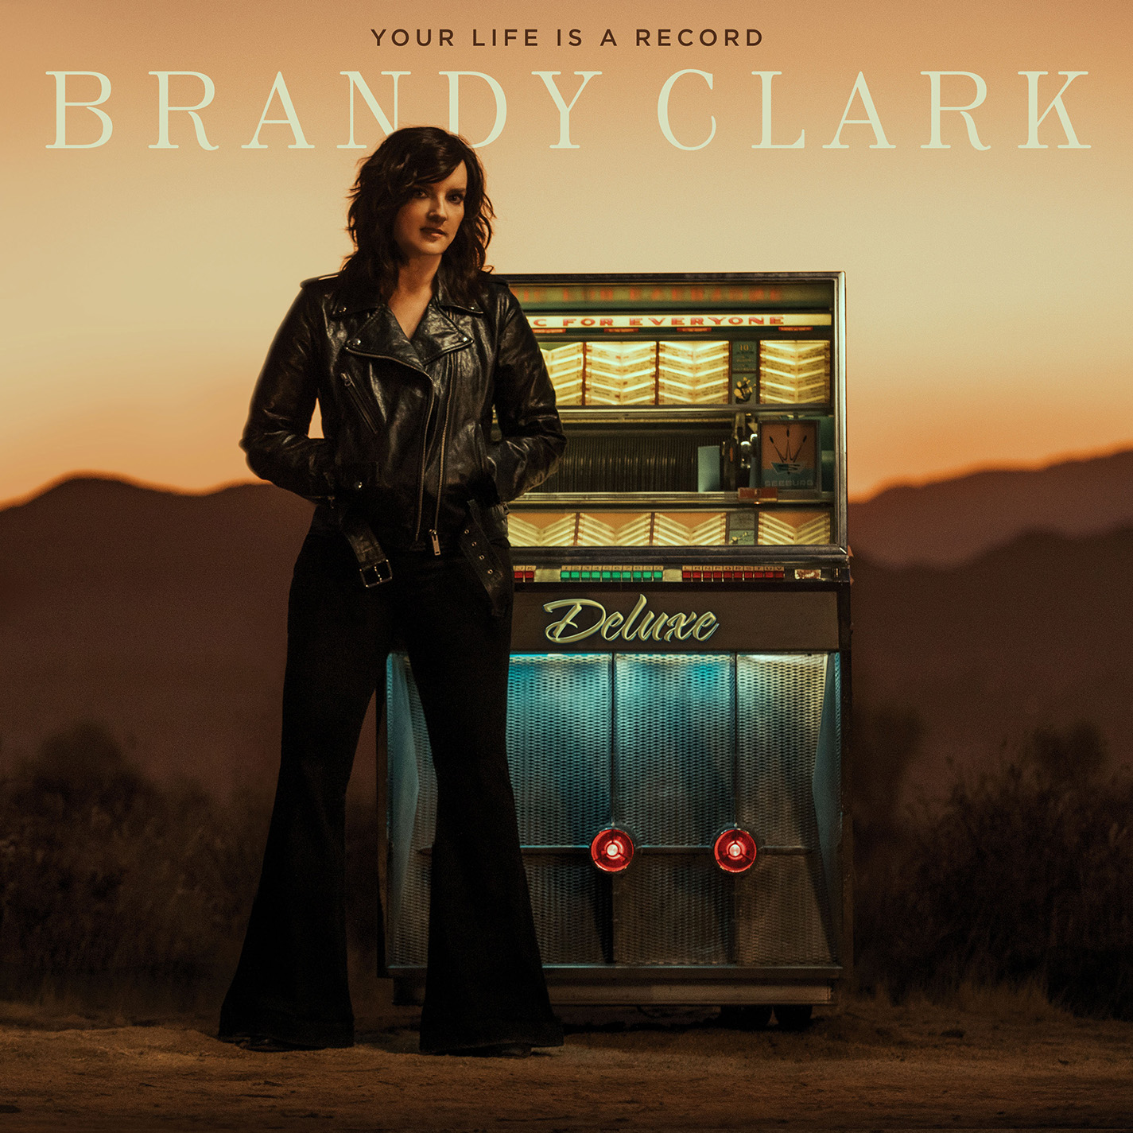
March 3, 2021(Los Angeles, CA) — GRAMMY-nominated singer, songwriter and musician Brandy Clark performs her song, “Like Mine,” on today’s episode of The Ellen DeGeneres Show. Watch/share HERE.
Produced by Brandi Carlile, “Like Mine” is from Clark’s new deluxe album, Your Life is a Record (Deluxe), which will be released this Friday, March 5 on Warner Records in celebration of the one-year anniversary of her critically acclaimed album, Your Life is a Record. Pre-save/pre-add HERE.
In addition to “Like Mine,” the deluxe album features all eleven songs from Your Life is a Record as well as five more bonus tracks including “Remember Me Beautiful,” a song Clark wrote earlier this year as part of NPR’s Morning Edition Song Project. It also includes a second collaboration with Carlile (“Same Devil”), a collaboration with Lindsey Buckingham (“The Past is the Past”) and live renditions of two album tracks: “Pawn Shop” and “Who You Thought I Was.”
Moreover, in honor of the album’s anniversary, Clark will perform her first ticketed livestream concert this Saturday, March 6 at 8:00pm ET/7:00pm CT via Mandolin. Tickets for the show are available now with a selection of purchase options, including a limited number of VIP packages with signed merchandise and a virtual meet & greet. Fans will also have the option to add a digital download of the deluxe album to their livestream ticket, to be delivered on release day. Full details can be found HERE.
The new release continues a triumphant year for Clark, who is nominated for two awards at the 63rd GRAMMY Awards—Best Country Album (Your Life is a Record) and Best Country Solo Performance (“Who You Thought I Was”)—as well as Outstanding Music Artist at the 2021 GLAAD Media Awards. Produced by Jay Joyce, Your Life is a Record continues to receive widespread critical praise and landed on several “Best of 2020” lists including NPR Music, Rolling Stone, Entertainment Weekly, Variety, Paste and Slate, who declares, “one of the greatest living short-story-song writers in country (which really means in any genre)…I don’t think there’s a 2020 country or country-adjacent album that outdoes Clark’s.”
An eight-time GRAMMY nominee and CMA Awards “Song of the Year” recipient, Clark is one of her generation’s most respected and celebrated songwriters and musicians. Her songs include Kacey Musgraves’ “Follow Your Arrow,” Miranda Lambert’s “Mama’s Broken Heart,” The Band Perry’s “Better Dig Two” and Hailey Whitter’s “Ten Year Town.” Her past two solo albums—2013’s 12 Stories and 2016’s Big Day in a Small Town—each garnered immense critical acclaim landing on “Best of the Year” lists at New York Magazine, Billboard, NPR Music Entertainment Weekly, Rolling Stone, Stereogum, etc. NPR Music’s Ann Powers calls her, “a storyteller of the highest caliber,” while Rolling Stone’s Will Hermes declares, “a country visionary…the consolation of a beautiful voice delivering a well-built song, cold truth rising from it like fog off dry ice.”

YOUR LIFE IS A RECORD (DELUXE) TRACK LIST
1. I’ll Be the Sad Song
2. Long Walk
3. Love is a Fire
4. Pawn Shop
5. Who You Thought I Was
6. Apologies
7. Bigger Boat (feat. Randy Newman)
8. Bad Car
9. Who Broke Whose Heart
10. Can We Be Strangers
11. The Past is the Past
12. Who You Thought I Was (Live From 3rd & Lindsley)
13. Pawn Shop (Live From 3rd & Lindsley)
14. Remember Me Beautiful
15. Like Mine
16. Same Devil (feat. Brandi Carlile)
17. The Past is the Past (feat. Lindsey Buckingham)
www.brandyclarkmusic.com

