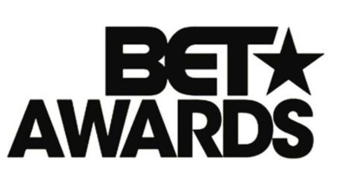

June 23, 2019

https://www.bet.com/video/betawards/2019/exclusives/saweetie-my-type-beta19.html

