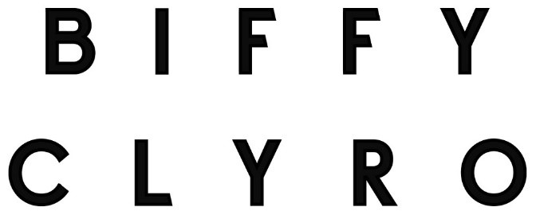

AN INTRODUCTION

PRAISE FOR ‘THE MYTH OF THE HAPPILY EVER AFTER’:

“Deconstructive, deliberate and exquisitely designed, The Myth Of The Happily Ever After is the sound of a world-class band making truly world-class music.” 5/5 – Kerrang!

“Biffy Clyro’s most emotionally powerful record in years.” 4.5/5 – DIY

“Adventurous in sound, buoyant in spirit and with ideas aplenty.” 4/5 - NME

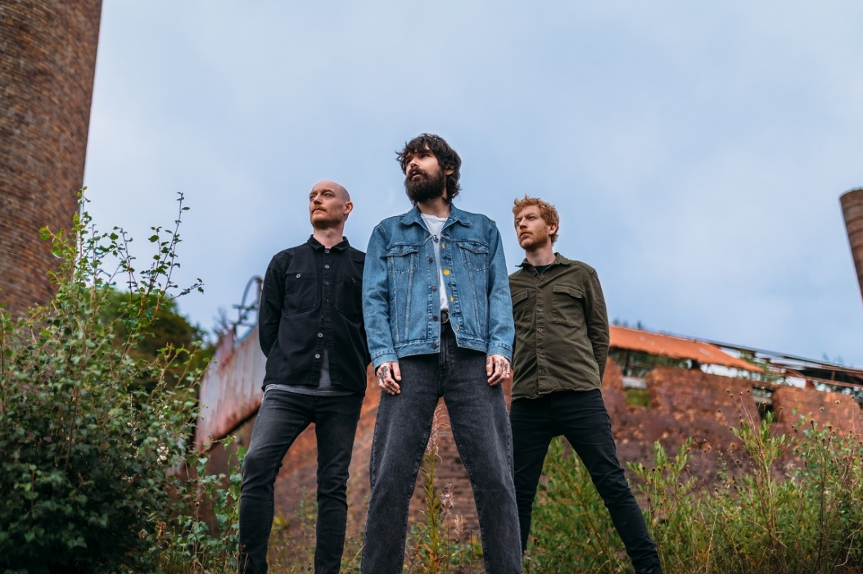
Photo by Kevin J. Thomson

Twenty years after releasing their debut album, Biffy Clyro have risen from their independent toots to become Britain’s premier rock band. Their three most recent studio albums – ‘A Celebration of Endings’ (2020), ‘Ellipsis’ (2016) and ‘Opposites’ (2013) – all went straight to #1 on the UK’s Official Album Chart.

Their critical adoration continued with 2021’s homegrown project ‘The Myth of the Happily Ever After’, which was a rapid emotional response to the chaos wreaked by COVID. It was the product of a strange and cruel time in our lives, but one that ultimately reinvigorated Biffy Clyro as they recorded in their homeland of Scotland for the first time.

The success of their huge selling, critically acclaimed albums is matched by the scale of their live show. Renowned for their incendiary blend of exuberant energy, sheer emotion and dazzling visuals, Biffy Clyro have headlined leading festivals including Reading, Leeds, Download and TRSNMT, and have been a main attraction at Glastonbury and dozens of others all over the world.

When restrictions were lifted in 2021, Biffy quickly embarked upon some of the biggest shows of the year. They headlined the Reading and Leeds festivals, sold-out their own huge outdoor shows in Glasgow, Cardiff and Margate, and performed at Radio 1’s Out Out! Live event at Wembley Arena. During the ‘Ellipsis’ campaign, they played headline sets to a combined audience of more than 200,000 people over the course of three nights.

Continually supported by the press, Biffy Clyro have also won a wide range of major awards. These include four NME Awards (2 x Best British Band, Best Live Band and Best Music Video); four Kerrang! Awards (Best British Band, Classic Songwriter, Best Album and Best Music Video); and two Q Awards (Best Live Band and Best Album). They’ve also been nominated for three BRIT Awards (all for Best British Group, most recently in 2021) and a Mercury Prize.

Outside of their core studio albums, Biffy have consistently explored other areas of their creativity. Their first live album, ‘Revolutions: Live At Wembley’, reached the Top 10 in 2011. And in 2018, they released their Top 5 acoustic album, ‘MTV Unplugged: Live At Roundhouse London’, which followed in the footsteps of the influential rock bands who had previously performed as part of the series, such as Nirvana, Oasis, Pearl Jam and R.E.M. 2019 saw the release of their first soundtrack, ‘Balance, Not Symmetry’, for the film of the same name which was co-written by Simon Neil and premiered at the Edinburgh Film Festival.

As the world changed during lockdown, Biffy Clyro channelled their creativity in new ways. James and Ben Johnstone rolled up their sleeves to get stuck into the DIY project of turning their rehearsal room in a farmhouse close to their homes in Scotland into a functional recording space. They subsequently used the studio to record ‘The Myth of the Happily Ever After’.

Meanwhile, Simon Neil designed his first ever signature guitar pedal, the ‘BOOOOOM / BLAST’, with the band’s long-term guitar tech Richard ‘Churd’ Pratt. Both production runs sold-out immediately. Simon also hosted the six-part radio show ‘The Simon Neil Experience’ for BBC Scotland and BBC Sounds. Guests included Joe Talbot (IDLES), Mike Patton (Faith No More, Mr. Bungle), Julien Baker, and film score composer Clint Mansell (‘Black Swan’, ‘Requiem for A Dream’).

Live plans for 2022 are now taking shape with the news that Biffy Clyro will headline the closing Sunday night at Download in June.

Follow Biffy Clyro:
Official website
Spotify
Apple Music
Facebook
Twitter
Instagram
YouTube

