

**SCOTTISH ALT-ROCK GIANTS BIFFY CLYRO UNLEASH NEW ALBUM**

***A CELEBRATION OF ENDINGS***

**TUNE IN: EXCLUSIVE LIVESTREAM CONCERT TOMORROW, AUGUST 15**

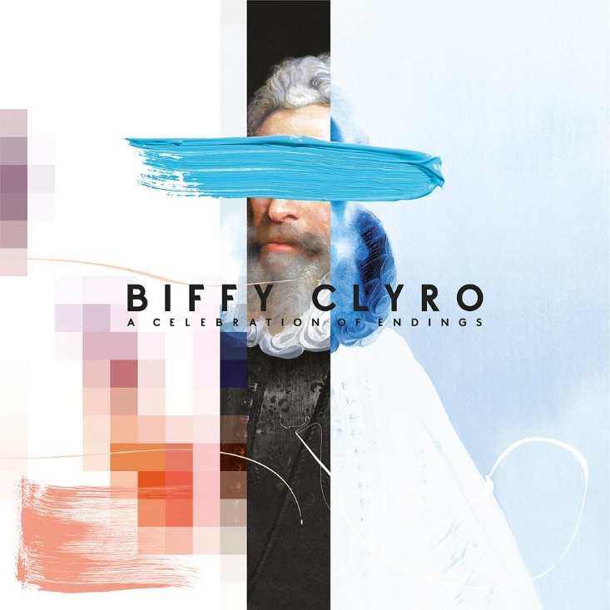 

*“This record channels and blends the raucous energy of Biffy’s early days with the perspective the band has developed – both artistic and social”* **** **- American Songwriter**

*“Biffy Clyro prove beyond doubt that they’ve got the idiosyncratic sewn up.”* **\*\*\*\* - Q**

*“Biffy illustrate that guitar music isn’t just alive and well - it’s bloody thriving.”* **8.5/10 – The Line of Best Fit**

*“An album that revels in subverting expectations.”* **\*\*\*\* - Mojo**

**August 14, 2020 (Los Angeles, CA) –** U.K. alt-rock giants Biffy Clyro unleash their highly-anticipated eighth studio album, *A Celebration of Endings* today via Warner Records. The new 11-track album features explosive lead single “[Instant History](https://biffyclyro.co/instanthistory)” – which is currently in the Top 20 at U.S. Rock radio – as well as recently-released tracks [“Tiny Indoor Fireworks,”](https://youtu.be/9z6tSKT9zdY) [“End Of”](https://biffyclyro.co/endof) and [“Weird Leisure.”](https://biffyclyro.co/WeirdLeisure)

**LISTEN/SHARE *A CELEBRATION OF ENDINGS*** [**HERE**](http://biffyclyro.co/acelebrationofendings)

*A Celebration of Endings* finds Biffy Clyro pushing everything they do to the next level, with the help of GRAMMY-winning producer Rich Costey (Foo Fighters, Muse, The Killers). Frontman Simon Neil explains, *“This is a very forward-looking album from a personal perspective and a societal perspective. The title is about seeing the joy in things changing, rather than the sadness. Change means progression and evolution. You can retain everything you loved before, but let’s lose the bad shit. It’s about trying to take back control.”*

To celebrate, Biffy Clyro will do an ambitious one-off, worldwide livestream performance tomorrow, Saturday, August 15th at 6pm PT/9pm ET at an iconic Glasgow venue. The trio will perform the new album in its entirety for the very first time, along with a selection of their top hits, across different spaces within the venue to create a unique, fully plugged-in live set. The show will be streamed globally via YouTube, with tickets and album bundles available now at [biffyclyro.com/livestream](https://shops.ticketmasterpartners.com/biffy-clyro-livestream).

Biffy Clyro have emerged from their independent beginnings to become Britain’s premier rock band. Their two most recent albums *Ellipsis* (2016) and *Opposites* (2013) both shot straight to #1 in the U.K. charts with 2 million+ copies sold, and the band boasts more than 750 million streams worldwide to date. The success of their huge-selling, critically-acclaimed albums is matched by the scale of their live show. In the U.S. they’ve toured arenas with the likes of Foo Fighters and Muse, in addition to sold-out headline runs, while overseas they’ve headlined leading festivals including Reading and Leeds, Download and TRNSMT, and this year will play Radio 1’s Big Weekend in Dundee in May. They’re part of an all-star bill that currently also features Calvin Harris, Camilla Cabello, Dua Lipa and Harry Styles. Continually supported by the press, Biffy Clyro have also won a wide range of major awards. These include four NME Awards (2 x Best British Band, Best Live Band and Best Music Video); four Kerrang! Awards (Best British Band, Classic Songwriter, Best Album and Best Music Video); and three Q Awards (Best Live Band, Best Album and the Fender Play Award). They’ve also been nominated for two BRIT Awards (both for Best British Group) and a Mercury Prize.

###

**For further information, please contact:**

Ceri Roberts / [Ceri.Roberts@warnerrecords.com](mailto:Ceri.Roberts@warnerrecords.com)

**Follow Biffy Clyro:**

[**Official website**](http://www.biffyclyro.com/)**|** [**Facebook**](https://www.facebook.com/biffyclyro) **|** [**Twitter**](https://twitter.com/biffyclyro) **|** [**Instagram**](https://www.instagram.com/biffy_clyro/) **|** [**YouTube**](https://www.youtube.com/user/biffyclyro)

**cid:image004.jpg@01D5E663.19B041B0**