BRANDY CLARK’S “LOVE IS A FIRE” MUSIC VIDEO PREMIERES AT CMT

NEW ALBUM YOUR LIFE IS A RECORD OUT MARCH 6 ON WARNER RECORDS
TOUR DATES CONFIRMED
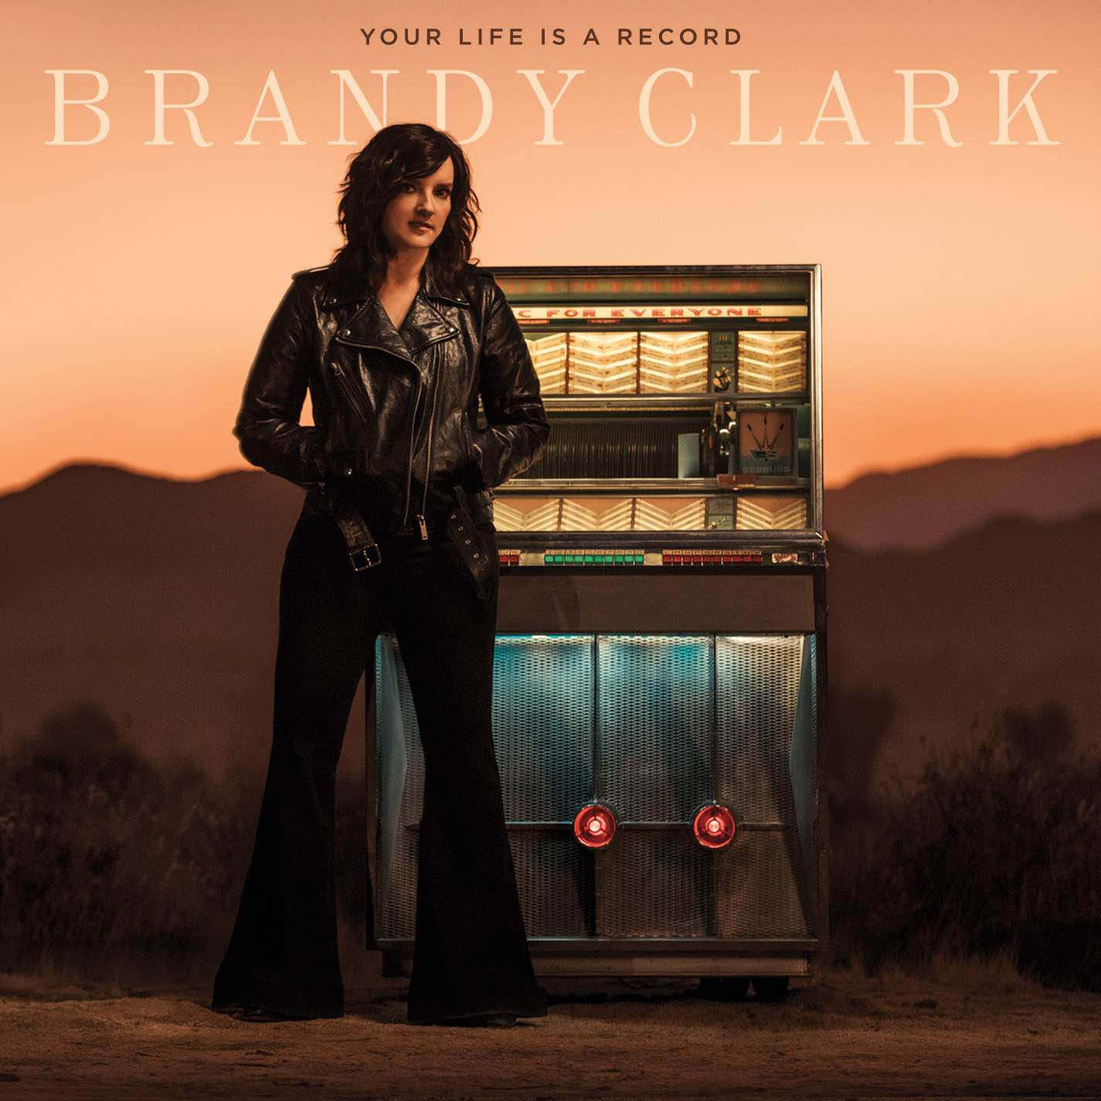
February 14, 2020 (Los Angeles, CA) - The official music video for Brandy Clark’s new song, “Love is a Fire,” is premiering today at CMT. Watch/share HERE.
Of the inspiration behind the song, Clark reflects, “I was obsessed with Bette Davis and Joan Crawford and Ryan Murphy’s ‘The Feud’ just got in my head. That idea that love is a fire, you just never know if it’s going to warm you—or burn you. That’s where ‘Fire’ came from.”
“Love is a Fire” is the latest song unveiled from Clark’s highly anticipated new album, Your Life is a Record, which will be released March 6 on Warner Records (pre-order). Already receiving widespread attention, NPR Music’s Ann Powers proclaims, “Breakthroughs don’t always have to come for brand new artists,” and continues, “[Your Life is a Record] sounds like an instant classic. It sounds vintage, it evokes classic ‘60s country albums, but it also sounds completely contemporary,” while Rolling Stone recently included it as one of their “70 Most Anticipated Albums of 2020.”
Produced by award winning producer Jay Joyce, the 11-track album was recorded largely as an intimate acoustic four-piece—featuring Clark, Joyce, Giles Reaves and Jedd Hughes—with subsequent Memphis strings and horns layered in with arrangements by Lester Snell. Created after the dissolution of a long-term relationship, the album features Clark’s most personal songwriting to date along with special guest appearances from Randy Newman (“Bigger Boat”) and guitarist John Osborne (“Bad Car”). Ahead of the release, the album’s lead single, “Who You Thought I Was,” premiered last month to critical acclaim. Of the song, The Tennessean praises, “entrancing,” while Music Row declares, “This woman is just awesome, that’s all. Her liquid vocal, her lovely melody, her pristinely constructed song and her overall artistry are all perfectly in place here. She is a country queen if I have ever heard one.” Watch the official music video HERE.
In celebration of the release, Clark will tour extensively throughout 2020 including a series of winter tour dates with Tanya Tucker on the CMT Next Women of Nashville Tour. Additionally, beginning in March, Clark will embark on her headlining “Who You Thought I Was Tour,” which includes special album release shows at Nashville’s 3rd & Lindsley on March 29, Los Angeles’ Lodge Room on April 7, New York’s Bowery Ballroom on April 28 and Chicago’s The Space on May 8. See below for complete tour itinerary. Every ticket purchased for the headline tour includes a choice of a CD or digital download copy of Your Life is a Record. Available in most markets, check ticket details for confirmation.

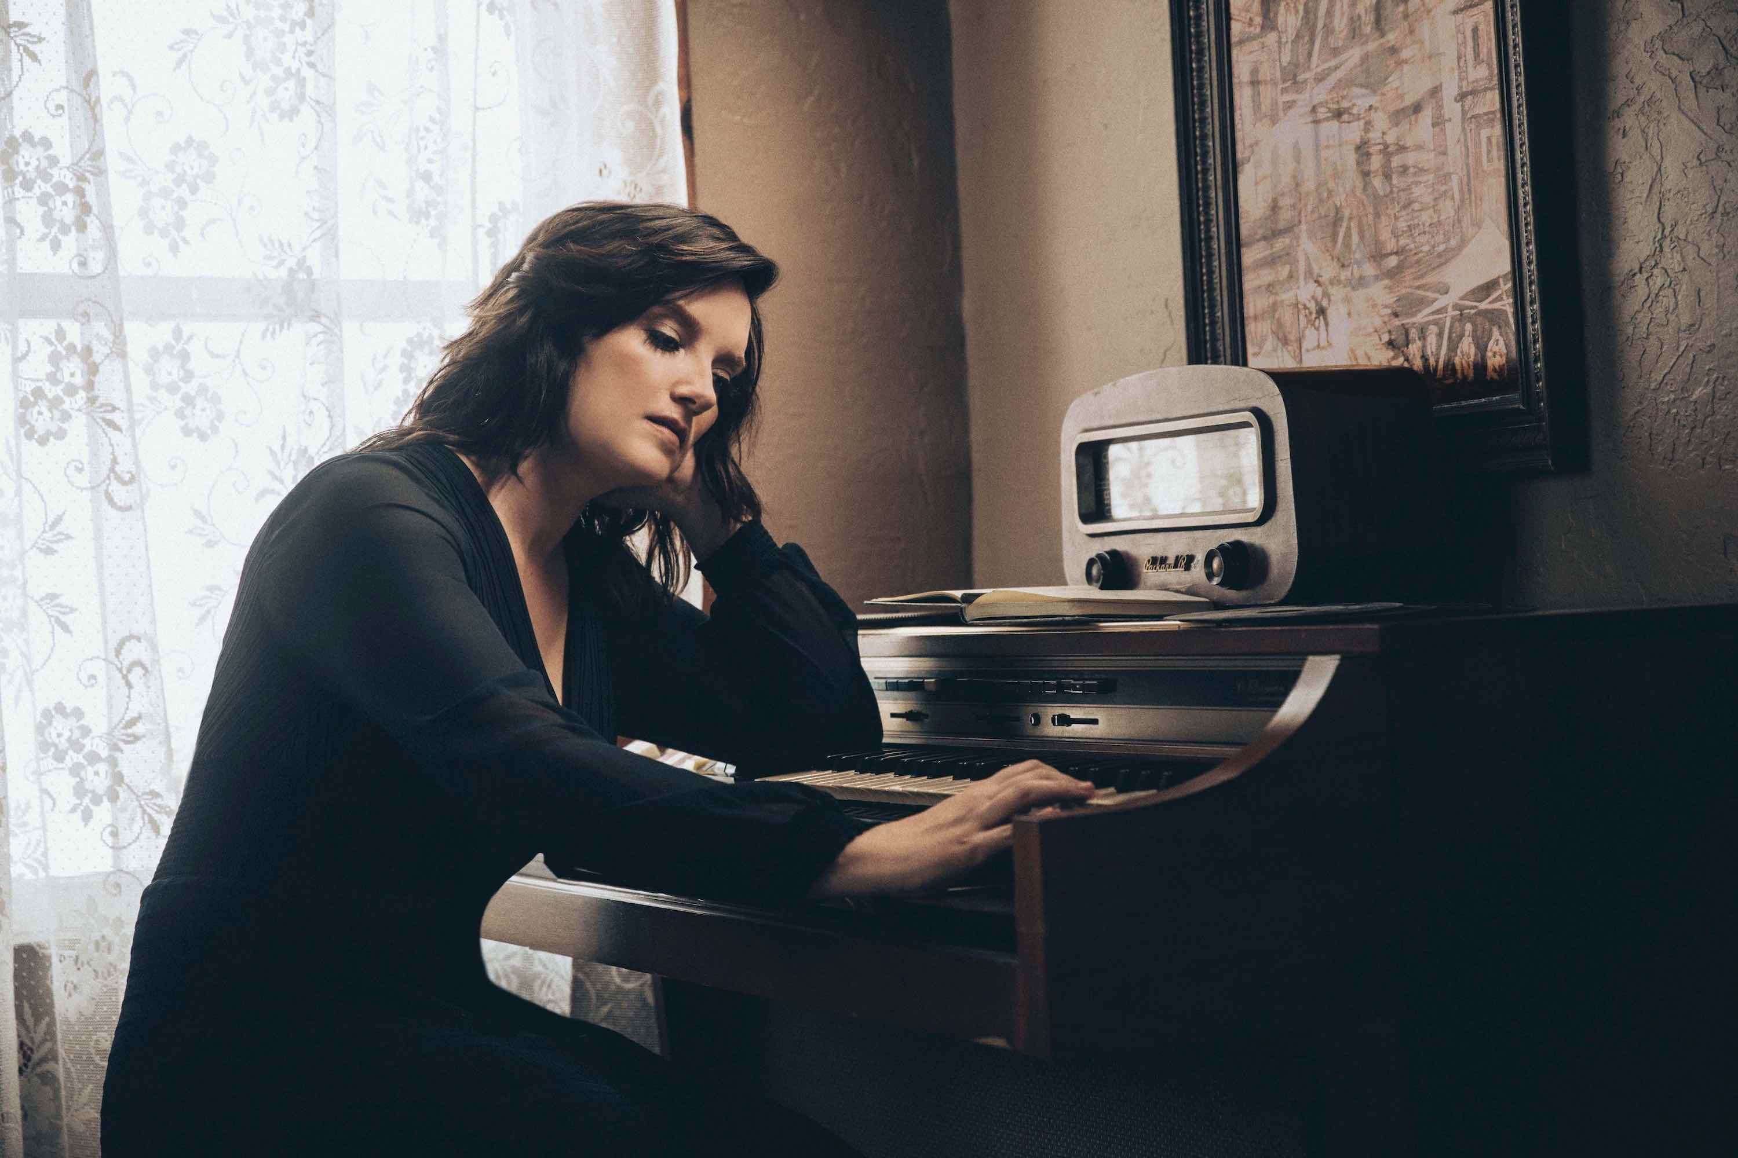
photo credit: Chris Phelps
A six-time Grammy nominee and CMA Awards “Song of the Year” recipient, Clark is one of her generation’s most respected and celebrated songwriters and musicians. Her songs include Kacey Musgraves’ “Follow Your Arrow,” Miranda Lambert’s “Mama’s Broken Heart,” The Band Perry’s “Better Dig Two” and Hailey Whitter’s “Ten Year Town,” which was just named #2 on Rolling Stone’s “25 Best Country and Americana Songs of 2019” round up. Her two solo albums—2013’s 12 Stories and 2016’s Big Day in a Small Town—each garnered immense critical acclaim landing on “Best of the Year” lists at New York Magazine, Billboard, NPR Music Entertainment Weekly, Rolling Stone, Stereogum, etc. NPR Music’s Ann Powers calls her, “a storyteller of the highest caliber,” while Rolling Stone’s Will Hermes declares, “a country visionary…the consolation of a beautiful voice delivering a well-built song, cold truth rising from it like fog off dry ice.”

YOUR LIFE IS A RECORD TRACK LIST
1. I’ll Be the Sad Song
2. Long Walk
3. Love is a Fire
4. Pawn Shop
5. Who You Thought I Was
6. Apologies
7. Bigger Boat (feat. Randy Newman)
8. Bad Car
9. Who Broke Whose Heart
10. Can We Be Strangers
11. The Past is the Past
BRANDY CLARK CONFIRMED TOUR DATES
February 20—Memphis, TN—Graceland Soundstage*
February 21—Springfield, MO—Gillioz Theatre*
February 22—Wichita, KS—Templelive Wichita*
February 24—Columbia, MO—The Blue Note*
February 25—Lincoln, NE—Bourbon Theatre*
February 27—Sioux Falls, ND—The District*
February 28—Fargo, ND—Fargo Theatre*
February 29—Hinckley, MN—Grand Casino Hinckley*
March 28—St. Louis, MO—Off Broadway†
March 29—Nashville, TN—3rd and Lindsley†
March 31—Houston, TX—White Oak†
April 1—Austin, TX—The Parish†
April 7—Los Angeles, CA—Lodge Room†
April 8—San Francisco, CA—Great American Music Hall†
April 10—Portland, OR—Alberta Rose Theatre†
April 11—Seattle, WA—Showbox Theatre†
April 13—Salt Lake City, UT—The State Room†
April 14—Denver, CO—Globe Hall†
April 16—Omaha, NE—The Waiting Room†
April 17—Minneapolis, MN—Fineline†
April 18—Des Moines, IA—Woolys†
April 20—Ann Arbor, MI—The Ark†
April 21—Cleveland, OH—Beachland†
April 22—Pittsburgh, PA—The Rex†
April 24—Uncasville, CT—Wolf Den†
April 25—Philadelphia, PA—Boot & Saddle†
April 27—Boston, MA—Brighton Music Hall†
April 28—New York, NY—Bowery Ballroom†
May 1—Alexandria, VA—Birchmere†
May 2—Charlotte, NC—McGlohon†
May 4—Atlanta, GA—Terminal West†
May 5—Birmingham, AL—Saturn†
May 7—Louisville, KY—Headliners†
May 8—Chicago, IL—The Space†
May 9—Indianapolis, IN—Vogue†
May 11—Madison, WI—Majestic Theatre†
May 13—Kansas City, MO—Saloon @ Knuckleheads†
May 14—Oklahoma City, OK—Tower Theatre†
*with Tanya Tucker as part of the CMT Next Women of Country Tour
†“Who You Thought I Was Tour”
www.brandyclarkmusic.com

