

**AUSTRALIAN R&B ARTIST BUDJERAH RELEASES *CONVERSATIONS* EP – LISTEN** [**HERE**](https://budjerah.lnk.to/Pre-ConversationsPR)

**TOURING NORTH AMERICA THIS APRIL & MAY + SPECIAL SUPPORT DATES WITH VANCE JOY – DATES** [**HERE**](https://www.budjerah.com/#tour)

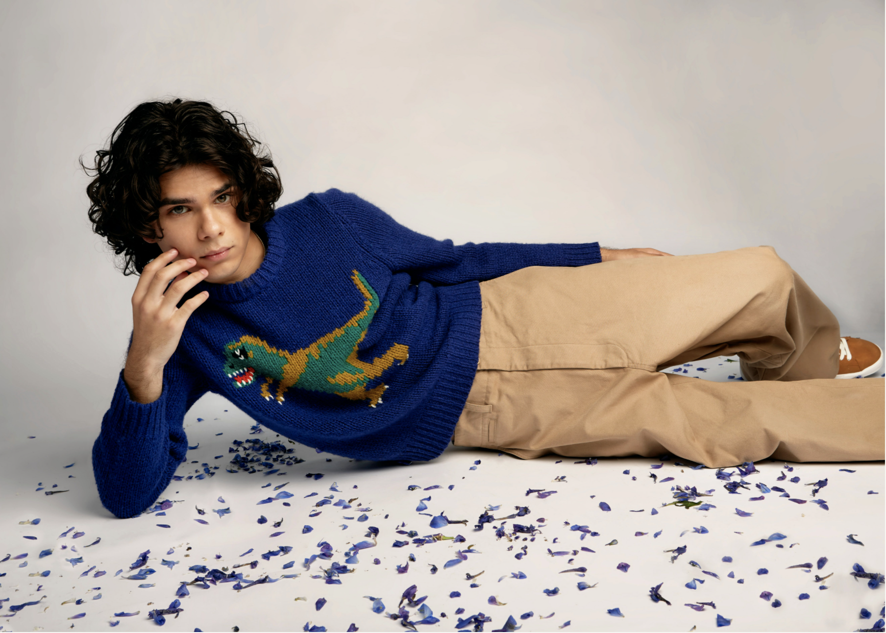

Photo credit: Elliott Lauren Ryan

*"...the track flirts with ’80s sounding synth and glittery production,* ***Budjerah’s*** *buttery voice tying it all together."*

**- NME**

*“In tow with his rich vocals,* ***Budjerah*** *laments themes of alienation and loneliness under an irresistibly catchy melody.”*

**- WONDERLAND**

*“.. the presence of his sound like sunlight for the senses."*

**- VOGUE**

**April 8, 2022 (Los Angeles, CA)** - Set to commence his world tour in Australia this weekend with stops in Europe and North America as well as special support dates with Vance Joy,today [**Budjerah**](https://positive-feedback.us13.list-manage.com/track/click?u=47d12b32f851a79a3139bb75f&id=6cb93c53da&e=0a8ccd0bac) releases his highly anticipatedsecond EP, [***Conversations***](https://positive-feedback.us13.list-manage.com/track/click?u=47d12b32f851a79a3139bb75f&id=00b15bb998&e=0a8ccd0bac)via **Warner Records**. The 20-year-old wunderkind marks the release with his futuristic and resplendent **new single “*Get Down.”*** Listen to ***Conversations*** [HERE](https://budjerah.lnk.to/Pre-ConversationsPR).

*On* ***Conversations****,* **Budjerah** reunites with longtime producers [Matt Corby](https://www.instagram.com/mattcorby/) (Sia/Kygo) and [Chris Collins](https://www.instagram.com/christopherglen/), as well as new collaborators [MAY-A](https://www.instagram.com/mayacumming/) and Konstantin Kersting (Tones And I). The EP - which features previously released singles “[**Talk” with MAY-A**](https://www.youtube.com/watch?v=t--BTXi5IeQ), “[**Wash My Sorrows Away**](https://www.youtube.com/watch?v=TdnwSvH3K84)**”** and “[**What Should I Do?**](https://www.youtube.com/watch?v=o5gnfKfTBzQ)**”** - reveals a darker, sleeker sound for **Budjerah**, reflective of the changes that have occurred in his life.

On “Get Down,”producer Matt Corby’s sparkling, glitched-out synths give way to one of ***Conversations*’** most affecting songs, a sleek jam whose ebb-and-flow melody underscores lyrics about anxiously forging forward through one’s youth. *“*’Get Down’ is about the idea that I’ve come so far now, I have to keep going, it’s too late to stop what I’m doing now,” **Budjerah** says. “If there’s a way, please show me how,” he sings on the track, a spiritual plea amidst a song suffused with an ultramodern atmosphere.

“This EP is about realizing that this stuff that’s happening is good for me — I’ve learned and I actually have grown up a little bit since the first EP. It’s a lot of feeling — so much has happened and it’s been a lot to process at the same time, good stuff and bad stuff. ***Conversations***is a way to understand those feelings,” he adds.

**Budjerah’s** acclaimed debut self-titled EP was released in 2021 where he took home the Michael Gudinski Breakthrough Artist ARIA award from five nominations – past nominees for the award include Tones and I, Tame Impala, The Kid Laroi and more. Most recently, **Budjerah** was nominated for Breakthrough Songwriter of the Year and Most Performed R&B / Soul Work for *Higher* at the forthcoming 2022 APRA Music Awards.

**Budjerah** is ready to charge forward, armed with a new set of songs that show off his range, his fire, and, of course, his gossamer, heart-wrenching voice.

**BUDJERAH TOUR DATES**

**US HEADLINE TOUR DATES**

Tickets on sale now via [www.budjerah.com](https://www.budjerah.com/#tour)

Presented by Lemon Tree Music

Sunday 29 May | Soda Bar, San Diego CA

Monday 30 May | School Night at Bardot, Los Angeles CA

Monday 6 June | Baby’s All Right, New York NY

**PERFORMING AS SPECIAL GUEST FOR VANCE JOY**

Sunday 22 May | Koko, London, UK

Friday 27 May | Rogers Arena, Vancouver BC

Thursday 2 June | Ryman Auditorium, Nashville TN

Saturday 4 June | The Rooftop at Pier 17, New York City NY

Thursday 9 June | Budweiser Amphitheatre, Toronto ON

Saturday 17 September | Gardens Amphitheatre, Darwin NT

Saturday 24 September | Munro Martin Parklands, Cairns QLD

Saturday 1 October | Queen Elizabeth Park, Gold Coast QLD

Saturday 8 October | Patrick White Lawns, Canberra ACT

Saturday 15 October | Camp Shortland, Newcastle NSW

Saturday 22 October | Lardner Park, Lardner VIC

Saturday 29 October | Botanic Gardens, Hobart TAS

Saturday 5 November | Glenelg Beach, Adelaide SA

Saturday 12 November | Barnard Park, Busselton WA

Saturday 19 November | Sydney Opera House Forecourt, Sydney NSW

Saturday 26 November | Sidney Myer Music Bowl, Melbourne VIC

**Press Assets** [**Here**](https://press.warnerrecords.com/budjerah/)

For more information, contact:

**Connor Hunt | Warner Records**

[Connor.Hunt@warnerrecords.com](mailto:Connor.Hunt@warnerrecords.com)

**Follow Budjerah:**

[WEBSITE](https://positive-feedback.us13.list-manage.com/track/click?u=47d12b32f851a79a3139bb75f&id=78845fbefc&e=0a8ccd0bac) | [INSTAGRAM](https://positive-feedback.us13.list-manage.com/track/click?u=47d12b32f851a79a3139bb75f&id=878020f2ff&e=0a8ccd0bac) | [FACEBOOK](https://positive-feedback.us13.list-manage.com/track/click?u=47d12b32f851a79a3139bb75f&id=70b9e2a76e&e=0a8ccd0bac) | [TWITTER](https://positive-feedback.us13.list-manage.com/track/click?u=47d12b32f851a79a3139bb75f&id=f5588c0270&e=0a8ccd0bac)

[YOUTUBE](https://positive-feedback.us13.list-manage.com/track/click?u=47d12b32f851a79a3139bb75f&id=d64fec3cdc&e=0a8ccd0bac) | [SPOTIFY](https://positive-feedback.us13.list-manage.com/track/click?u=47d12b32f851a79a3139bb75f&id=34c5ecd761&e=0a8ccd0bac) | [APPLE MUSIC](https://positive-feedback.us13.list-manage.com/track/click?u=47d12b32f851a79a3139bb75f&id=dd3ea42284&e=0a8ccd0bac)

