

**AUSTRALIAN R&B ARTIST BUDJERAH REVEALS NEW SINGLE + VIDEO**

**“WHAT SHOULD I DO?” OUT NOW WORLDWIDE**

**NEW EP *CONVERSATIONS* OUT APRIL 8**

**ANNOUNCES WORLD TOUR WITH STOPS IN THE US IN SUPPORT OF**

**VANCE JOY**

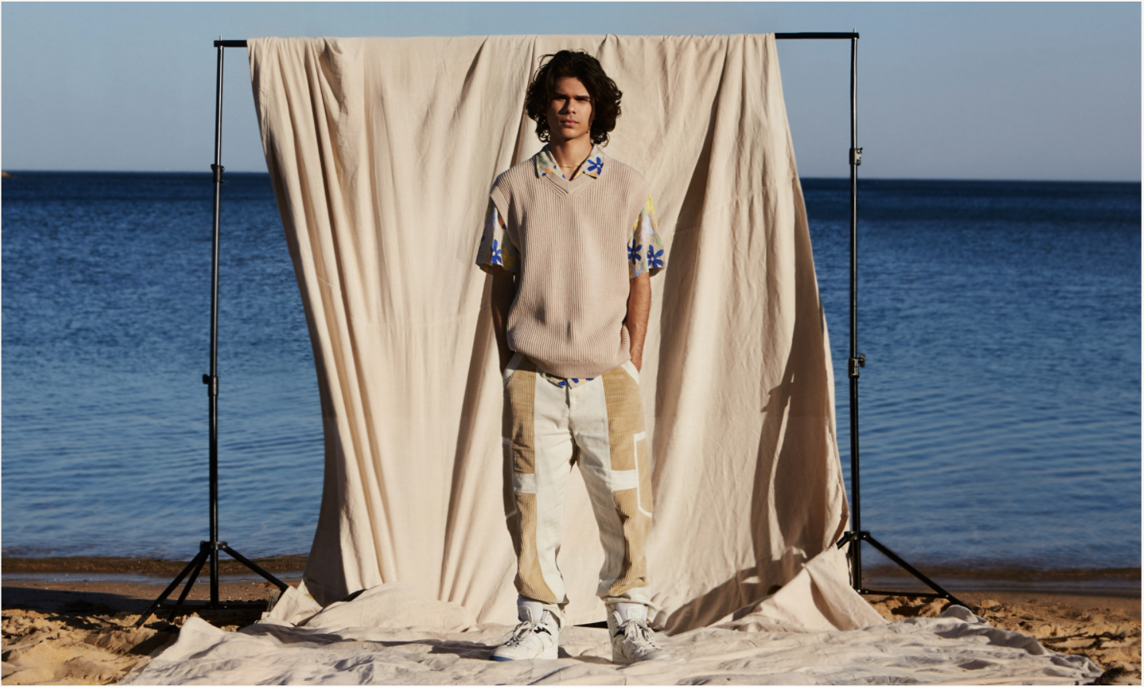

Photo credit: Elliott Lauren Ryan

“.. the presence of his sound like sunlight for the senses."

**- VOGUE**

“Budjerah pieces together elements of traditional R&B, pop and gospel, all underpinned by a dreamy, soul-infused chord progression."

**- NME**

“…smooth and divine…”

**-PAPER**

**February 25, 2022 (Los Angeles, CA)** - Today, **Budjerah** reveals his [**new single**](https://budjerah.lnk.to/WhatShouldIDoPR)and [**video**](https://budjerah.lnk.to/WSIDVideo) **“What Should I Do?,”**and announces his highly anticipated **second EP**, ***Conversations****,* available **April 8** via **Warner Records**. To celebrate the release, the 19-year-old wunderkind has announced a world tour that will take him through Australia and Europe before traveling to North America, and includes dates in support of Vance Joy. See below for details.

On “What Should I Do?,”Budjerah unites with producer **Konstantin Kersting** on a track that finds powerful tension in its clash of electro-R&B production and emotive lyricism. Kersting’s trademark synths render with a warped, almost vaporwave-like patina, glide and glissando beneath. “The lyricscame really easily,” Budjerah says of the meaning behind the track. “The inspiration came a few weeks earlier - I noticed that my friends weren’t really texting me or calling me; they had sort of pushed me to the side. I was sad because I didn't have any friends, and didn't know what to do. But now it's over: I got some new friends.” Fittingly, the song sparkles with the knowledge of hindsight.

Reunited with [Mick Soiza](https://www.instagram.com/micksoiza/) who directed Budjerah’s ARIA-nominated video **“**[**Higher**](https://www.youtube.com/watch?v=lPsj-dWp9t8)***,”*** the moody [**visual accompaniment** for](https://budjerah.lnk.to/WSIDVideo) “[What Should I Do?](https://budjerah.lnk.to/WSIDVideo)” was captured in the Byron hinterland. Soiza had this to say of the clip, “Apart from the track being a soulful undercover dance floor banger, I feel this song captures a lot of the social anxiety and disconnection so many people feel but are too afraid or embarrassed to voice. His ability to articulate how he was feeling in a genuinely exposed way and to back himself by not wanting to cave to peer pressure as a young man is well beyond his years. The aim was to tap into this and create something quite literal to the meaning of the song and dive into how confident Budjerah was in his vulnerability in this song.”

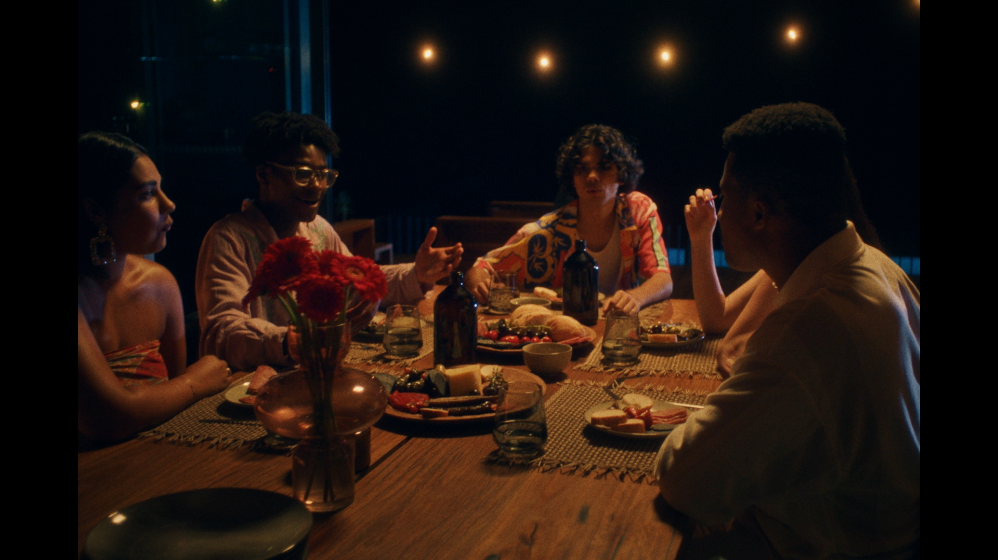

[WATCH THE VIDEO HERE](https://budjerah.lnk.to/WSIDVideo)

“What Should I Do?” is one of six tracks on ***Conversations***, Budjerah’s **second EP** out April 8. Reuniting with longtime producers **Matt Corby** and **Chris Collins**, as well as new collaborators **MAY-A** and **Konstantin Kersting**, the EP - which features previously released singles “[Talk](https://www.youtube.com/watch?v=t--BTXi5IeQ)” [with MAY-A](https://www.youtube.com/watch?v=t--BTXi5IeQ), and “[Wash My Sorrows Away](https://www.youtube.com/watch?v=TdnwSvH3K84)”- reveals a darker, sleeker sound for Budjerah, reflective of the changes that have occurred in his life. “These songs speak about the last year — about me figuring out what’s important.” Budjerah says.

He might be young, but there’s always been something wise-beyond-his-years about Budjerah. His debut, self-titled EP, released earlier in 2021, displayed an aptitude for the sheen and indelibility of old-school soul singers, a quality that spoke to the classic records he was raised on growing up in coastal New South Wales. His acclaimed debut single “[**Missing You**](https://www.youtube.com/watch?v=PFq9h4GYAd8)**”** landed the #1 most played position on triple j, and soon followed with his runaway hit single *“*[**Higher**](https://positive-feedback.us13.list-manage.com/track/click?u=47d12b32f851a79a3139bb75f&id=b5090fc363&e=0a8ccd0bac)**”***,* which achieved **Top 30 national airplay.** Budjerah took home the 2021 Breakthrough Artist award at the ARIAs. He announced a partnership with **Warner Records US,** was named an **Apple Music Up Next artist**, named one of NME’s 2022 Artist to Watch, and most recently was selected as one of the artists from around the globe for **#YouTubeBlack Voices Artist Class of 2022**.

**BUDJERAH TOUR DATES**

(For international dates and on sale information, please visit [www.budjerah.com](http://www.budjerah.com))

Sunday May 29 | Soda Bar, San Diego CA

Monday May 30 | School Night at Bardot, Los Angeles CA

Thursday June 2 | Ryman Auditorium, Nashville TN*

Saturday June 4 | Pier 17, New York City NY*

Monday June 6 | Baby’s All Right, New York NY

*Performing as special guest for Vance Joy

MORE INFO:

[WEBSITE](http://www.budjerah.com/) | [INSTAGRAM](https://www.instagram.com/budjerah/?hl=en) | [FACEBOOK](https://www.facebook.com/Budjerah) | [TWITTER](https://twitter.com/budjerahs?lang=en) | [YOUTUBE](https://www.youtube.com/channel/UCFQXeU__ExeTFCFqeuiZXxA) | [SPOTIFY](https://open.spotify.com/artist/4hOb2WdQMQWyG6RQAhR7iE?si=hxx3-KZhQP68iDCX-DN14Q) | [APPLE MUSIC](https://music.apple.com/au/artist/budjerah/1535027426)

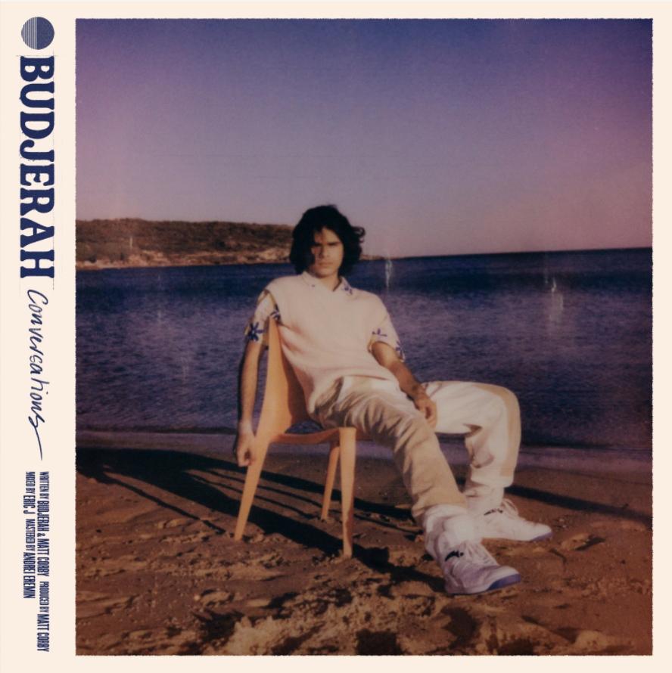

Budjerah

New single “[What Should I Do?](https://budjerah.lnk.to/Pre-ConversationsPR)”- out now

New EP [*Conversations*](https://budjerah.lnk.to/Pre-ConversationsPR) - out April 8

###

For More Information, contact:

[Jaime.Rosenberg@warnerrecords.com](mailto:Jaime.Rosenberg@warnerrecords.com)

[Laura.Swanson@warnerrecords.com](mailto:Laura.Swanson@warnerrecords.com)