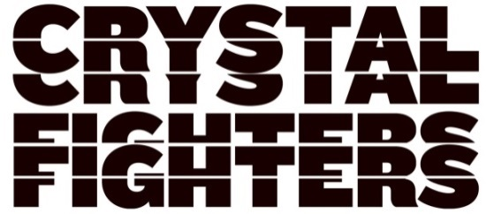

SHARE THE NEW TRACK “BY YOUR SIDE” FEATURING DAGNY
LISTEN HERE

“Basque, bizarre and oddly brilliant.” – The Times

“[Crystal Fighters] maintain that feeling of beachside freedom, a drink in your hand and sand between your toes.” – Evening Standard

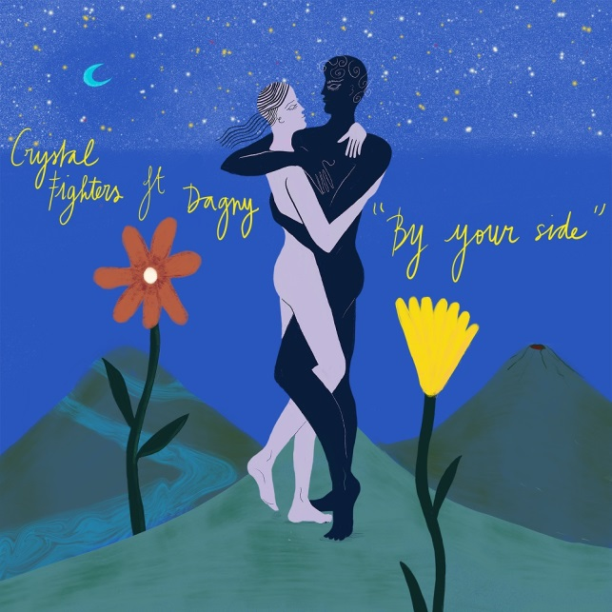

Consistently expanding their musical and cultural horizons, the free-spirited CRYSTAL FIGHTERS return with their brand new track “By Your Side.” The track features Dagny, the Norwegian pop artist who commands 2 million monthly listeners at Spotify for tracks such as "Backbeat," "Love You Like That," and "Wearing Nothing," and his recent collaboration with The Wombats.

‘By Your Side’ finds CRYSTAL FIGHTERS’ exuberant electronic-folk flourishing. An organically crafted mix of live instrumentation and dynamic alt-pop beats, it’s a song that celebrates love as a beacon of positivity in testing times. Bast Pringle and Dagny’s voices naturally complement each other on the spacious verses before they harmonise on its killer hook.

“Dagny is such an incredible singer and artist, whose music we love so much,” said Bast. “We knew her voice would be so fitting for this duet and she totally delivered, really communicating such great emotion in her vocal.”

Dagny adds, “‘Cave Rave’ was the soundtrack to my life when I first moved to London many years ago. I was obsessing over Crystal Fighters and I've been dreaming of going to one of their shows ever since. When they reached out to hear if I wanted to sing on their new record ‘By Your Side’ it was a pretty easy decision: hell yes. I think the song is amazing. I love the mood it puts me in!"

“By Your Side” is the first new music from CRYSTAL FIGHTERS since they released their latest project "Gaia & Friends" earlier in the year. With a crew of collaborators and with a clear message at its heart, the projects features the singles "Boomin In My Jeep," "All My Love" and "Wild Ones." Radio support across the project included airplay from Jack Saunders and Annie Mac at Radio 1.

CRYSTAL FIGHTERS followed “Gaia & Friends” by headlining the O2 Academy Brixton. They also featured on "Summer Luv," a collaboration between Whethan and The Knocks. Their summer festival schedule included curating their own Wave Rave festival in Basque Country, headlining a bill that featured Belako, Bad Gyal, Hinds and many more. Back home they headlined the Festival Republic Stage at the Reading and Leeds Festivals, while other European festivals included headlining Sonorama in Spain as well as sets at Pukkelpop and Pol’and’Rock.

Official site | Spotify | Apple Music | Facebook | Twitter | YouTube | Instagram

For more information please contact
Warner Records | Bobbie.gale@warnerrecords.com

