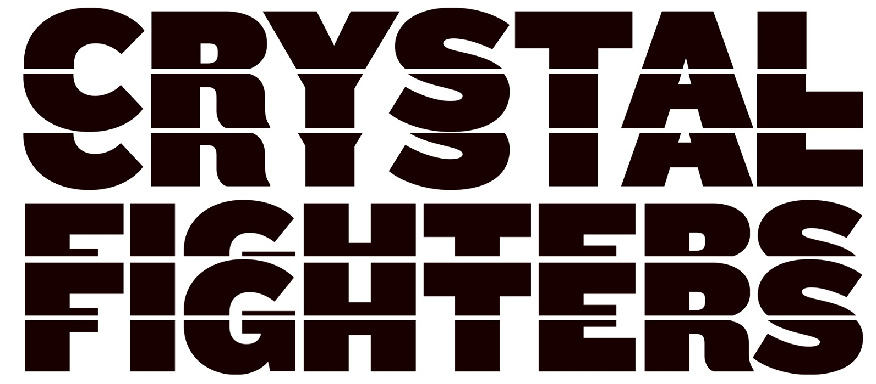

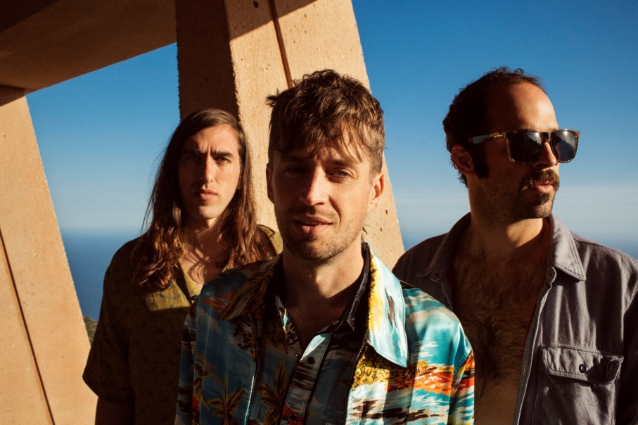

Almost ten years ago, the then-unknown Crystal Fighters were playing their first shows at warehouse parties across London. This summer they’re headlining a run of huge European festivals. Spanning continents, the band’s ever-evolving music captures everything that makes their shows a life-affirming experience: a joyous explosion of beats, electronics and bass delivered dazzlingly onstage.

The band’s new single ‘Boomin’ In Your Jeep’ represents another bold step into the unknown. Released under a new deal with Warner Bros. Records, the track captures the band’s famous spirit, character and colour, but delivered in a way in which their messages can reach a much wider audience.

It’s a joyous, intoxicating mix that exudes positivity: the band’s patented style powered by the bass-heavy energy of contemporary hip-hop production.

It’s the Crystal Fighters the world has come to love, but bigger, bolder and better than ever before. It was written on the same MPC that frontman Bast Pringle has used since he was a teenager, and in the same warehouse where they recorded their debut collection ‘Star of Love’. The track pays homage to the band’s past while pushing them towards a bright new future; a future which includes a hugely anticipated forthcoming album, soon to follow the single.

It’s “a new journey with a new sound and a new approach that’s still true to our core values,” states Gilbert. “We’ll always be about mixing sounds, and combining the old with the new. We also see ourselves as global citizens; dreaming of a world without borders and of music without genres.”

Crystal Fighters’ progress has been an international voyage of discovery. In parallel, the band’s adventures since previous album ‘Everything Is My Family’ have led to each living for periods in Peru, Costa Rica, the Basque country and beyond.

Bast shares a tale from an eight-hour trek through a Peruvian jungle as an example of the inspiration for his new writing.

“We got to the top of the mountain and we’re like, what’s that sound? And there’s banging reggaeton coming from a tiny battery-powered speaker. The kids there have an interesting experience in that they’ve lived a more isolated lifestyle than others, but they’re still heavily influenced by what’s coming out globally. It’s a mini-metaphor for our music.”

These travels won’t be stopping anytime soon, as their live show has become a mainstay of festival mainstages across the globe. Graham glows with passion as he describes their shows as being “like all of the elements of the universe combining into one moment and exploding.” Gigwise’s summary was more prosaic but no less true: “The best festival band on the planet.”

When the best festival band on the planet are tuned in to the vibrations of the planet you know Crystal Fighters’ new music is going to be more than simply music: it’s a philosophy and an energy for people everywhere to tap into. Join with them. And turn it up!

