CAVETOWN TEAMS UP WITH BEABADOOBEE FOR NEW SINGLE
“FALL IN LOVE WITH A GIRL”

VIDEO OUT NOW

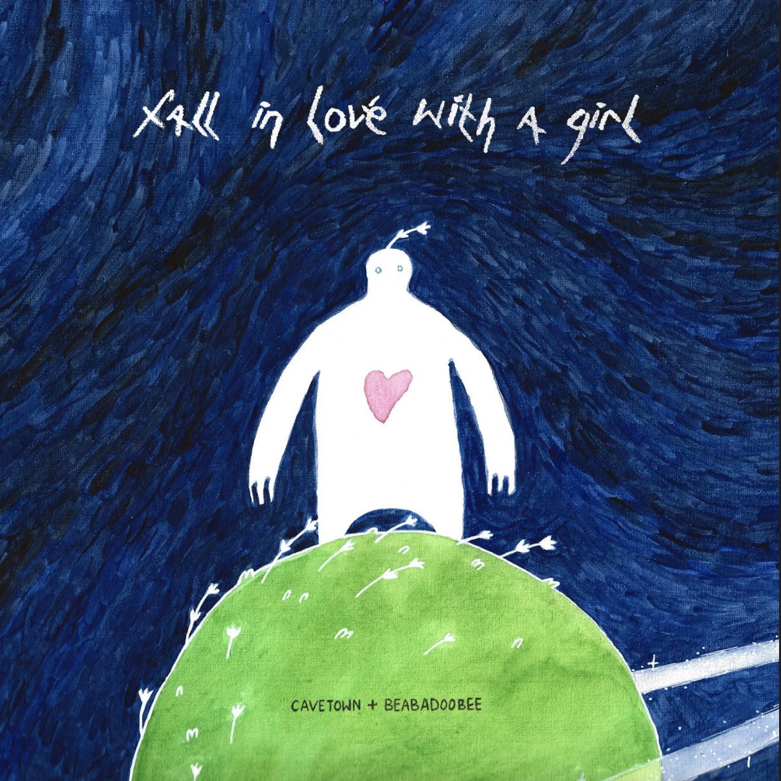
DOWNLOAD ARTWORK HERE

Los Angeles, CA (February 25, 2022) – Today, acclaimed singer/songwriter and producer Cavetown, also known as Robin Skinner, has released his new single and video “Fall In Love With A Girl (ft. beabadoobee)” available everywhere now via Sire Records. After coming up with the concept, Robin invited beabadoobee and guitarist Jacob Bugden to meet up in London to finish writing and producing the track.

About the new song, Robin shares, “Fall in Love With a Girl" is about someone who's struggling with their sexuality and how that affects their happiness. This person is scared to take the leap to make themselves happy and tries to make things work in a hetero relationship. When they finally take the step to be in a same-sex relationship, they realize how happy it makes them and that it's okay to trust yourself.”
CLICK HERE TO WATCH “FALL IN LOVE WITH A GIRL”
CLICK HERE TO LISTEN TO “FALL IN LOVE WITH A GIRL”

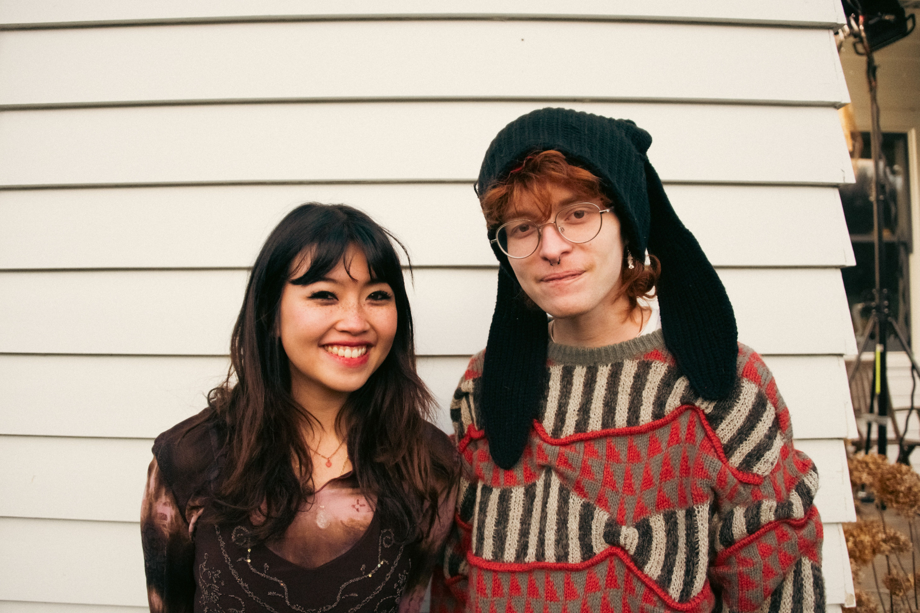
DOWNLOAD PHOTO HERE (Photo Credit: Daniela Monteiro)

The new video tells the story of the song through a ‘picture-perfect’ dollhouse as Robin first tries, then fails, to piece together the narrative of its characters. Receiving some secret help from beabadoobee, the characters’ desires become clearer to Robin as he puts the final touches on their project.

DOWNLOAD PHOTO HERE (Photo Credit: Amir Hoissain)

With over 50,000 tickets sold, Robin’s nearly sold-out US tour will kick off on March 22nd with stops at Terminal 5 in NYC on March 25th and Hollywood Palladium in Los Angeles on April 8thalong the way. See a full list of dates below, and stay tuned for much more from Cavetown in 2022.

CAVETOWN 2022 TOUR DATES
March 22 Buffalo, NY Town Ballroom (Sold Out)
March 24 Boston, MA House of Blues (Sold Out)
March 25 New York, NY Terminal 5
March 26 Philadelphia, PA The Fillmore
March 28 Baltimore, MD Rams Head Live! (Sold Out)
March 30 Carrboro, NC Cat’s Cradle (Sold Out)
April 1 Orlando, FL House of Blues (Sold Out)
April 2 Atlanta, GA Tabernacle (Sold Out)
April 5 Dallas, TX Studio at The Factory
April 7 Tempe, AZ Marquee Theatre
April 8 Los Angeles, CA Hollywood Palladium
April 9 San Diego, CA Soma
April 12 Berkeley, CA UC Theatre (Sold Out)
April 13 San Francisco, CA The Fillmore
April 15 Portland, OR Crystal Ballroom (Sold Out)
April 16 Seattle, WA The Neptune Theatre (Sold Out)
April 18 Salt Lake City, UT The Complex (Sold Out)
April 19 Denver, CO The Filmore Auditorium
April 21 Minneapolis, MN Varsity Theater (Sold Out)
April 22 Minneapolis, MN Varsity Theater (Sold Out)
April 23 Chicago, IL Riviera Theatre (Sold Out)
April 24 Detroit, MI The Fillmore
April 26 St. Louis, MO The Pageant
April 27 Nashville, TN Brooklyn Bowl
April 29 Cleveland, OH Agora Theatre
April 30 Pittsburgh, PA Roxian Theater (Sold Out)

ABOUT CAVETOWN:
Since the age of 14, Cavetown has created self-produced songs both intensely diaristic and touched with offbeat imagination. Now 22, the Cambridge-based artist, otherwise known as Robin Skinner, has emerged as one of the preeminent voices in the DIY bedroom pop scene, with more than 1 billion global streams to date, including 8 million monthly Spotify listeners and 2 million YouTube subscribers. He did so without a viral hit or easy gimmicks, but rather pure heart, filling his YouTube channel and Bandcamp with a mix of covers and original music he wrote and self-recorded in his bedroom. With the release of his 2018 breakthrough album Lemon Boy, Skinner’s unassuming yet captivating personality took the internet by storm, catapulting him become a go-to collaborator for bedroom pop mainstays mxmtoon, Chloe Moriondo, and Tessa Violet, plus selling out major venues across the U.S. and U.K. as well as taking the stage at leading festivals like Lollapalooza and Reading & Leeds. In 2020, he unveiled his major label debut album, SLEEPYHEAD, followed by his most critically-acclaimed EP to date, Man’s Best Friend, which earned global praise from the likes of The New York Times, The FADER, Rolling Stone, Billboard, CLASH Magazine, and many more upon its release earlier this year.

FOLLOW CAVETOWN:
Press Assets | Website | Facebook | Twitter | Instagram | YouTube

Cavetown US Press Contacts:
Chloe Walsh
chloe@theoriel.co
Amy Fennie
amy@theoriel.co

