DISTURBED CONFIRM 31-DATE THE SICKNESS 20TH ANNIVERSARY AMPHITHEATER TOUR
WITH VERY SPECIAL GUEST STAIND AND BAD WOLVES
DEBUT NEW MUSIC VIDEO FOR “HOLD ON TO MEMORIES”
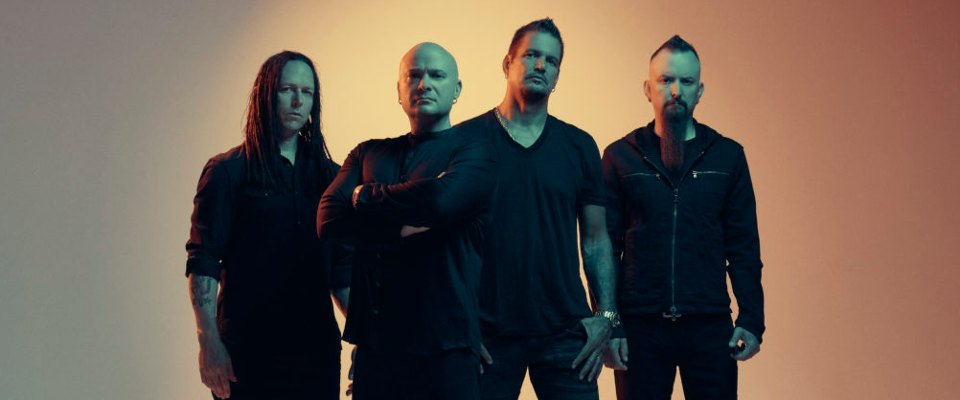
This morning, two-time Grammy nominated and multi-platinum band, Disturbed confirm their extensive 31-date The Sickness 20th Anniversary Tour throughout North America, co-produced by Frank Productions and Live Nation. The amphitheater tour, with very special guest Staind and Bad Wolves, celebrates the two-decade anniversary of the band’s seminal album, The Sickness. On this tour, the band will perform songs off the album, as well as tracks from their most recent studio release, Evolution, and their extensive catalog. The Sickness 20th Anniversary Tour will run from mid-July through mid-September, with dates in cities including Tampa, Toronto, Cincinnati, Phoenix, and Irvine (full dates below).
Tickets will go on sale Friday, Jan. 31 at 10am local time (with the exception of the Rogers, AR show which will go on-sale at 12pm local time) here. Select presales will begin Tuesday, Jan. 28. Special VIP, meet & greet, and merch bundle packages are available for all dates - more info HERE. Disturbed’s tour will also be a part of Ticket to Rock 2020, an exclusive ticket package at select Live Nation amphitheaters across the country—additional details to be announced, for more info: tickettorock.livenation.com
Disturbed also share a new music video for “Hold on to Memories” directed by Matt Mahurin, who also directed their “Sound of Silence” music video. The video is inspired by the Mexican holiday “Día de Muertos,” a day of remembrance and celebration of loved ones who have passed, with which it shares the sentiment that as long as we keep their memories with us, a piece of them is still alive. Watch the music video for “Hold on to Memories” here.
The band previously shared their live video for “Hold on to Memories,” directed by Rafa Alcantara. The video captures a moment during Disturbed’s live show where the band perform alongside a video collage of their favorite memories, with photos and videos of their friends and families, both here and gone. Watch the live video for “Hold on to Memories” here.
Disturbed have continued their record-breaking streak at rock radio, claiming the title of “2019’s Most Played Artists” in the Active Rock format. The band earned their seventh consecutive #1 on the Mediabase Active Rock Chart and Billboard’s Mainstream Rock Songs Chart with their latest single “No More,” an achievement unmatched by any artist in history. Disturbed have earned ten #1 singles on the chart, including “A Reason To Fight,” the track that initially broke the record earlier this year. “No More” is the third top-charting single from the band’s #1 album, Evolution (Reprise Records).

About Disturbed:
Simply put, DISTURBED are one of the most successful rock bands in modern history. The multiplatinum-selling quartet accomplished the rare feat of achieving five consecutive number one debuts on the Billboard Top 200. That accolade historically elevated them to rarified air alongside Metallica, the only other hard rock group to do so in the history of the chart. Immortalized (2015) received a platinum certification and spawned the triple-platinum crossover smash “The Sound of Silence,” which garnered a nomination at the 2017 GRAMMY® Awards in the category of “Best Rock Performance.” Since their formation in 1996, the band has sold 16 million albums globally and scored twelve No. 1 singles at Active Rock Radio. Their quadruple-platinum 2000 debut, The Sickness, formally announced their arrival as hard rock leaders, with that status solidified by subsequent GRAMMY® Award nominations as well as gold-, platinum- and double platinum-certified records, as well as countless sold-out shows around the globe. Named “Best Rock Artist” during the 2017 iHeartRadioMusic Awards, Disturbed continue to boldly forge ahead with the release of their aptly titled seventh offering, Evolution.
About STAIND:
Aaron Lewis, Mike Mushok, Johnny April and Jon Wysocki formed Staind in 1995,in their hometown of Springfield, Massachusetts. Over the course of their career, the band released seven studio albums and eight Top 10 singles, selling over 15 million albums worldwide. Break The Cycle, released in 2001 and RIAA certified 5x platinum, featured the smash single, “It’s Been A While,” one of the most played songs in modern rock radio history, spending 20 weeks at Number 1. Staind is currently comprised of lead vocalist and rhythm guitarist Aaron Lewis, lead guitarist Mike Mushok, bassist and backing vocalist Johnny April, and drummer Sal Giancarelli. This year STAIND reunited for a few select dates, after a five-year hiatus.
www.staind.com

About Bad Wolves:
Bad Wolves consists of vocalist Tommy Vext (ex-Divine Heresy), drummer John Boecklin (ex-Devil Driver), guitarist Doc Coyle (Vagus Nerve, ex-God Forbid), guitarist Chris Cain (Bury Your Dead) and bassist Kyle Konkiel (ex-In This Moment). They released their debut album, Disobey (May 2018), via Better Noise Music, which reached #22 on the Billboard Top 200, #2 on the Hard Rock Chart, #4 on Rock, and #8 on the Top Current Albums Chart. Their global breakout single, “Zombie,” is certified Platinum in the U.S. and Sweden, double Platinum in Canada, Gold in Australia and IMPALA Diamond in Europe. The track has topped-charts worldwide, including the U.S. iTunes Overall and Rock charts, Billboard’s Mainstream Rock Songs chart, Spotify’s Global Viral 50 chart, while also reigning atop the Active Rock radio chart for three straight weeks. The album yielded the follow-up tracks “Hear Me Now,” featuring Diamante, and the soaring ballad “Remember When,” which both reached #1 at Active Rock Radio. The official music video for “Zombie,” a tribute to the late singer Dolores O’Riordan of The Cranberries and an homage to the original, has garnered over 255 million views across platforms. On June 19th, 2018, Bad Wolves presented a $250,000 check to Dolores O’Riordan’s four children, with a continued promise to donate all of their royalties from the song to them. In 2019, they continued that momentum with their sophomore album, N.A.T.I.O.N. which came in at #1 upon its release on the Top Hard Rock, Current Hard Rock and Billboard Hard Rock charts. The single “Killing Me Slowly” recently hit #1 to make it 4 consecutive #1 songs for the band at Active Rock Radio.
Disturbed Tour Dates
May 01 /// Virginia Beach, VA /// Veterans United Home Loans Amphitheater at Virginia Beach (FM99 Lunatic Luau)
May 2 /// Charlotte, NC /// Epicenter Festival
May 9 /// Daytona Beach, FL /// Welcome to Rockville Festival
May 16 /// Camden, NJ /// BB&T Pavilion (MMR*B*Q 2020)
May 24 /// Dallas, TX /// Dos Equis Pavilion (97.1 The Eagle presents BFD 2020)
June 5 /// Nurburgring, DEU /// Rock AM Ring Fest
June 7 /// Nuremburg, DEU /// Rock IM Park Fest
June 9 /// Bremen, DEU /// Bremen Buergerweide
June 11 /// Nickelsdorf, AUT /// Nova Rock Fest
June 12 /// Interlaken, SWI /// Greenfield Fest
June 14 /// Donington, UK /// Download Fest
June 16 /// Gdansk, POL /// Ergo Arena
June 17 /// Hannover, DEU /// Swiss Life Hall
June 19 /// Copenhagen, DNK /// Copenhell Fest
June 20 /// Dessel, BEL /// Graspop Fest
June 21 /// Landgraaf, NLD /// Pinkpop Fest
June 24 /// Stockholm, SWE /// Grona Lund Tivoli
June 25 /// Oslo, NOR /// Tons of Rock Fest
June 27 /// Seinajoki, FIN /// Provinssi Fest
July 15 /// Maryland Heights, MO /// Hollywood Casino Amphitheatre*
July 16 /// Cadott, WI /// Rock Fest
July 18 /// Grand Rapids, MI /// Upheaval Festival
July 21 /// Alpharetta, GA /// Ameris Bank Amphitheatre*
July 23 /// Tampa, FL/// MIDFLORIDA Credit Union Amphitheatre*
July 24 /// West Palm Beach, FL /// iTHINK Financial Amphitheatre*
July 26/// Bristow, VA /// Jiffy Lube Live*
July 29 /// Holmdel, NJ /// PNC Bank Arts Center*
July 30 /// Mansfield, MA /// Xfinity Center*
August 01 /// Hershey, PA /// Hersheypark Stadium*
August 02 /// Hartford, CT /// XFINITY Theatre*
August 04 /// Saratoga Springs, NY /// Saratoga Performing Arts Center*
August 06 /// Wantagh, NY /// Northwell Health at Jones Beach Theater*
August 08 /// Syracuse, NY /// St. Joseph's Health Amphitheater at Lakeview*
August 10 /// Darien Center, NY /// Darien Lake Amphitheater*
August 11 /// Toronto, ON /// Budweiser Stage*
August 13 /// Burgettstown, PA /// S&T Bank Music Park*
August 15 /// Cincinnati, OH /// Riverbend Music Center*
August 16 /// Clarkston, MI /// DTE Energy Music Theatre*
August 20 /// Tinley Park, IL /// Hollywood Casino Amphitheatre *
August 21 /// Cuyahoga Falls, OH /// Blossom Music Center*
August 23 /// Noblesville, IN /// Ruoff Music Center*
August 26 /// Rogers, AR /// Walmart AMP*^
August 27 /// The Woodlands, TX /// The Cynthia Woods Mitchell Pavilion*
August 29 /// Albuquerque, NM /// Isleta Amphitheater*
August 30 /// Phoenix, AZ /// Ak-Chin Pavilion*
September 01 /// Chula Vista, CA /// North Island Credit Union Amphitheatre*
September 02 /// Irvine, CA /// FivePoint Amphitheatre*
September 04 /// Mountain View, CA /// Shoreline Amphitheatre*
September 05 /// Wheatland, CA /// Toyota Amphitheatre*
September 09 /// West Valley City, UT /// USANA Amphitheatre*
September 11 /// Ridgefield, WA /// Sunlight Supply Amphitheater*
September 12 /// Auburn, WA /// White River Amphitheatre*
*The Sickness 20th Anniversary Tour with very special guest Staind and Bad Wolves

For more information, please contact Mary Moyer (mary@qprime.com) and Emilio Herce (emilio@qprime.com) at Q Prime 212.302.9790 or Patrice Compere (Patrice.Compere@warnerrecords.com - 212-707-3450) at Warner Records.

For Live Nation U.S. Concerts, please contact Emily Bender (emilybender@livenation.com) and Monique Sowinski (moniquesowinski@livenation.com)

About Live Nation Entertainment
Live Nation Entertainment (NYSE: LYV) is the world's leading live entertainment company comprised of global market leaders: Ticketmaster, Live Nation Concerts, and Live Nation Sponsorship. For additional information, visit www.livenationentertainment.com.

About Frank Productions
Frank Productions (FPC Live) is a full-service concert promotion company involved in every facet of live events including production, logistics, ticketing, marketing, sponsorships, food and beverage, operations, and merchandising. Frank Productions produces and promotes live entertainment events in arenas, amphitheaters, performing arts centers, clubs, and other venues across the country. For additional information, visit www.FPC-Live.com.

