**UK HYPERPOP INNOVATOR** [**EZEKIEL**](https://www.instagram.com/ezek1el/?hl=en) **ENLISTS** [**SIIICKBRAIN**](https://www.instagram.com/siiickbrain/?hl=en) **FOR NEW REMIX “help_urself 2”**

[**LISTEN HERE**](https://ezekiel.lnk.to/help_urself2)

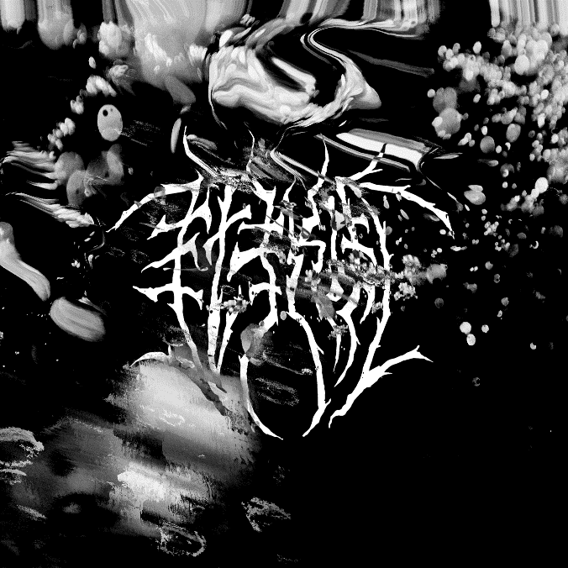

**February 11, 2022 (Los Angeles, CA) –** Hailed by *Dummy Mag* as one of the “Best Emerging UK Hyperpop Artists,” 19-year-old Ezekiel today drops a new version of his TikTok and streaming hit “help_urself” – **“help_urself 2” feat. Siiickbrain**. “help_urself” has been used by some of the biggest creators on TikTok – from Bella Poarch to @stapeyourmouthshut – and led Ezekiel to over 72 million global streams. The addition of Siiickbrain’s haunting vocals takes this darkly addictive track to the next level.

Based in Manchester, U.K., Ezekiel has been attending fashion school while writing, producing, and honing his musical style all from his own bedroom. He’s a true DIY artist, turning genre every which way in his creations and mining inspiration from EDM to drum & bass to 2000s pop. One listen to “help_urself” and you can’t help but need more – stay tuned for what’s to come.

###

**For further information, please contact Ceri Roberts:**

[Ceri.Roberts@warnerrecords.com](mailto:Ceri.Roberts@warnerrecords.com)

**Follow Ezekiel:**

[Instagram](https://nam04.safelinks.protection.outlook.com/?url=https%3A%2F%2Fwww.instagram.com%2Fezek1el%2F&data=04%7C01%7CPatrice.Compere%40warnerrecords.com%7Cc4550ab9148b4008cc6b08d98f5d833d%7C8367939002ec4ba1ad3d69da3fdd637e%7C0%7C0%7C637698454056154738%7CUnknown%7CTWFpbGZsb3d8eyJWIjoiMC4wLjAwMDAiLCJQIjoiV2luMzIiLCJBTiI6Ik1haWwiLCJXVCI6Mn0%3D%7C1000&sdata=M4v%2FgHJYLczYqoueQP0WsPLZk%2B06F%2FxXA%2FeyjFyfFm4%3D&reserved=0) | [Twitter](https://nam04.safelinks.protection.outlook.com/?url=https%3A%2F%2Fmobile.twitter.com%2Fteenwrist&data=04%7C01%7CPatrice.Compere%40warnerrecords.com%7Cc4550ab9148b4008cc6b08d98f5d833d%7C8367939002ec4ba1ad3d69da3fdd637e%7C0%7C0%7C637698454056154738%7CUnknown%7CTWFpbGZsb3d8eyJWIjoiMC4wLjAwMDAiLCJQIjoiV2luMzIiLCJBTiI6Ik1haWwiLCJXVCI6Mn0%3D%7C1000&sdata=vc89QuBswacn2j1XCIopsit16JjXP9AqciS0ccwoA8s%3D&reserved=0) | [YouTube](https://nam04.safelinks.protection.outlook.com/?url=https%3A%2F%2Fwww.youtube.com%2Fchannel%2FUC0eEG8ejFedOqcHhayQBQ4g%2Fabout&data=04%7C01%7CPatrice.Compere%40warnerrecords.com%7Cc4550ab9148b4008cc6b08d98f5d833d%7C8367939002ec4ba1ad3d69da3fdd637e%7C0%7C0%7C637698454056164729%7CUnknown%7CTWFpbGZsb3d8eyJWIjoiMC4wLjAwMDAiLCJQIjoiV2luMzIiLCJBTiI6Ik1haWwiLCJXVCI6Mn0%3D%7C1000&sdata=8ZdkS1kQSDbo9Zo5IddkGttQk5l0NHfzPJZpYMzTvIU%3D&reserved=0) | [Spotify](https://nam04.safelinks.protection.outlook.com/?url=https%3A%2F%2Fopen.spotify.com%2Fartist%2F4qUoZ6ErhTYFhAI0W1iI9q%3Fsi%3DQDZJJf5DTA-zVDdoEP2p3A%26dl_branch%3D1&data=04%7C01%7CPatrice.Compere%40warnerrecords.com%7Cc4550ab9148b4008cc6b08d98f5d833d%7C8367939002ec4ba1ad3d69da3fdd637e%7C0%7C0%7C637698454056164729%7CUnknown%7CTWFpbGZsb3d8eyJWIjoiMC4wLjAwMDAiLCJQIjoiV2luMzIiLCJBTiI6Ik1haWwiLCJXVCI6Mn0%3D%7C1000&sdata=%2BYHSMzyV5whJNm%2BfeL8wSfwfL%2FWJS59lf3WpDZvVNaE%3D&reserved=0)

