BREAKOUT SINGER/SONGWRITER PATRICK DRONEY DELIVERS DEBUT STUDIO ALBUM STATE OF THE HEART VIA WARNER RECORDS - AVAILABLE NOW

Droney Celebrates with Striking Debut Performance on The Late Show with Stephen Colbert’s #PLAYATHOMESERIES

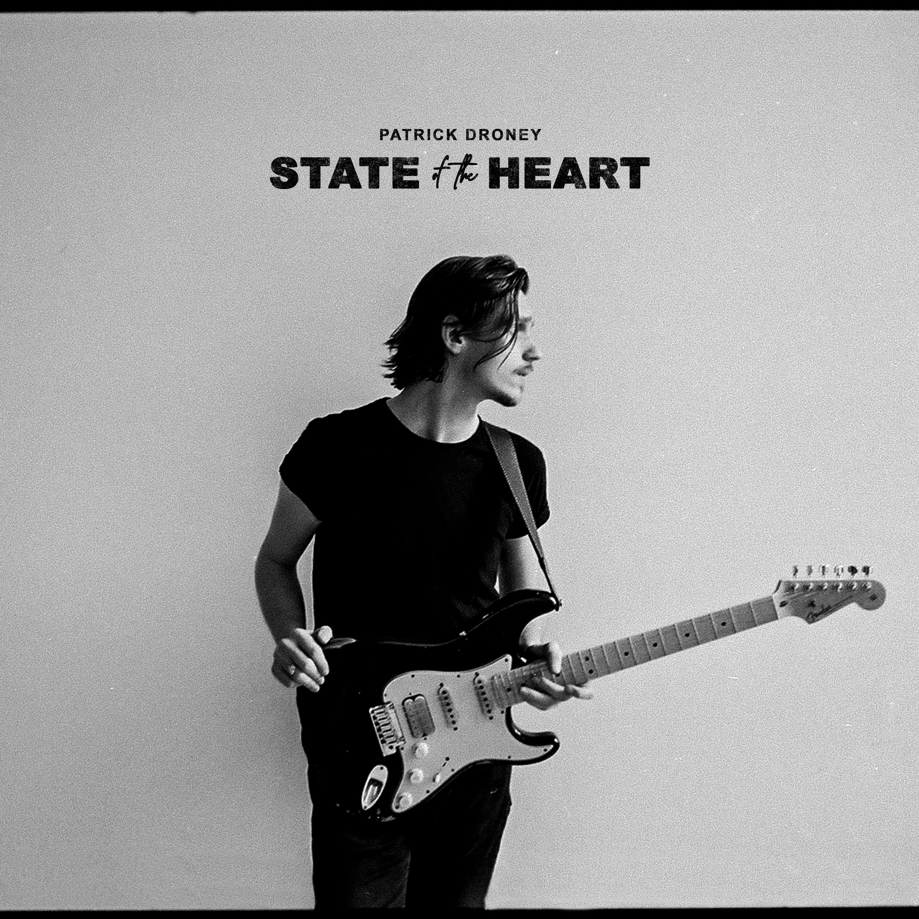

Nashville, TN - May 21, 2021 - Singer, songwriter and celebrated guitarist Patrick Droney’s eagerly-awaited debut studio album STATE OF THE HEART is available today via Warner Records. Inspired by the journey that connects us all, Droney’s layered debut collection masterfully explores themes of the human condition like the meaning of loss, the pursuit of self and reconciling what’s behind you in order to make sense of the present. Entirely co-produced and co-written by Droney, while also contributing multiple instrumental credits including signature electric guitar, keys, bass and drums, his expansive 15-track debut project is available to listen to here.

At its core, STATE OF THE HEART offers an in-depth look into the long journey its creator undertook in order to get to this exact moment in time. Droney explains, "We are all made up of stories. 'State of the Heart' reflects my own up to this point and with its release gives me the chance to embark on the next chapter. Music has always been my way of keeping a record of my experience of human condition. My hope is that this record can be a friend to others and remind them they aren’t alone in their various states of heart."

The fast-rising Warner Records artist marks release day with a performance on The Late Show with Stephen Colbert as part of their #PlayAtHome series with a special full-band performance of “When The Lights Go Out,” available to watch at 3PM ET on The Late Show’s YouTube, Twitter, IGTV, Facebook & CBS.com.

STATE OF THE HEART inspires from start to finish, with Droney’s singing and guitar playing matched by the other areas of production, from synth-laden peaks and drone-inspired rhythms to saxophone parts, and wry, tough, yet tender ballads. The influence of Droney’s heroes (Don Henley, Steve Winwood, B.B. King, Bruce Springsteen, Jeff Buckley) is undeniable, yet the music always feels urgent and contemporary, with Droney’s chops and heart-forward expression leading the charge.

Growing up in South Jersey, Droney’s career began with a bang, as at age 13 he won a Robert Johnson New Generation Award as “Best Young Blues Guitarist” and began sharing stages with the likes of B.B. King, James Brown, The Roots, Taj Mahal, Macy Gray, and Elvis Costello. Droney became enamored of New York City at an early age, gigging frequently in esteemed Manhattan clubs and eventually attending the Clive Davis Institute of Recorded Music at NYU. He moved to LA and signed a publishing deal, and in 2018 relocated to Nashville to craft a self-titled EP, also making his TV debut on Late Night with Seth Meyers, performing at Barclays Center for Tidal X, and seeing his song “High Hope” featured on Grey’s Anatomy. After signing to Warner Records in 2019, he appeared at Bonnaroo and ACL, collaborated with Kygo, released the first half of his debut, and recently reached the 60 million streams milestone. With a résumé that reads like a dream, and after extensive touring and playing onstage with some of the all-time legends of blues, pop, rock, and soul, Droney released a debut album of his own — STATE OF THE HEART — available now.

###

Contacts:
The GreenRoom PR
Kristie Sloan / kristie@thegreenroompr.com
Tyne Parrish / tyne@thegreenroompr.com

Warner Records Publicity
Rick Gershon / Rick.Gershon@warnerrecords.com
Patrice Compere / Patrice.Compere@warnerrecords.com

