CONFIRMS NEW TOUR DATES

Tickets Go On Sale This Friday At 10:00AM Local Time

New Album THIS LAND Released February 22,
Via Warner Bros. Records

Gary Clark Jr. is the Musical Guest on Saturday Night Live - February 16th!

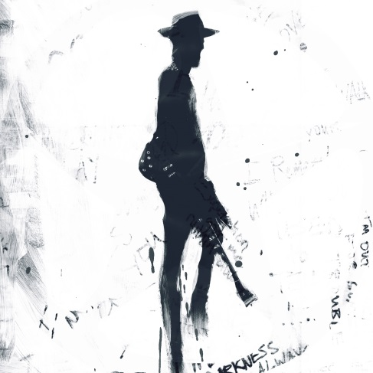

February 13, 2019 (Los Angeles, CA) - Today, Gary Clark Jr. announces newly confirmed tour dates in support of his upcoming full length album THIS LAND to be released February 22, via Warner Bros. Records. Tickets go on sale this Friday, February 15, at 10:00AM local time. For all participating venues, ticket bundles will be available that will include a standard CD or digital copy of THIS LAND with each ticket purchased. Click here to purchase THIS LAND and click here to ticket information. Check out the official tour trailer.
As previously announced, Gary Clark Jr. will make his “Saturday Night Live” debut February 16 on NBC performing two songs from THIS LAND. Click here for broadcast details.
Recently, Clark was featured in the latest episode of Rolling Stone’s Music Now Podcast. Click here to listen and share. Clark was also featured on flagship episode of Rolling Stone’s new series, “How I Wrote That” spotlighting the creative process behind the album’s title track “This Land” along with the first-ever live performance of the song from Arlyn Studios in Austin, Texas. Click here to view and share.
Click here to view and share the official video for “This Land,” directed by Savanah Leaf.
More recently, Clark has shared another stunning new song from the forthcoming album, “Pearl Cadillac” which is a heartfelt tribute to his mother. Click here to listen and share.

Gary Clark Jr. welcomes you to THIS LAND on tour in 2019.
*Indicates newly confirmed date

Mar 09 Miami, FL Fillmore Miami Beach at The Jackie Gleason Theater
Mar 10 Tampa, FL Gasparilla Music Festival
Mar 13 Springfield, MO Gillioz Theatre
Mar 14 Columbia, MO The Blue Note
Mar 15 Chicago, IL Chicago Theatre presented by Chase
Mar 16 Chicago, IL Chicago Theatre presented by Chase
Mar 18 Indianapolis, IN Old National Centre - Murat Theatre
Mar 20 Pittsburgh, PA Benendum Center
Mar 21 New York City, NY Beacon Theatre presented by Chase
Mar 22 New York City, NY Beacon Theatre presented by Chase
Mar 23 New York City, NY Beacon Theatre presented by Chase
Mar 26 Boston, MA House of Blues
Mar 27 Boston, MA House of Blues
Mar 29 Philadelphia, PA Met Opera House
Mar 30 Washington, DC The Anthem
Mar 31 Richmond, VA The National
Apr 02 Durham, NC Durham PAC
Apr 03 Charlotte, NC The Fillmore Charlotte
Apr 05 Nashville, TN Ryman Auditorium
Apr 06 Nashville, TN Ryman Auditorium
Apr 07 Nashville, TN Ryman Auditorium
May 04 Atlanta, GA Shaky Knees Music Festival
*May 18 Albuquerque, NM Sandia Resort & Casino – Amphitheatre
*May 20 Tucson, AZ The Rialto Theatre
*May 22 Valley Center, CA The Event Center – Harrahs SoCal
May 25 Napa, CA BottleRock Music Festival
*July 19 Honolulu, HI Republik
*July 20 Honolulu, HI Republik
*July 21 Kahului-Maui, HI Maui Arts & Cultural Center – Castle Theater
*Aug 04 Rochester Hills, MI Meadow Brook Amphitheater
*Aug 08 Council Bluffs, IA Harrah’s Council Bluffs – Stir Cove
*Aug 09 Minneapolis, MN Surly Festival Field
*Aug 12 Saint Louis, MO Fox Theatre
*Aug 13 Kansas City, MO Crossroads KC
*Aug 19 Asheville, NC Highland Brewing Company
*Sept 04 Morrison, CO Red Rocks Amphitheatre
*Sept 05 Vail, CO Gerald R. Ford Amphitheatre
*Sept 08 Bonner, MT Kettle House Amphitheater
*Sept 10 Vancouver, BC PNE Forum
*Sept 13 Troutdale, OR Edgefield
*Sept 14 Bend, OR Les Schwab Amphitheatre
*Sept 15 Reno, NV Grand Sierra Resort & Casino – Grand Theater
*Sept 17 Aspen, CO Belly Up Aspen
*Sept 24 Phoenix, AZ Comerica Theatre
*Sept 27 Santa Barbara, CA Santa Barbara Bowl
*Sept 29 Los Angeles, CA Hollywood Bowl

Ticket & Tour info: http://www.garyclarkjr.com/tour

THIS LAND track listing:
This Land
What About Us
I Got My Eyes On You (Locked & Loaded)
I Walk Alone
Feelin’ Like A Million
Gotta Get Into Something
Got To Get Up
Feed The Babies
Pearl Cadillac
When I’m Gone
The Guitar Man
Low Down Rolling Stone
The Governor
Don’t Wait Til Tomorrow
Dirty Dishes Blues
BONUS TRACKS:
Highway 71
Did Dat
# # #
Contacts:

National: Rick Gershon Warner Bros. Records Publicity:
818-953-3473 / rick.gershon@wbr.com

Regional/ Tour Press: Bre Flores Warner Bros. Records Publicity:
818-953-3638 / Breanne.flores@wbr.com

Follow Gary Clark Jr.:
Official: garyclarkjr.com
Facebook: facebook.com/GaryClarkJr
Twitter: @GaryClarkJr
YouTube: www.youtube.com/user/garyclarkjr
Press Materials: http://press.wbr.com/garyclarkjr/

