

cid:image002.png@01D59F78.72944830

**FEATURED ON *CBS SUNDAY MORNING* THIS WEEKEND**

**CLARK SET TO PERFORM ON**

**“LET’S GO CRAZY: THE GRAMMY® SALUTE TO PRINCE CONCERT” JANUARY 28TH**

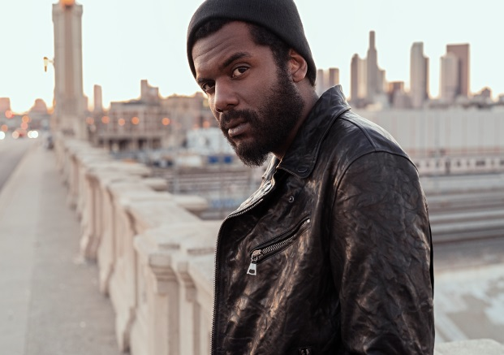

**(Photo credit: Frank Maddocks - Click** [**here**](https://press.warnerrecords.com/wp-content/uploads/2019/03/DSC01301.jpg)**)**

**January 10, 2020 (Los Angeles, CA) –** Grammy-Award-winning artist [**Gary Clark Jr.**](https://nam04.safelinks.protection.outlook.com/?url=http%3A%2F%2Fwww.garyclarkjr.com%2F&data=02%7C01%7CRick.Gershon%40warnerrecords.com%7C25b9b12fa1df4884ec0208d76ddf1997%7C8367939002ec4ba1ad3d69da3fdd637e%7C0%7C0%7C637098677278575928&sdata=1XJ85dOP%2FwYQqmPkqu%2BG8Yt6Kk5kD2IF5%2F1ZrRstwZA%3D&reserved=0)will be the featured musical guest on [***CBS Sunday Morning***](https://www.cbsnews.com/sunday-morning/) this weekend, January 12th. CBS visits Clark at his home in Austin, Texas for his most revealing interview yet along with an exclusive live performance. Tune in to CBS 6:00am PT / 9:00am ET. Click [**here**](https://www.cbsnews.com/sunday-morning/) for broadcast details.

As previously announced,Clark has recently releaseda new mix of **“Pearl Cadillac”** -- from his current Warner Records album, ***THIS LAND*** – and features additional vocals by fellow Warner artist and Grammy nominee [**Andra Day**](https://www.andraday.com/)**.** The new streamlined edit showcasing Day’s commanding vocal performance with Clark now plays like a classic Prince-inspired power ballad. Click [**here**](https://warnerr.ec/pearlcaddyremix) to stream the new version of **“Pearl Cadillac,”** and click [**here**](https://warnerr.ec/pearlcaddyremix_v)to view and share the visualizer.

Gary Clark Jr., nominated for four Grammy’s this year for the song, album and video **“This Land,”** will be part of two all-star celebrations during Grammy week starting with the annual **2020** **MUSICARES**®**Person of The Year Tribute Honoring Aerosmith** on January 24th, at the Los Angeles Convention Center. Clark joins a star-studded lineup that includes Gavin DeGraw, Johnny Depp, Cheap Trick, Alice Cooper, Foo Fighters, H.E.R., Jonas Brothers, Emily King, John Legend, John Mayer and Yola. Greg Phillinganes will be the musical director with additional guest performers to be announced.

Clark has also been tapped to be part of **“Let’s Go Crazy: The Grammy Salute To Prince**.” The live concert taping will be held Tuesday, January 28th at 7:30 p.m. PT at the Los Angeles Convention Center. The special will feature a lineup of all-star artists paying tribute to Prince's unprecedented influence on music, including GRAMMY Award-winning artists **Beck, Common, Earth, Wind & Fire, Foo Fighters, H.E.R., Juanes, Alicia Keys, John Legend,** Coldplay’s **Chris Martin, Mavis Staples, St. Vincent, Usher** and singer/songwriter **Susanna Hoffs.** Plus, a historic joint performance by several of Prince's most celebrated musical friends and collaborators including GRAMMY Award-winning band **the Revolution**, past GRAMMY Award nominee **Sheila E.**, and Prince-formed funk band **Morris Day And The Time**. Additional performers will be announced in the coming weeks. The special will be broadcasted later in 2020 on **[CBS](http://www.cbs.com/)**. Tickets are on sale now and available for purchase [**here**](https://www.axs.com/events/389980/letys-go-crazy-the-grammy-salute-to-princey-tickets).

**About Gary Clark Jr.:** Clark made a major impact throughout 2019. Upon release, ***This Land*** – Clark’s third full-length studio album – bowed at #6 on the *Billboard* Top 200, marking his third Top 10 debut. It also attracted acclaim from the likes of *The New York Times*, *The Washington Post*, *The Los Angeles Times*, *Rolling Stone*, *Pitchfork* and more.  He has performed on *Saturday Night Live*, *The Late Show with Stephen Colbert, The Ellen DeGeneres Show, The Tonight Show Starring Jimmy Fallon, The Late Late Show with James Corden*, *Jimmy Kimmel Live!*, *Good Morning America, CBS Sunday Morning, CBS This Morning, The Today Show, Late Night with Seth Meyers, The Daily Show with Trevor Noah, The Howard Stern Show, WTF with Marc Maron* and more.  Clark embarked on his biggest international headline run to date, topping bills at legendary festivals and venues such as the Hollywood Bowl, and made multiple appearances in stadiums supporting and sharing the stage with The Rolling Stones.

**# # #**

Contact **Rick Gershon** at Warner Records

818-953-3473 | [**rick.gershon@warnerrecords.com**](mailto:rick.gershon@warnerrecords.com)

**Follow Gary Clark Jr.:**

[**Official**](https://www.garyclarkjr.com/thisland?ref=https://www.google.com/) **|** [**Facebook**](https://www.facebook.com/GaryClarkJr/) **|** [**Twitter**](mailto:@GaryClarkJr) **|** [**Instagram**](https://www.instagram.com/garyclarkjrofficialfanpage/?hl=en) **|** [**YouTube**](http://www.youtube.com/user/garyclarkjr) **|** [**Press Site**](https://press.warnerrecords.com/garyclarkjr/)