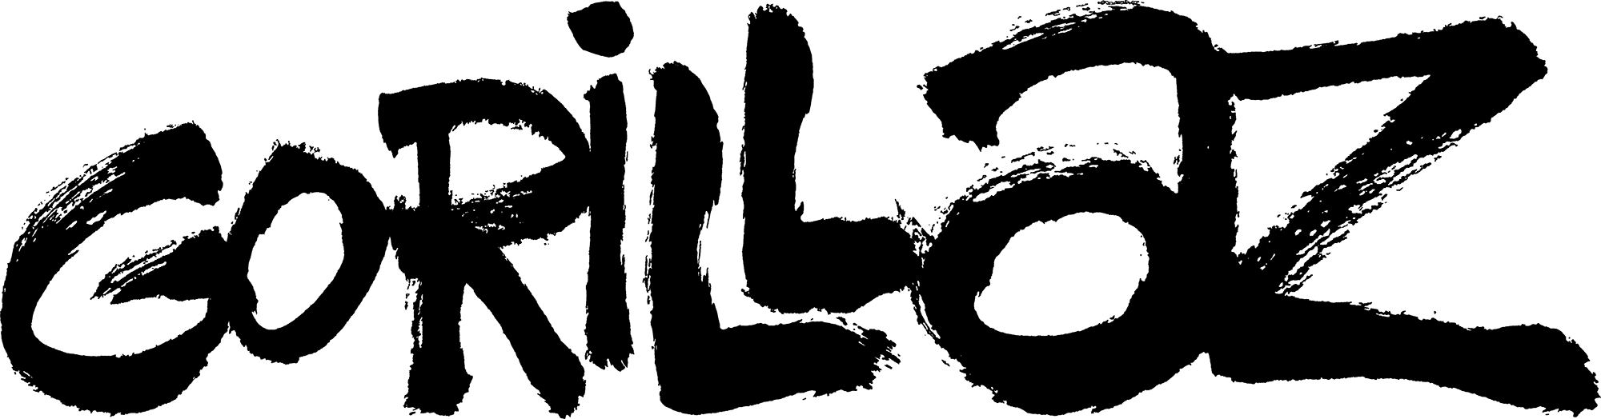

&
BECK

TEAM UP FOR EPISODE 8 OF SONG MACHINE

“The Valley Of The Pagans” - WATCH NOW!

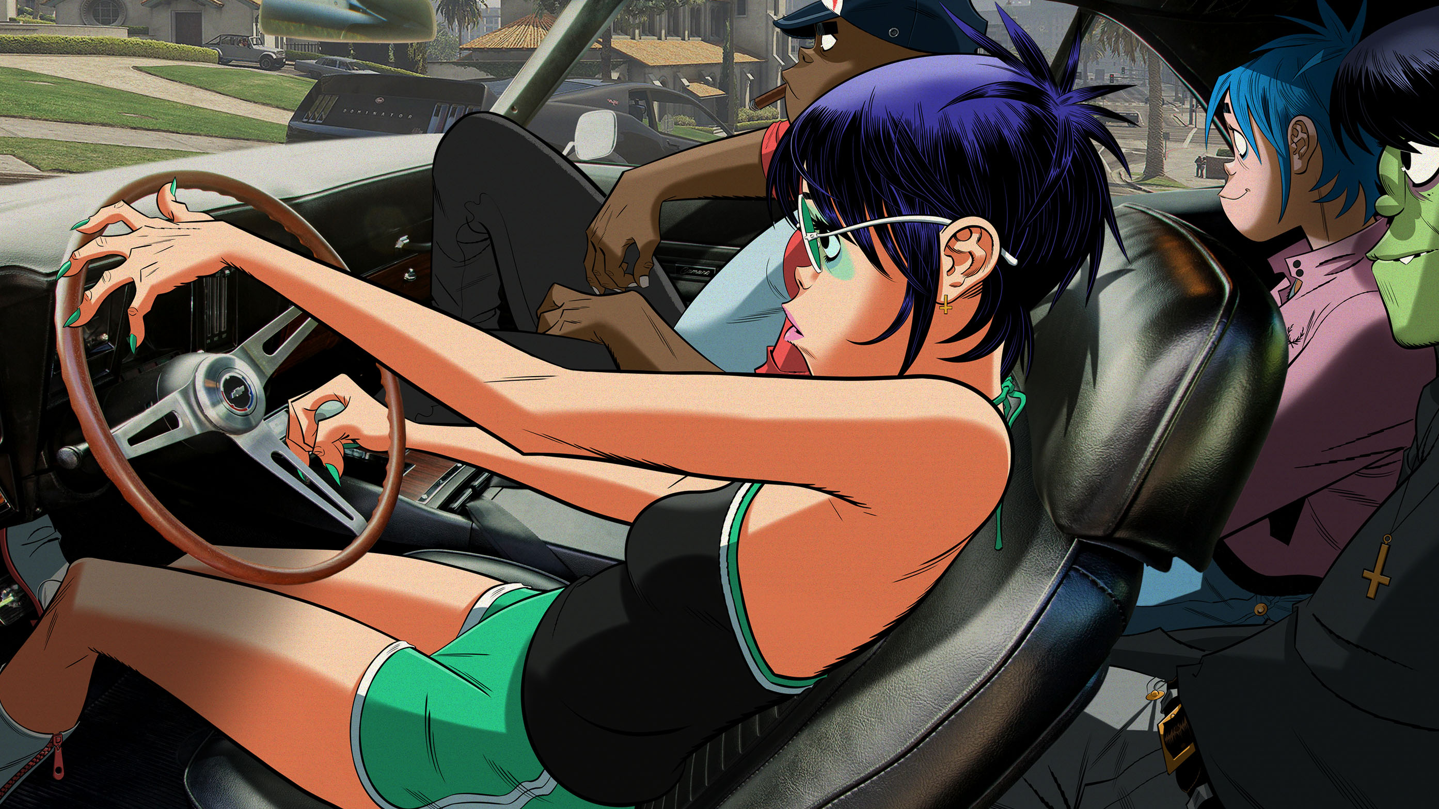

FOLLOW SONG MACHINE HERE

November 5, 2020 (Los Angeles, CA) - Out today, “The Valley Of The Pagans” feat. Beck is the latest episode from the critically-acclaimed ever-evolving Song Machine, which has seen Gorillaz take us through 2020 with a myriad of sounds, styles, genres and attitudes from a breath-taking line-up of guest artists captured live in Kong Studios and beyond. Listen to “The Valley Of The Pagans” feat. Beck here.

The video for the track, featuring BRIT and Grammy Award winning artist Beck, sees the idiosyncratic, West Coast infused “The Valley Of The Pagans” blast through the band’s car stereo as 2D, Murdoc, Noodle and Russel take a chaotic road trip through the streets of Los Angeles, with Beck joining the fun via FaceTime. Watch the video here NOW!

Arriving on the 12th & 13th of December is SONG MACHINE LIVE, Gorillaz’ first live performance since 2018 broadcast live around the world with three separate shows taking place across three time zones through the magic of LIVENow. WATCH TEASER HERE
For full ticket and viewing information, see WWW.GORILLAZLIVENOW.COM

Episode 2 of Song Machine Radio – hosted by Russel Hobbs – will broadcast on Apple Music 1 at 8pm GMT this Friday November 6th. Episode 1, hosted by 2D, is available to hear now here. The four-part series sees 2D, Russel Hobbs, Murdoc Niccals and Noodle team up with collaborators past and present to share their world and music in celebration of Song Machine and reflect on 20 years of Gorillaz.

The complete collection of Song Machine: Season One is out now, details here.

Download high res press shot here: https://we.tl/t-xaqLOnkmzf

Further Information:
Watch Episode 1 - Momentary Bliss ft. slowthai and Slaves - here.
Watch Episode 2 - Désolé ft Fatoumata Diawara – here.
Watch Episode 3 – Aries ft Peter Hook and Georgia – here.
Watch Episode 4 – Friday 13th ft Octavian – here
Watch Episode 5 – Pac-Man ft ScHoolboy Q - here
Watch Episode 6 – Strange Timez ft Robert Smith – here
Watch Episode 7 – Pink Phantom ft Elton John and 6LACK - here
Virtual band Gorillaz is singer 2D, bassist Murdoc Niccals, guitarist Noodle and drummer Russel Hobbs. Created by Damon Albarn and Jamie Hewlett, their acclaimed eponymous debut album was released in 2001. The BRIT and Grammy Award winning band’s subsequent albums are Demon Days (2005), Plastic Beach (2010), The Fall (2011), Humanz (2017) and The Now Now (2018). A truly global phenomenon, Gorillaz have achieved success in entirely ground-breaking ways, touring the world from San Diego to Syria, winning numerous awards including the coveted Jim Henson Creativity Honor.
* The band are recognised by The Guinness Book Of World Records as the planet’s Most Successful Virtual Act.

Song Machine is out on standard CD, vinyl and cassette; plus the 17-track Deluxe and Super Deluxe box sets. Not forgetting the bulging full-colour, one-of-a-kind 210-page Almanac, the very first annual from Gorillaz. Order here.

www.gorillaz.com

