ANNOUNCE NEW ALBUM
angel in realtime.
OUT FEBRUARY 25, 2022 VIA WARNER RECORDS
FEATURING NEW TRACK “tend the garden”

LISTEN HERE / WATCH HERE

NORTH AMERICAN TOUR CONFIRMED. TICKETS ON SALE NOVEMBER 10,
AT 1PM PT / 4PM ET

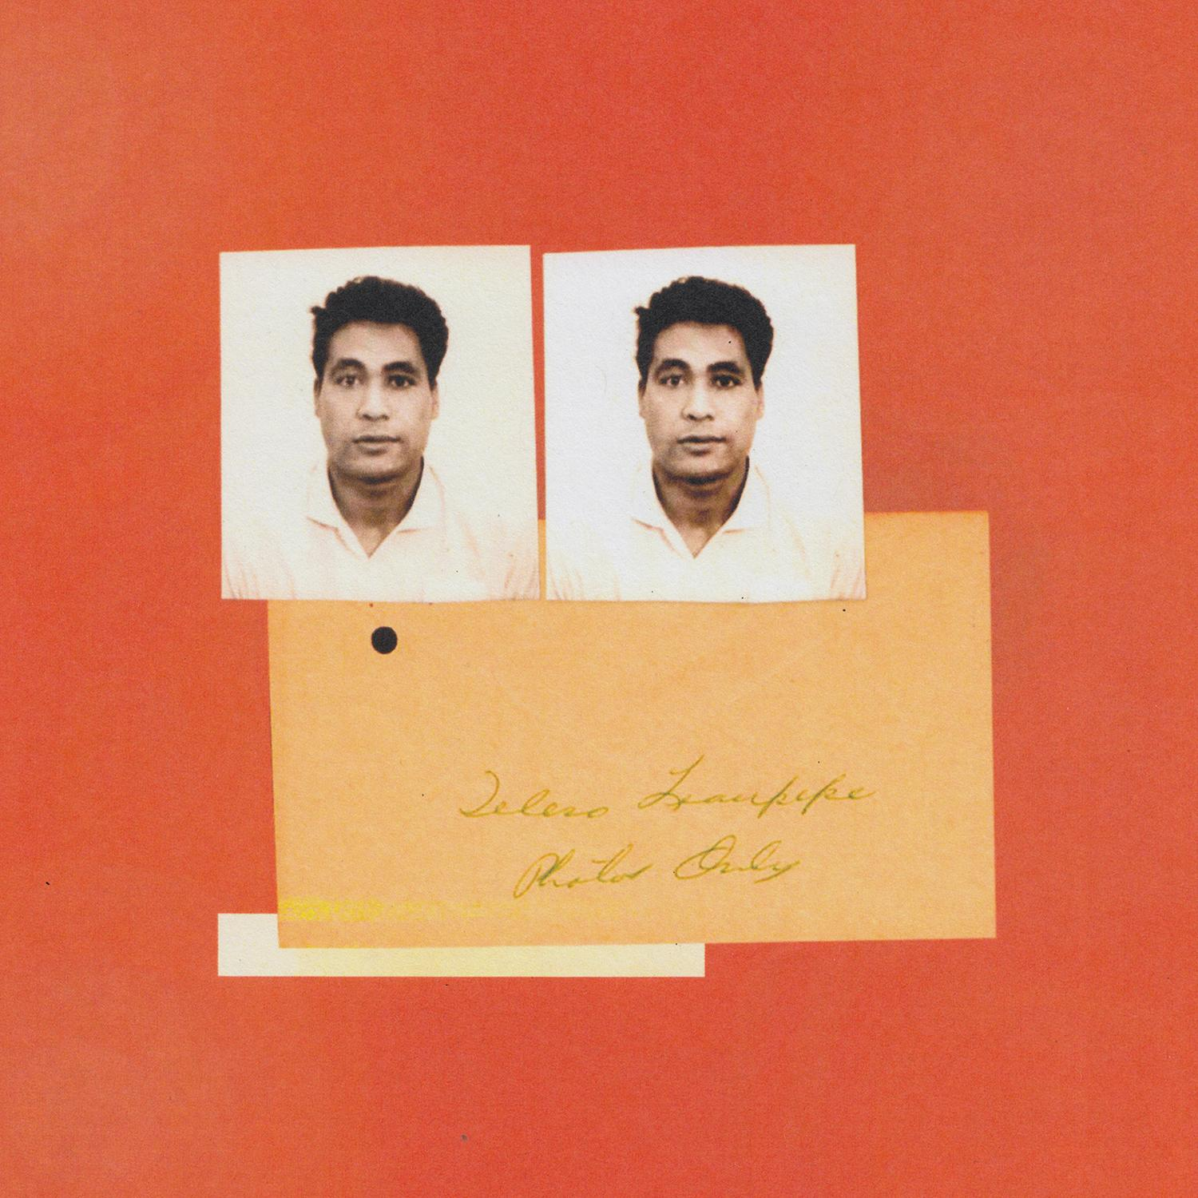
(Download high-res album art here)

November 10, 2021 -- (Los Angeles, CA.) -- Gang of Youths today announce their eagerly anticipated album angel in realtime. set for release February 25th via Warner Records. The band is also excited to announce an extensive North American tour that will see them playing Brooklyn, Los Angeles, San Francisco, Boston and more. See below for a full rundown.

Gang of Youths explain, “the album is about the life and legacy of Dave Le’aupepe’s father, indigenous identity, death, grief and God. And also, the Angel, Islington.”

Despite and indeed because of lead singer Le’aupepe’s father’s absence, his influence permeates every talking point that the album has to offer. At times it’s solely focused upon the precise, personal experiences of loss: the dichotomy of intensity and peace that comes as someone passes through their final days; the overwhelming feeling in the wake of their death that life will never be the same, even if the rest of the world at large remains utterly unchanged.

Following their recent singles, “the angel of 8th ave.,” telling of falling in love in a new city and making a home in another, and “the man himself,” a song created around a sample recording from the island of Mangaia in the Cook Islands that is about living without the guiding hand of your own father, today they release “tend the garden.” Click here to stream and here to view the video.

Le’aupepe said, “My dad was a gifted and passionate gardener. It's where he funnelled a lot of his energy and sensitivity, and despite our humble surroundings, we were always enveloped by beauty. The journey he made from Samoa to NZ to Australia was a difficult and inspiring one, but also fraught with mistakes, regret and terrible choices. I like to think he was building something beautiful, and pondering what life had given him in spite of his mistakes and concealment. We never knew his story until after he died, so this is the most poetic interpretation of his affinity for gardening that I could think of.”

Although the album is eclectic - influences range from American minimalism and contemporary classical, to drawing upon the legacy of Britain’s alternative/indie scenes, from drum ‘n’ bass to the most transcendent moments of Britpop -- it’s equally rooted in Le’aupepe’s Samoan heritage, with the majority of tracks featuring samples from David Fanshawe’s recordings of indigenous music from the Polynesian islands and the wider South Pacific. angel in realtime. also features contributions from a cast of talented Pasifika and Māori vocalists and instrumentalists.

Le’aupepe says, “I hope the record stands as a monument to the man my father was and remains long after I’m gone myself. He deserved it.”

angel in realtime. will be released on digital, double white vinyl and CD and is now available to pre-order here. Fans who pre-order the album will receive instant downloads of “tend the garden,” “the man himself,” “unison,” and “the angel of 8th ave.”

Fans who pre-order the album via the band's official store will receive access to a pre-sale for the band’s 2022 North American tour. The pre-sale will open from Wednesday, November 10th at 1pm PT / 4pm ET, and remain live until remaining tickets go on general sale here from 10:00AM local time on Friday, November 19th.

Gang of Youths are: Dave Le’aupepe (vocals, guitar), Max Dunn (bass), Jung Kim (guitar, keyboards), Donnie Borzestowski (drums) and Tom Hobden (keyboards, guitar, violin).

Acclaim for Gang of Youths:
“An example of the eclectic, evolved direction in which their music is heading.” -- Rolling Stone Australia

“Le’aupepe has embraced indigenous music native to his family’s Samoan culture, as well as the hip-hop and dance sounds that he grew up on.” – UPROXX

“The band sounds more electrified and alive than ever” - Paste Magazine

angel in realtime. tracklist:

- you in everything
- in the wake of your leave
- the angel of 8th ave.
- returner
- unison
- tend the garden
- the kingdom is within you
- spirit boy
- brothers
- forbearance
- the man himself
- hand of god
- goal of the century

2022 North American tour dates:
Apr 21: Madison, WI Majestic Theatre
Apr 22: Indianapolis, IN The Vogue
Apr 24: Columbus, OH Newport Music Hall
Apr 25: Louisville, KY Mercury Ballroom
Apr 27: Carrboro, NC Cat’s Cradle
Apr 28: Charlotte, NC The Underground
May 01: Nashville, TN The Basement East
May 03: Chicago, IL Metro
May 04: Detroit, MI Shelter
May 06: Toronto, ON Danforth Music Hall
May 07: Montreal, QC L’Astral
May 09: Boston, MA Paradise Rock Club
May 10: Brooklyn, NY Brooklyn Steel
May 12: Philadelphia, PA Theatre of the Living Arts
May 13: Washington, DC Union Stage
May 16: San Francisco, CA The Fillmore
May 18: Los Angeles, CA Belasco Theater
May 20: Las Vegas, NV 24 Oxford
May 21: Phoenix, AZ Crescent Ballroom
May 23: Austin, TX Scoot Inn
May 24: Dallas, TX The Echo Lounge & Music Hall
May 26: Tulsa, OK Cain’s Ballroom
Sep 13: Milwaukee, WI The Rave II
Sep 14: Minneapolis, MN First Avenue - Mainroom
Sep 16: St. Louis, MO Delmar Hall
Sep 17: Lawrence, KS The Bottleneck
Sep 19: Englewood, CO Gothic Theatre
Sep 20: Salt Lake City, UT Urban Lounge
Sep 22: Portland, OR Revolution Hall
Sep 23: Vancouver, BC Rickshaw Theatre
Sep 25: Seattle, WA Neumos
Sep 27: Sacramento, CA Ace of Spades

Contacts:
Grandstand Media
Kate Jackson katej@grandstandhq.com
Katie Nelson katien@grandstandhq.com

Warner Records
Rick Gershon Rick.Gershon@warnerrecords.com
Jenny Huynh Jenny.Huynh@warnerrecords.com

Follow Gang of Youths:
Official website | Instagram | Facebook | Twitter | Spotify | Apple Music | YouTube | Tik Tok
Press Materials

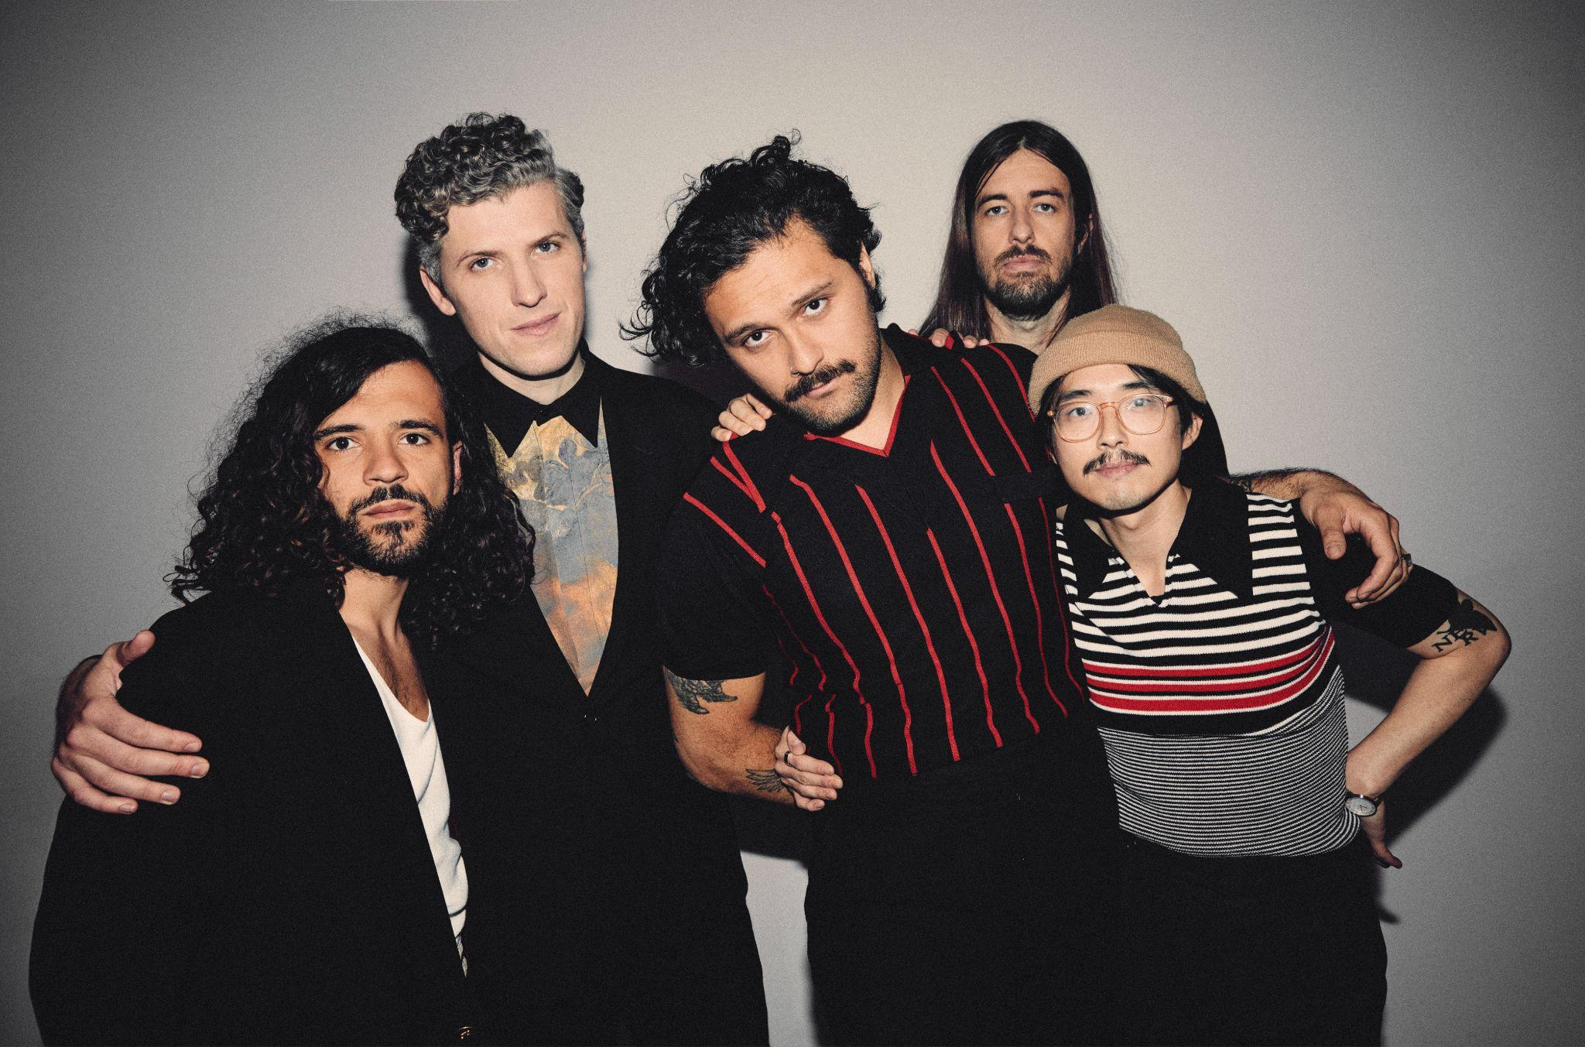
(Download high-res photo by Edward Cooke HERE)

