SHARE THE NEW SINGLE “the angel of 8th ave.”

LISTEN HERE / WATCH HERE

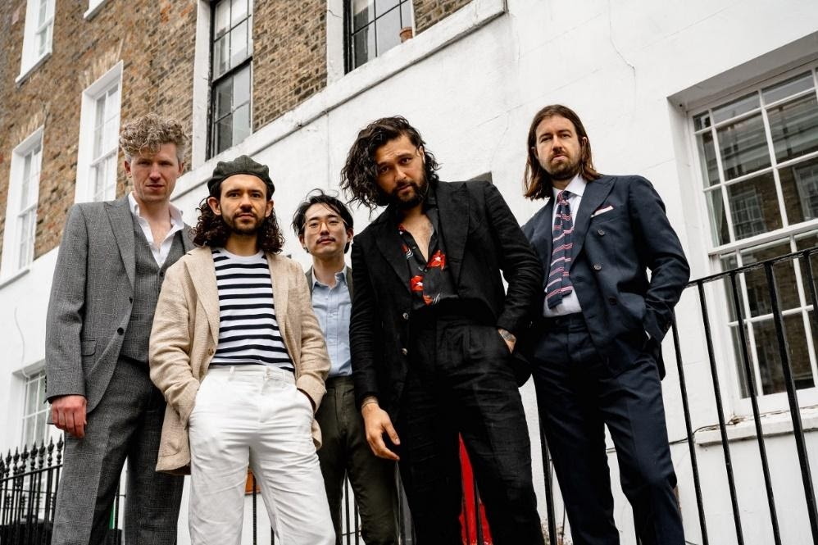
(Hi-res photo by Amy Heycock here)

June 16, 2021 – (Los Angeles, CA.) -- Having relocated from Australia to the U.K., rock band Gang Of Youths have redefined their creative process and evolved their sound as they look to make their boldest statement to date. Today they release “the angel of 8th ave.”, the first song to come out of that new process. Click here to stream.

“the angel of 8th ave.” is a striking step forward for the band, following the success of the 2017 LP Go Farther In Lightness, as they embark upon the most vital phase of their career so far. This time they’re channelling the musical lineage of their new life in London, drawing on the hypnotic, motorik grooves of Joy Division and the luminous synths that embody classic New Order. It’s an utterly assured evolution of the ambitious, transformative power of music that they have become renowned for.

The song also represents a shift in Dave Le’aupepe’s lyrical approach. Now his focus falls on exposing the beauty and elegance of conversational language in a song about the grandest of emotions. Simultaneously, it is still both poetic and intensely real. His opening words hone sharply in on a moment that changed the direction of his life, while the spectre of death conversely provides a glimpse of a brighter future.

He says, “It’s about falling in love, and finding a new life in a new city together.”

Entirely self-produced, the track was recorded in their own studio, a place which provides them with unlimited creative freedom. It was subsequently mixed by the Grammy Award-winning Craig Silvey (Arcade Fire, The National).

Directed by Joel Barney, the song’s accompanying video was filmed in the band’s neighborhood of Angel, North London. The focal point is a tight close-up of Le’aupepe’s hugely charismatic performance, as the band dart from the bustle of the station to the relative desolation of the canal. Click here to view and share.

“You hear something like that, and you know your life is changed and the lives of your friends have changed because you won’t shut up about it.” - Zane Lowe

Since forming in Sydney, Australia in 2011, Gang Of Youths have made a big impression with their two albums to date, The Positions (2015) and Go Farther In Lightness (2017), the latter of which won four prestigious ARIA Awards, including Album of the Year and Best Group.

When they moved half a world away to London in 2017, they effectively had to start again. But with a live experience already conditioned to filling huge rooms, their decision to re-establish a personal connection with their fervent audience in more intimate experiences has not been taken for granted. International festival dates have spanned everywhere from Splendour In The Grass (Australia) to Austin City Limits, Lollapalooza, Rock Werchter (Belgium), Mad Cool (Madrid) and more.

Completed by Max Dunn (bass), Jung Kim (guitar, keyboards), Donnie Borzestowski (drums), Tom Hobden (keyboards, guitar, violin), and Dave Le’aupepe (vocals, guitar), Gang Of Youths are now making a fresh start, with music that’s heavily inspired by their new life that fully realizes Le’aupepe’s vision for the band. More from Gang Of Youths soon.

Contacts:

Grandstand Media
Kate Jackson katej@grandstandhq.com
Katie Nelson katien@grandstandhq.com

Warner Records
Rick Gershon Rick.Gershon@warnerrecords.com
Jenny Huynh Jenny.Huynh@warnerrecords.com

Follow Gang Of Youths:
Official website | Instagram | Facebook | Twitter | Spotify | Apple Music | YouTube | TikTok
Press Materials

