GRAMMY AWARD-WINNER GARY CLARK JR. ANNOUNCES FIRST LEG
OF 2022 TOUR

Tickets On Sale Now!

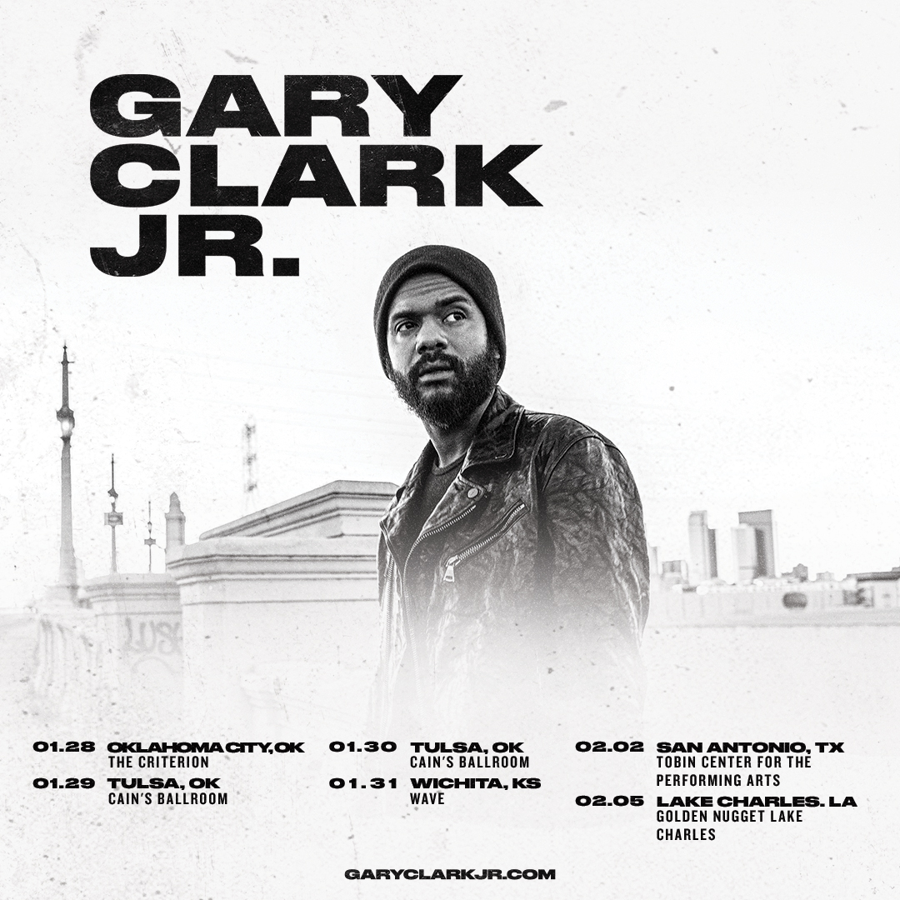

December 9, 2021 (Los Angeles, CA) –Grammy Award-winner Gary Clark Jr. announces his first domestic dates of the new year set for late January/early February 2022. Tickets are on sale now. Click here for further details.

Clark is currently writing/recording new material for his next full-length album. Details to follow.

US TOUR DATES 2022:
Jan 28 Oklahoma City, OK The Criterion
Jan 29 Tulsa OK Cain’s Ballroom
Jan 30 Tulsa OK Cain’s Ballroom
Jan 31 Wichita, KS Wave
Feb 02 San Antonio, TX Tobin Center For The Performing Arts
Feb 05 Lake Charles, LA Golden Nugget Lake Charles

Europe 2022: All dates below with Guns N’ Roses
Jun 04 Lisboa, Portugal Passeio Maritimo
Jun 07 Seville, Spain Benito Villamerin Stadium
Jun 15 Rogaland, Norway Forus Travbane (Forus Racecourse)
Jun 18 Prague, Czech Republic Letnany Airport
Jun 20 Warsaw, Poland PGE Narodowy
Jun 23 Groningen, Netherlands Stadspark Groningen
Jun 28 Dublin, Ireland Marlay Park
July 01 London, UK Tottenham Hotspur Stadium
July 02 London, UK Tottenham Hotspur Stadium
July 05 Glasgow, UK TRNSMT Festival (Glasgow Green)
July 08 Munich, Germany Munich Olympic Stadium
July 10 Milan, Italy San Siro Stadium
July 13 Vienna, Austria Ernst Happel Stadion Wien

About Gary Clark Jr.:
Clark achieved global impact following his first Grammy Award® in 2014 winning Best Traditional R&B Performance for the track “Please Come Home” from his Warner Records debut album Blak And Blu, and seemingly never left the road. 2015’s The Story Of Sonny Boy Slim wrought hard- won international acclaim as a critical force to be reckoned with. Throughout 2019 Clark ascended to greater heights with the release of THIS LAND – his third full-length studio album which bowed at #6 on the Billboard Top 200, marking his third consecutive Top 10 debut. The album and single of the same name attracted acclaim from the likes of The New York Times, The Washington Post, The Los Angeles Times, Rolling Stone, Pitchfork and more. He has performed on Saturday Night Live, The Late Show with Stephen Colbert, The Ellen DeGeneres Show, The Tonight Show Starring Jimmy Fallon, The Late Late Show with James Corden, Jimmy Kimmel Live!, Good Morning America, CBS News Sunday, CBS This Morning, The Today Show, Late Night with Seth Meyers, The Daily Show with Trevor Noah, The Howard Stern Show, WTF with Marc Maron and more. Clark’s domestic tours became instant sell outs and his international profile found him topping bills at legendary festivals around the world and venues including the Hollywood Bowl, along with multiple appearances in stadiums supporting and sharing the stage with The Rolling Stones. Most recently, Clark won three more Grammy Awards including Best Rock Performance “This Land,” Best Rock Song “This Land,” and Best Contemporary Blues Album THIS LAND. Clark also performed his award-winning single “This Land,” backed by The Roots at last year’s Grammy Award® ceremony and released their version of the track. Countless collaborations have been recorded with Stevie Wonder, Andra Day, John Legend, Alecia Keys, Foo Fighters, Nas, Sheryl Crow, Brandi Carlile, Eric Clapton, Gustavo Santaolalla, Booker T. Jones, and many more. To date, Clark has been nominated for six GRAMMY Awards® and won four. Clark is currently working on his follow-up to THIS LAND.

For further information, contact:
Rick Gershon at Warner Records:
Rick.Gershon@warnerrecords.com
Regional: Jenny Huynh at Warner Records:
Jenny.Huynh@warnerrecords.com

FOLLOW GARY CLARK JR.:
Official | Facebook | Twitter | Instagram | YouTube | Spotify | Publicity Materials

