September 26, 2019

https://hitsdailydouble.com/the_bside&id=318053

GRAMMY PREVIEW: SAWEETIE
9/25/19
ENTREPRENEURIAL RAPPER
By: Jon Pikus
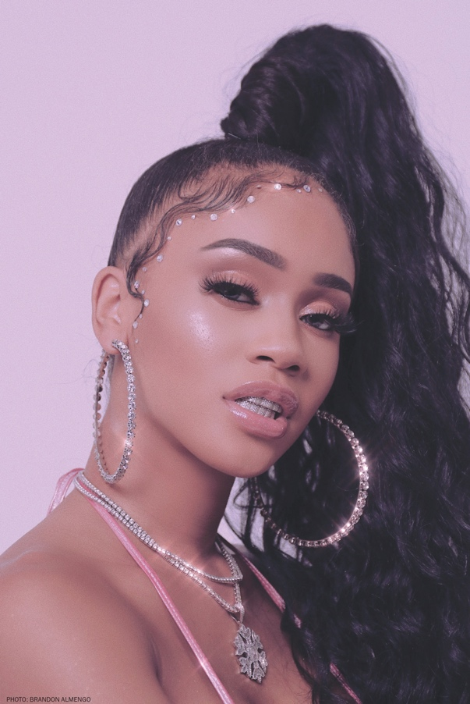
Hailing from the Bay Area, Cali girl Saweetie is poised for a breakthrough. Her raunchy hit “My Type” from her ICY EP is nearing the top of the MediabaseRhythmic chart at press time. While attending USC to study communications, Saweetie (real name: Diamonté Harper) moonlighted as a SoundCloudrapper, was discovered by manager Max Gousse at a Downtown L.A. Puma event and eventually signed to ICY/Artistry/Warner Records. We caught up with her just after her big splash at NYFW, where she performed and debuted her streetwear capsule collection PrettyLittleThing x Saweetie.

How did the California culture you grew up with influence your sound and your songwriting?
Cali influenced my sound, songwriting and visuals. From the tracks I select to the lyrical content, I incorporate the Bay Area and Sacramento culture in my videos and shows—it’ll always be a part of me.
What music was playing around you as you grew up, and what inspired you to make music?
My dad played a lot of old-school classics like Earth, Wind & Fire, The Stylistics and Marvin Gaye; my mother loved No Doubt. Together, they were hip-hop heads—a lot of East Coast, West Coast in the house, from Ice Cube to Pac to Biggie, Kim and Foxy.
It’s been a breakthrough year for female rappers. How does it feel to be included in that elite group of women in the spotlight?
It’s an honor to be in that elite group. It’s also a testament to the fans who support us—they’re reshaping hip-hop and urban culture.
You first worked with producer London on da Track for your song “Up Now” in 2018. How did you reconnect with him to make your latest hit, “My Type”?
My manager Max Gousse made the initial intro, and London has been close to the camp ever since.
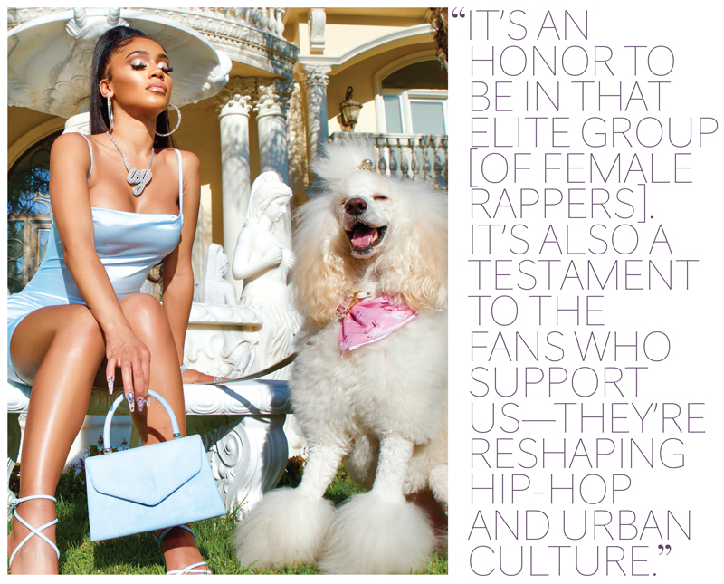
Are there any Grammy-winning artists past or present that you look up to, and what do the Grammys mean to you?
I honestly look up to them all, because it’s an amazing achievement. The Grammys represent the biggest night in music—it would mean the world to me to be nominated for my work.
What’s next for you? Anyone on your wish list of collaborators?
J. Cole, of course. He’s one of the reasons I decided to get my USC degree first and then pursue music. Next up: My fans have been requesting new music since “My Type” exploded, and I don’t want to let them down, so I’m focused on recording and releasing new music for the holidays. I’m gearing up for my first headline tour of the U.S. and Europe, and I’ll be releasing my second capsule collection with PrettyLittleThing. And look out for the launch of Icy Beauty, my cosmetics company—coming real soon.

