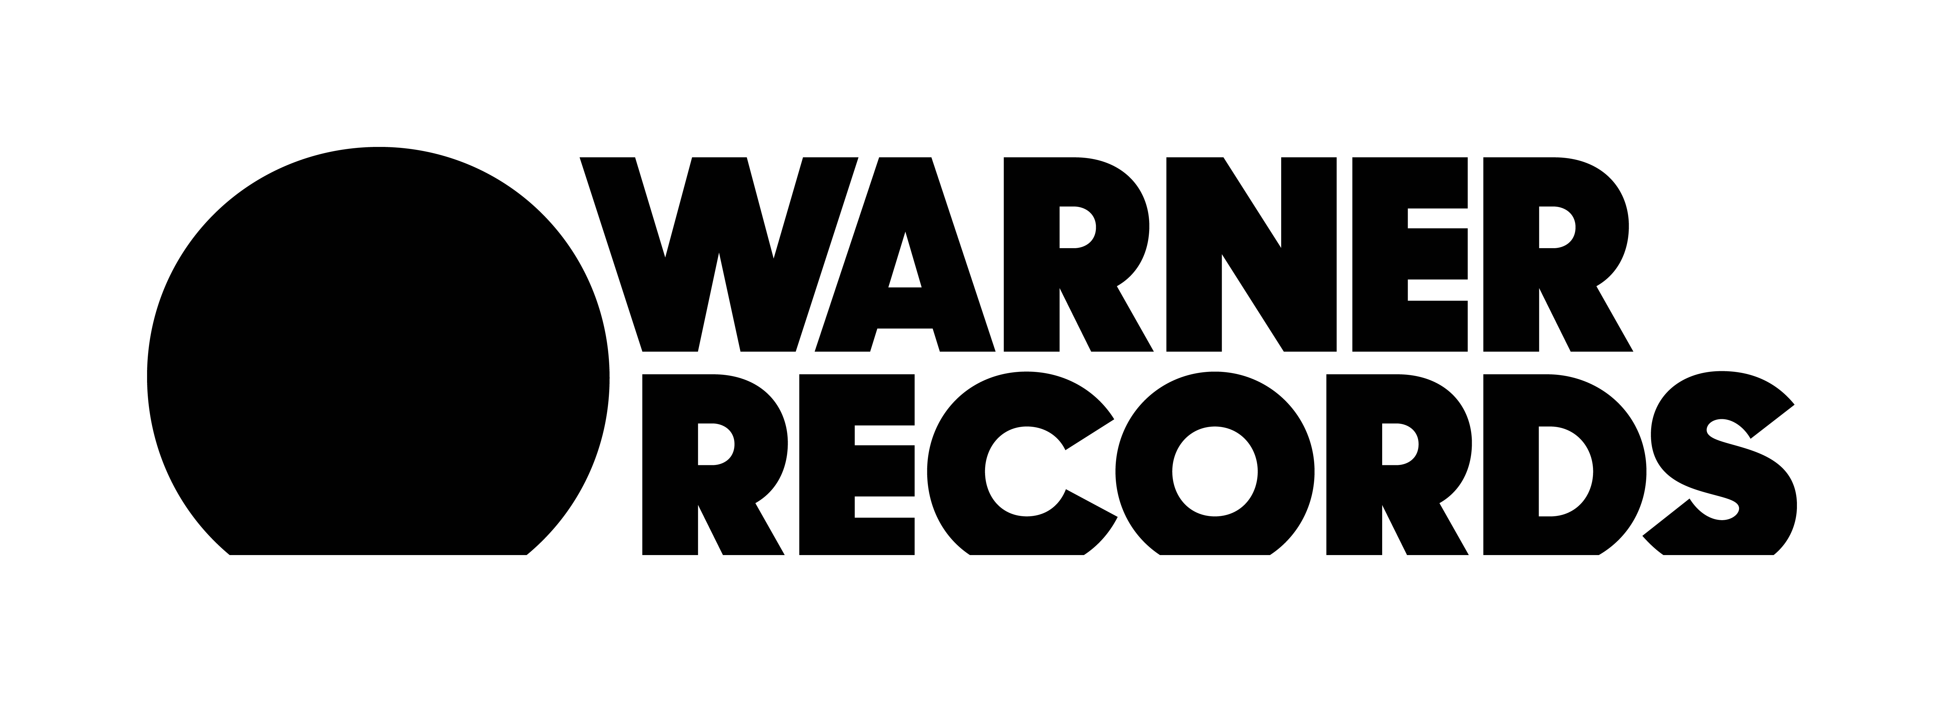
GRIFF PREMIERES BRAND NEW TRACK, “PARADISE”
DEBUT EP COMING SOON
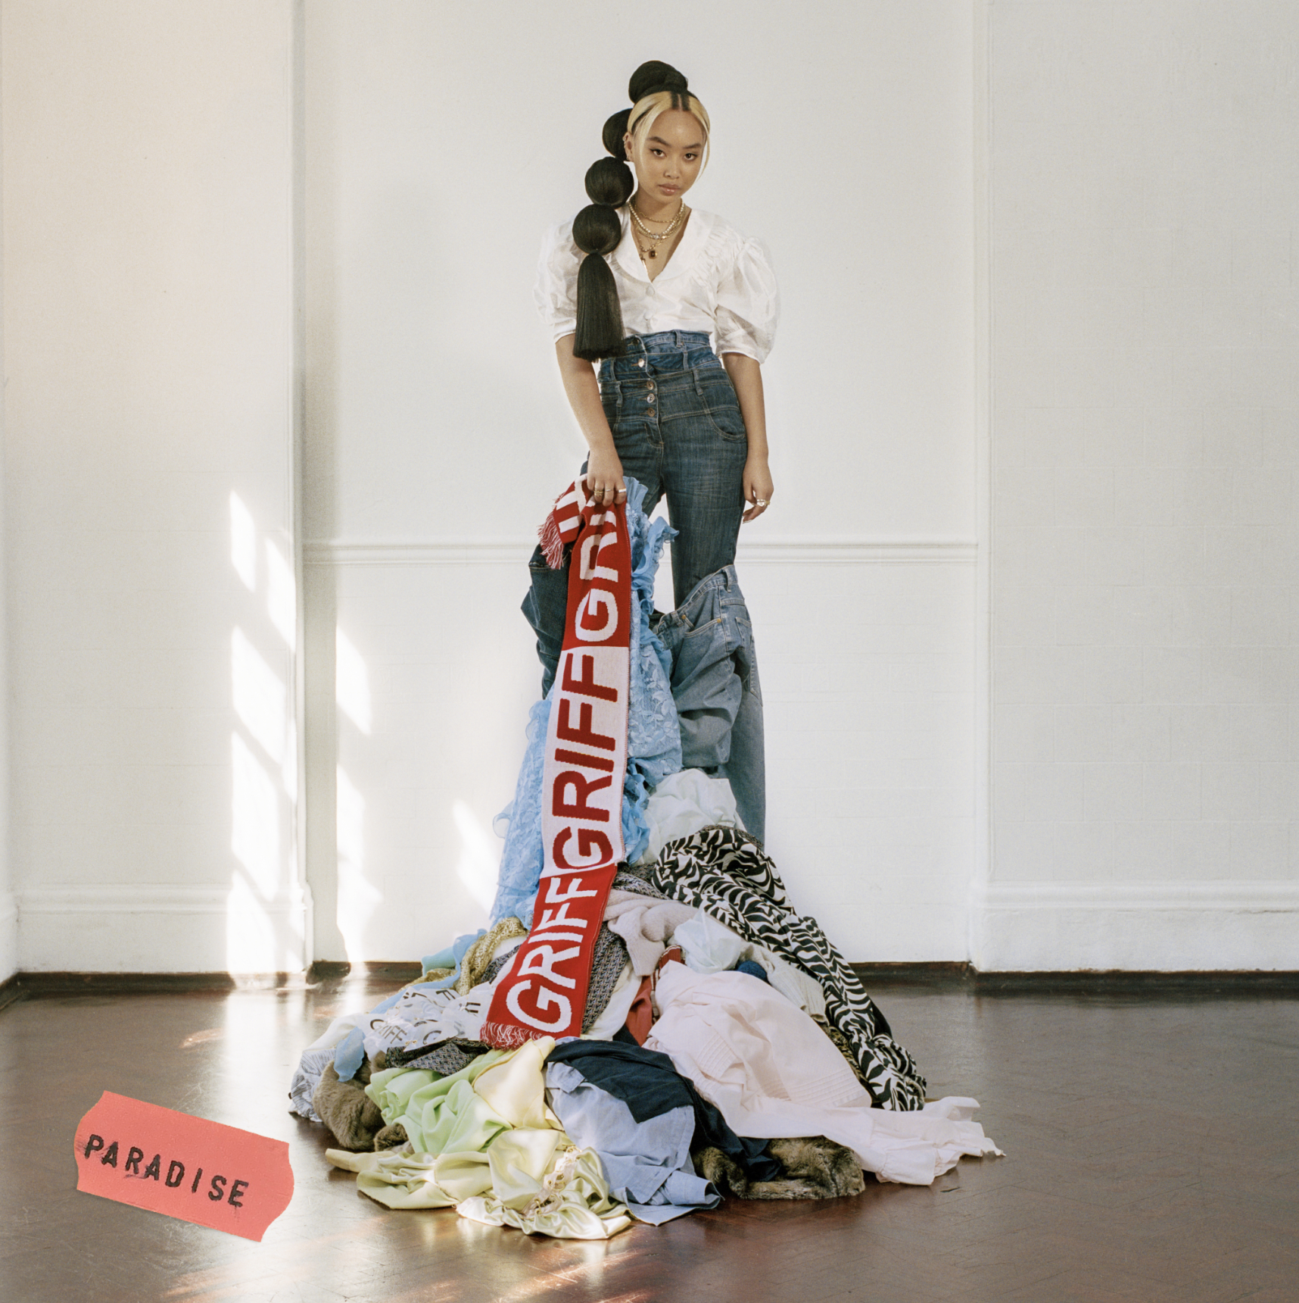
"GRIFF looks every bit like pop’s bright new star...it is, quite frankly, all rather brilliant" - i-D
"Writer, producer, stylist, designer and creative director, it's clear that GRIFF is a force to be reckoned with" - Vogue
“Bedroom pop at its finest…electric” – Nylon

LISTEN TO TRACK HERE

October 25, 2019 (Los Angeles, CA) – UK artist GRIFF has dropped her new track, “Paradise,” (Warner Records) from her forthcoming debut EP, which also includes acclaimed debut single “Mirror Talk” - which received its first play on BBC’s Radio 1 days after Griff's final exams - and the self-produced “Didn't Break It Enough.”

“Paradise” strips back influences of electronic music, soul and R&B to its rawest essentials, allowing Griff's remarkably elastic voice to shine through. “I wrote ‘Paradise’ in one of my first ever writing sessions two years ago," she recalls. "I remember saying I wanted to write about something other than relationships and love and out came ‘Paradise.’”

“Paradise” is a further glimpse of everything a multifaceted talent like Griff is capable of. Born to Chinese and Jamaican parents just outside of Watford, England - alongside two brothers and the family's foster children - Griff grew up knowing that she stood out. She first started making music after borrowing her brother's Logic, but ended up spending the last few years outside of the already-punishing schedule of school making beats in secret from her classmates. Already, Griff is showing her ability to take those conflicts of young adulthood (the insecurities, but also the fearlessness) and twist them to her advantage. Hers is a multi-disciplined approach, which extends to Griff not only writing and producing music, but making her own clothes - as exhibited in her striking artwork - or shooting live visuals crammed into her home studio.

Coming soon, Griff's debut EP is a vivid snapshot of those thrilling highs and occasionally melodramatic lows of modern teenage life. The bulk of the EP was produced by Griff herself.

###
Press Contact:
Bobbie Gale / Warner Records
(818) 953-3692 / Bobbie.Gale@warnerrecords.com

