October 13, 2020

“BKTHERULA broke out of Atlanta on her terms with a perfect combination of magnetic melodies and airtight bars.” – Hype Off Life

https://hypeofflife.com/bktherula-nirvana-interview/

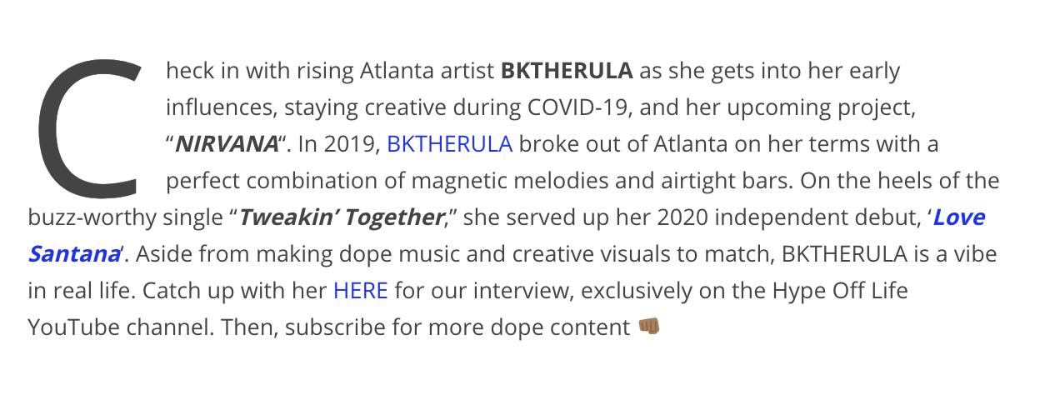

https://www.youtube.com/watch?v=3d2sbbZWYmo&feature=youtu.be

