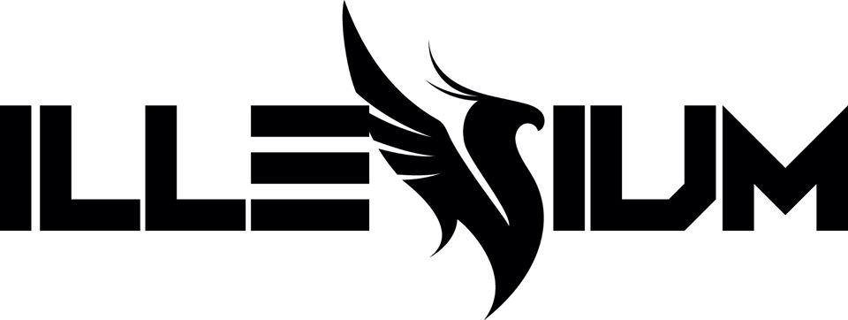
Biography

As one of the most successful crossover electronic artists today, Denver-based producer/DJ ILLENIUM, born Nick Miller, has elevated dance music via his bold, progressive take on the genre. His expansive sound, which mixes elements of celestial electronic, mellow alternative, rock-fuel dubstep, emotional indie and pop-tinged bass music, has topped the U.S. charts, garnered more than 4 billion collective streams and solidified the breakout artist as a festival-headlining act—all within a few short years. Hailed by Billboard as one of the Top Dance/Electronic Artists of the 2010s and recognized as part of Forbes' coveted 30 Under 30 list in 2020, ILLENIUM has captivated millions of self-identified, die-hard "Illenials" around the world who share a direct and personal bond with him through his music.

First emerging as a then-unknown bedroom producer in 2013, ILLENIUM has since taken the pop and electronic worlds by storm via his breakthrough independent releases, including his 2014 self-released Risen EP and his 2016 debut album, Ashes.

His follow-up album, Awake, expanded his vision and cultural impact. Released in September 2017, Awake broadened ILLENIUM's taste for powerful vocals, emotive lyrics and complex, layered electronic melodies. A critical and commercial success, Awake topped the iTunes Top Electronic Albums Chart in 12 countries with over 100 million streams and peaked at No. 3 on the Top Dance/Electronic Albums chart on Billboard. Awake features ILLENIUM classics "Crawl Outta Love," featuring Annika Wells; "Fractures," featuring Nevve; and "Feel Good," with Gryffin featuring Daya, the latter of which garnered +166 million Spotify streams and +25 million YouTube views.

Where Ashes and Awake formed the ILLENIUM sound, Ascend secured his arrival as dance music's newest crossover king. Released in August 2019 on Astralwerks, Ascend marks ILLENIUM's third full-length album and his major label debut. As one of the biggest electronic releases of 2019, counting more than 1 billion collective streams, Ascend became ILLENIUM's first album to top Billboard's Top Dance/Electronic Albums chart and his highest-placing release on the all-genre Billboard 200 chart, peaking at No. 14. The album is led by several breakout tracks, including: the cross-format hits "Takeaway" with The Chainsmokers featuring Lennon Stella and "Good Things Fall Apart" with Jon Bellion; "Crashing" featuring Bahari; and "In Your Arms" with X Ambassadors. Ascend also features an all-star cast of guest producers including Rock Mafia (Justin Bieber, Eminem), Jonny Coffer (Beyoncé, Rita Ora) and Sandy Vee (Rihanna, Katy Perry). Pushing his intricate sound design to new production heights, Ascend elevates ILLENIUM's songwriting prowess, as evidenced by the album’s lead single “Take You Down,” a moving confessional chronicling his past battles with drug addiction, a near-fatal overdose and his triumphant recovery through it all.

With the release of his most recent major project, ILLENIUM concluded the epic saga of his first three thematically connected albums: Ashes, Awake, Ascend. Now as a newly independent artist, joining 12Tone Music Group, he looks ahead with upcoming music set for release throughout 2020.

"When I started the ILLENIUM project about seven years ago, I lost myself in making music," he reflects. "I would literally live in a computer. After I began touring heavily, it became harder to get back to my true passion of creating music. Now that I'm taking time off the road and concentrating on producing and writing music again, it's given me the freedom to make exactly what I want to make. Once I started figuring out this next chapter, I became really hopeful and excited about where I could take my music next. I'm at a good point, artistically, where I feel more free in the creative process. I'm at peace with it all."

Onstage, ILLENIUM brings his empowering music to life via his dynamic live show—fully equipped with live keyboards, drum pads and cinematic visuals—that's seen him dominate the world's leading festivals, including Coachella, Lollapalooza, Bonnaroo and EDC Las Vegas, as well as his own international solo tours. His 2017 Awake Tour saw ILLENIUM selling out major U.S. arenas and venues. In 2019, he launched his Ascend Tour, a 42-date North American trek featuring a massive production design comprising a five-piece live band, which included ILLENIUM on guitar alongside fellow electronic stars Dabin (guitar) and Said The Sky (keyboard). As his most ambitious live excursion to date, the Ascend Tour sold out landmark venues like Madison Square Garden in NYC, STAPLES Center in Los Angeles and three consecutive nights at the legendary Red Rocks Amphitheatre in Denver.

ILLENIUM now embraces his next creative phase with an independent spirit and new music that speaks directly to his fans and presents the same much-needed escape he's delivered over the years.

"The world is having such a hard time right now," ILLENIUM says. "I think people are pretty low on excitement and low on hope. I want people to take these new songs to help them heal from the struggles they've encountered over the past few months or years and give them some escape. Hopefully, my new music can spark some hope in people's hearts and provide that outlet for them."

For more information on ILLENIUM, visit:
Website | Facebook | Twitter | Instagram
YouTube | Spotify | Apple Music | SoundCloud | Shop

