

White-hot rapper Saweetie doesn’t want to be a role model

Photography Ben Taylor By on March 9, 2018
https://www.interviewmagazine.com/music/white-hot-rapper-saweetie-doesnt-want-role-model
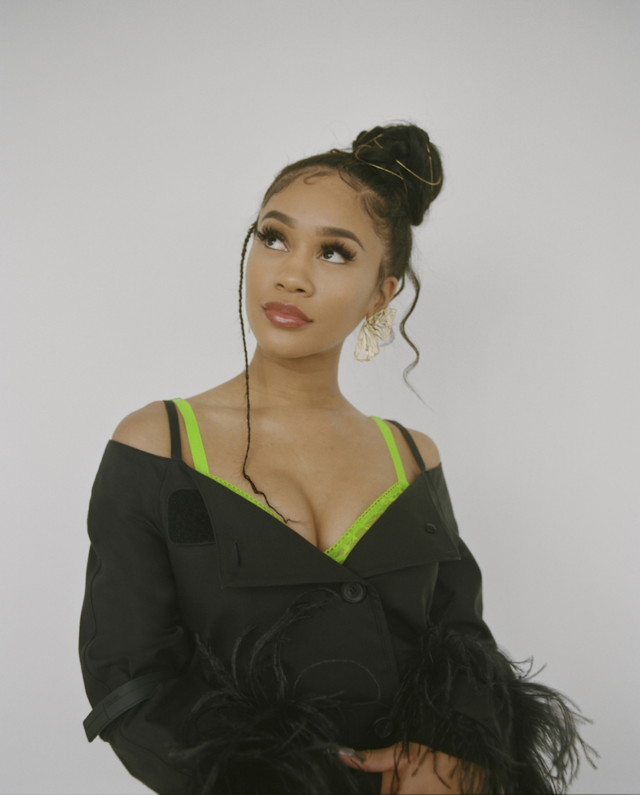

Saweetie is a magnetic young rapper with a surplus of personality. The Bay Area native burst into the limelight with her 2017 single “Icy Grl,” which flips the beat from Khia’s gonzo 2002 single “My Neck, My Back,” into something entirely different. Saweetie’s magnetic charisma lends a chic strut to her bravado; “All these girls excited / Oh ya know they like it / I’m so icy, so icy,” she rhymes.

Her video for the song took off late last year, eventually gaining 15 million views and landing her a contract with Warner Bros Records. Now, the USC grad is gearing up to release her debut EP, titled High Maintenance, later this month. With her effortless charisma and deep understanding of what makes a song tick—in an interview with Billboard, her manager called her a “student of the game”—don’t be surprised if she’s a household name before long.

TAMEKA ABRAHAM: What inspired your artist name?

SAWEETIE: My grandmother used to call me Sweetie, and I really loved it. So I put it on my myspace, and I’ve mentioned in other interviews as well that my myspace was poppin. So people would just be like, “Yo, Sweetie,” and I would be like “Oh, wassup!” It kind of just stuck. What kind of finalized it was, my step-mom had gotten me a nameplate my sophomore year of high school, one of those gold ones.

ABRAHAM: You went to the University of Southern California. Many students with aspirations in the entertainment or music industry tend to leave school prematurely, what convinced you to stay in school and get your Bachelor’s degree?

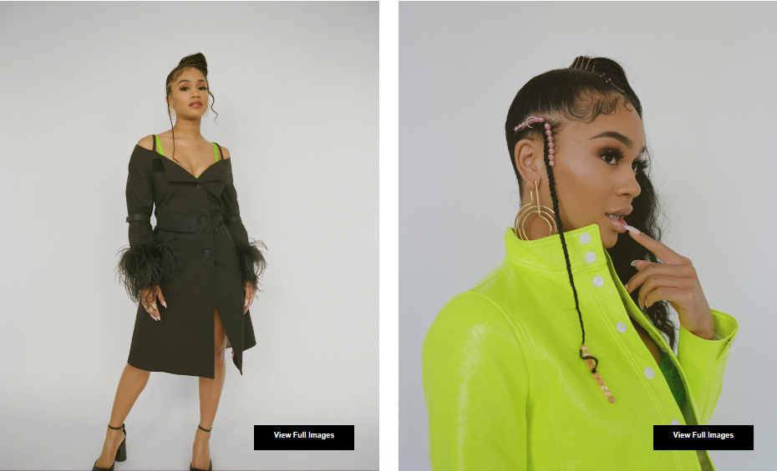

SAWEETIE: Girl, so I was going to San Diego State, right? It was a great school, but I didn’t like being in that college. My dream school was USC. So I was like, alright, I’m going to apply to USC, and If I don’t get in—I’m dropping out of school, and I’m pursuing music. So I applied, and I got in. I was like alright, I’m at the number one communications school in the country, and that was my major. So, I decided to thug it out, and get this degree. Nothing was touching a USC diploma, ya know? I loved it. I learned a lot. A lot of my colleagues I went to school with, I’m still cool with them. They’re all black, they’re successful, they’re just doing their thing, and it’s just dope to see them thriving.

ABRAHAM: What were you going to do with your degree before you decided to pursue music?

SAWEETIE: I’ve been wanting to do music since I was 14, but like I’ve really always enjoyed giving speeches and I enjoy talking to people, so I was like, maybe I can be a newscaster. But then I was like um—nah. I feel you have to be a certain type of caster, like you have to portray yourself in a certain way, and I have too much personality for that. So I needed to stop putting my dreams on the back burner.

ABRAHAM: When did you discover your drive to be a musician?

SAWEETIE: I was on Limewire when I wasn’t supposed to be, and my friend told me to look up this song “Can’t Stop Won’t Stop” by Nicki Minaj ft. Lil Wayne. I heard that and I was like, “This is hella cute.” I fell in love with it. I loved her work, I loved her voice, I loved how she was playful. Kim, Foxy, Trina, Nicki—they were just so legendary to me, and so unrealistic. It was like, I loved rapping their songs, but it never dawned on me that I could do it too, until I saw Nicki Minaj, because I was only listening to classics.

ABRAHAM: Was there ever a point you considered taking a safe route instead of following your dream?

SAWEETIE: Actually, I was interviewing in the hospital field, because they make a lot of money, and I was trying to get that check. I was offered some positions that were paying like $17.50 an hour, and for me at the time, that was really good. But it was like my soul—it would cringe and get sick. Even in the interviews, I was lying my ass off—I ain’t tryna work here. “Where do you see yourself in 10?” Oh, I see myself you know, managing the business—running this department. But I definitely was going to take the safe route for financial purposes. I was supporting myself. But you only get to live one life. After its done, it’s done, I’m never coming on this Earth again. So if I have to thug it out with my dream, I at least want to go 100 percent. I stopped going to the interviews. I was still getting call backs, and I was like you know what? No. Once I decided I was going to pursue music, my soul just felt so much more comfortable.

ABRAHAM: What advice would you give your fans?

SAWEETIE: One thing I want to share with my fans is that, parents who love you and want to protect you out of love, they may suggest other jobs that seem safer. You have to go against the grain sometimes, because when you make it, that’s when they see. They might not be there for the whole ride, but it’s out of love—if you’re trying to view it from a positive perspective. When my mother was telling me “Everybody wants to be a rapper,” I was like, you’re not helping me! When you feel it in your spirit, like this is what I’m supposed to do, no one can tell you nothing. That’s how I felt, like “No—this is what I’m supposed to do.” When I write music, I get butterflies and fireworks inside.

ABRAHAM: Back in 2017, Cardi B explained that she felt that it was important for her to be a better example for her younger fans. Do you feel the same way?

SAWEETIE: Hell to the no, no, no. Who we are gets us to where we are. We don’t have to do everything right in the public eye, but what I always say is—I might be a role model, but at the end of the day I’m a lesson. So it’s up to you to be like, “She didn’t do this right. Let me do it this way.” You can take it or leave it. Especially as an artist, the creative freedom we have makes us who we are. We’re human beings—we’re gonna mess up sometimes. I definitely feel like people should continue being who they are. As long as you’re staying true to who you are, that’s super important. That’s so limiting to tell an artist, “You need to be a better role model.” Like, what? I’m not the parent of your kids. So no, I don’t really believe in that to be honest with you.

SAWEETIE’S EP HIGH MAINTENANCE IS DUE OUT MARCH 16, 2018.

