**SHARES THE NEW SINGLE “BETTER DAYS”**

**LISTEN / WATCH THE VIDEO** [**HERE**](https://liamgallagher.link/betterdays)

**FROM HIS NEW ALBUM *C’MON YOU KNOW* OUT MAY 27**

*“Contains enough sizeable bangers and rousing anthems to kickstart the much-heralded post-pandemic Third Summer Of Love.”* **– NME**

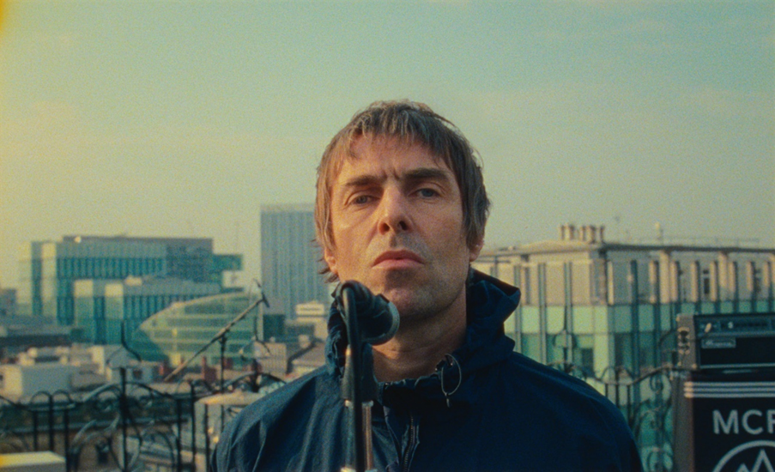

**April 22, 2022 (Los Angeles, CA) –** What can we expect from **Liam Gallagher’s** eagerly anticipated new album ***C’MON YOU KNOW***? A set full of classically instant **Liam** bangers topped by that iconic snarling vocal and his effortless rock star attitude. But this time there’s a twist as **Liam** infuses his sound with an eclectic array of new influences. It’s an approach that has made his recent tracks, the Dave Grohl-assisted **“Everything’s Electric”** and the album’s title track, instant fan favorites.

Today, **Liam** shares his latest single **“Better Days”** which takes that experimental touch to a new level. It’s a shot of sunshine dopamine in audio form, as thunderous, **‘90s**-style big beats add jet-fuelled propulsion to a classic crowd-pleasing anthem. Celebrating a summer in which we can all be reunited, it’s a summer song perfectly suited to receiving a huge audience reaction when **Liam** hits the road across the UK this summer. See a list of dates [here](https://www.liamgallagher.com/home/?tour=1).

**Liam** says, *“‘Better Days’ is the sound of the summer.”*

**Liam** also captures that spirit with the song’s official video. Joined by his band, he takes to the roof of the historic **Midland Hotel** in Manchester, England for a full-throttle performance as crowds gather around to watch from nearby offices and the street. Given another cinematic touch as the sky turns psychedelic, it’s a video that nods to **The Beatles’** legendary **Apple Corps** rooftop show. It was directed by the multiple **Grammy** nominee **Paul Dugdale**, whose credits include numerous major artists as varied as **The Rolling Stones**, **Adele**, **Taylor Swift** and **Coldplay**.

Reflecting the song’s positive spirit, **Liam** will donate all UK proceeds from the song to [**Warchild**](https://www.warchild.org.uk/). The charity aims to protect, educate and stand up for the rights of children living through conflict, and campaigns on the root causes of conflict to help create a safer future for children across the world.

**Rich Clarke**, **Head of War Child Records**, says*, “We could not be more grateful to Liam for his incredible, continued support for the charity. With us since the earliest days of our music-focused fundraising almost 27 years ago, Liam’s contributions have extended to putting exclusive Oasis tracks on our classic ‘****HELP’*** *and* ***‘1 Love’*** *albums to donating £1 from every ticket sold on his 2019 UK tour. Now, in these most challenging times, Liam’s generosity stretches further still, to help us reach more children living conflict around the world.”*

**“Better Days”** was written by **Liam** with his regular collaborators, the **Grammy**-winning **Andrew Wyatt** and **Michael Tighe**. **Andrew Wyatt** produced the song with **Greg Kurstin** (**Adele**, **Sir Paul McCartney**). It also features guitar courtesy of **Nick Zinner** of **Yeah Yeah Yeahs**.

**“Better Days,” “Everything’s Electric”** and the title track will all feature on the ***C’MON YOU KNOW*** album, which is perfectly positioned to become **Liam’s** fourth **UK #1** solo albumwhen it is released on **May 27th.**

# That same day will also see Liam release the *Down By The River Thames* live album. Originally streamed in December 2020, the show became one of the most memorable performances of the lockdown era. Liam followed the precedent set by the Sex Pistols and The Clash, and decided to hit the River Thames, armed with a boatload of attitude, a phenomenal live band (including Bonehead) and an arsenal of classic songs.

Both ***Down By The River Thames*** and ***C’MON YOU KNOW*** are available to pre-order [**HERE**](https://lnk.to/LG-OfficialStore/officialstore). These include both albums on CD or standard vinyl, as well as a bundle featuring the ***C’MON YOU KNOW*** cassette and the ***Down By The River Thames*** vinyl.

**About War Child UK**

War Child UK is the only specialist charity for children affected by conflict. For more than two decades they’ve been driven by a single goal – for no child’s life to be torn apart by war. They aim to reach children as early as possible when conflict breaks out and stay to support them through their recovery – keeping them safe, helping them learn and cope with their experiences, and equipping them with skills for the future. They understand children’s needs, respect their rights, and put them at the centre of the solution and campaign for changes to policies and practices to support children in conflict, working with children and young people themselves to demand their rights. Together with their partners they deliver vital, life-saving work in 15 countries across Africa, Asia and the Middle East, and Latin America. For more info, visit [www.warchild.org.uk](https://www.warchild.org.uk/)

**###**

**Follow Liam Gallagher:**

[**Facebook**](https://nam04.safelinks.protection.outlook.com/?url=https%3A%2F%2Fwww.facebook.com%2FLiamGallagherOfficial%2F&data=04%7C01%7CPatrice.Compere%40warnerrecords.com%7C0c005a5a579d483655aa08d9e5b4e386%7C8367939002ec4ba1ad3d69da3fdd637e%7C0%7C0%7C637793387338872343%7CUnknown%7CTWFpbGZsb3d8eyJWIjoiMC4wLjAwMDAiLCJQIjoiV2luMzIiLCJBTiI6Ik1haWwiLCJXVCI6Mn0%3D%7C3000&sdata=eRoYEWBijoHVyNO4jVlDryK27Y4TlVrF3iXLKHZb51I%3D&reserved=0)**|**[**Twitter**](https://nam04.safelinks.protection.outlook.com/?url=https%3A%2F%2Ftwitter.com%2Fliamgallagher&data=04%7C01%7CPatrice.Compere%40warnerrecords.com%7C0c005a5a579d483655aa08d9e5b4e386%7C8367939002ec4ba1ad3d69da3fdd637e%7C0%7C0%7C637793387338872343%7CUnknown%7CTWFpbGZsb3d8eyJWIjoiMC4wLjAwMDAiLCJQIjoiV2luMzIiLCJBTiI6Ik1haWwiLCJXVCI6Mn0%3D%7C3000&sdata=F5n42typSIhSNoXySENw210WcvjvLxikNBnhp%2BsVGqM%3D&reserved=0)**|**[**Instagram**](https://nam04.safelinks.protection.outlook.com/?url=https%3A%2F%2Fwww.instagram.com%2Fliamgallagher&data=04%7C01%7CPatrice.Compere%40warnerrecords.com%7C0c005a5a579d483655aa08d9e5b4e386%7C8367939002ec4ba1ad3d69da3fdd637e%7C0%7C0%7C637793387338872343%7CUnknown%7CTWFpbGZsb3d8eyJWIjoiMC4wLjAwMDAiLCJQIjoiV2luMzIiLCJBTiI6Ik1haWwiLCJXVCI6Mn0%3D%7C3000&sdata=9%2FcRC8oiQEHgClkHGSCvGlTFbTnoKMVKBYFLZKaMjug%3D&reserved=0)**|**[**TikTok**](https://nam04.safelinks.protection.outlook.com/?url=https%3A%2F%2Fwww.tiktok.com%2F%40liamgallagher&data=04%7C01%7CPatrice.Compere%40warnerrecords.com%7C0c005a5a579d483655aa08d9e5b4e386%7C8367939002ec4ba1ad3d69da3fdd637e%7C0%7C0%7C637793387338872343%7CUnknown%7CTWFpbGZsb3d8eyJWIjoiMC4wLjAwMDAiLCJQIjoiV2luMzIiLCJBTiI6Ik1haWwiLCJXVCI6Mn0%3D%7C3000&sdata=GlX83R0Mez5TU2lyMNWfjNmV5onlXC9DQLyhMQ4V3sQ%3D&reserved=0)**|**[**Spotify**](https://nam04.safelinks.protection.outlook.com/?url=https%3A%2F%2Fopen.spotify.com%2Fartist%2F6sN51vEARnAAdBw1IKZ8Q9&data=04%7C01%7CPatrice.Compere%40warnerrecords.com%7C0c005a5a579d483655aa08d9e5b4e386%7C8367939002ec4ba1ad3d69da3fdd637e%7C0%7C0%7C637793387338872343%7CUnknown%7CTWFpbGZsb3d8eyJWIjoiMC4wLjAwMDAiLCJQIjoiV2luMzIiLCJBTiI6Ik1haWwiLCJXVCI6Mn0%3D%7C3000&sdata=xH2JmVEATp3cLWDJmwmO9kg%2FmcaR%2FBVE5VzYQW8sCiw%3D&reserved=0)**|**[**Website**](https://nam04.safelinks.protection.outlook.com/?url=http%3A%2F%2Fliamgallagher.com%2F&data=04%7C01%7CPatrice.Compere%40warnerrecords.com%7C0c005a5a579d483655aa08d9e5b4e386%7C8367939002ec4ba1ad3d69da3fdd637e%7C0%7C0%7C637793387338872343%7CUnknown%7CTWFpbGZsb3d8eyJWIjoiMC4wLjAwMDAiLCJQIjoiV2luMzIiLCJBTiI6Ik1haWwiLCJXVCI6Mn0%3D%7C3000&sdata=9qqtttH3xjPiCOVUW6DfhHyoY%2B%2BCfxcPCmou1PIEF1w%3D&reserved=0)

**For more information please contact:**

Ceri Roberts | Warner Records

[ceri.roberts@warnerrecords.com](mailto:ceri.roberts@warnerrecords.com)

