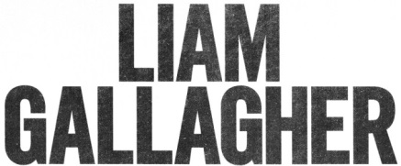
SHARES NEW VIDEO FOR “SHOCKWAVE”
WATCH IT HERE

NEW ALBUM WHY ME? WHY NOT. TO BE RELEASED ON SEPTEMBER 20TH
AVAILABLE TO PRE-ORDER NOW

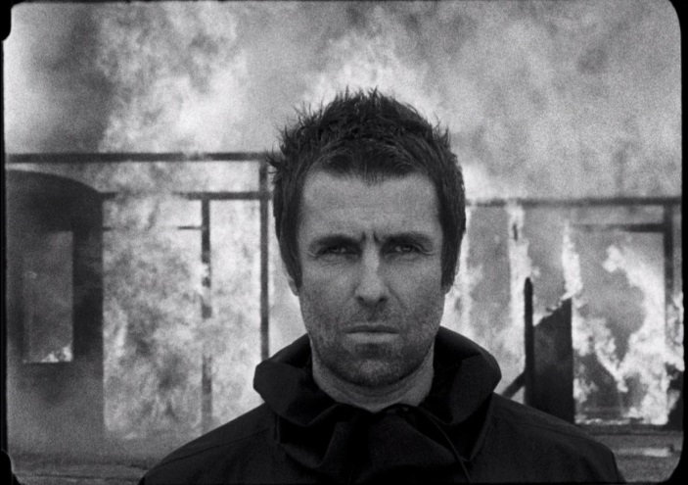
(Photo credit: Tom Beard)

June 13, 2019 (Los Angeles, CA) - Liam Gallagher’s 2017 debut solo single “Wall of Glass,” from the album As You Were put him back into the global spotlight, but his brand new single “Shockwave” is already powering towards a much bigger launch that will comfortably top the Official Vinyl Singles U.K. Chart. His debut solo album was a critical and commercial smash. It entered the U.K. album chart at #1, outselling the rest of the Top 10 in the process, and was soon certified Platinum. Gallagher was back where he belonged, selling out huge outdoor shows and earning major British awards from Q, NME and GQ magazine.

Now, Gallagher builds on that auspicious start by sharing the “Shockwave” official video. Directed by the award-winning François Rousselet, the video sets the iconic frontman’s swaggering charisma to some striking, cinematic-scale photography. It takes him on a voyage through America’s Deep South, from desolate wastelands to train tracks and large-scale protests.

The video arrives as Gallagher confirms his eagerly-anticipated second album Why Me? Why Not. will be released on September 20th via Warner Records. The album is now available to pre-order and will be available on a variety of CD, vinyl, download and streaming formats. There will also be a special D2C package which compiles a deluxe CD, a sun yellow vinyl album and a one-sided etched 12” which features three deluxe bonus tracks along with a demo recording that’s exclusive to this format – all packaged in a hardcover book.

Why Me? Why Not. was written by Gallagher along with producers Andrew Wyatt and Greg Kurstin, and recorded in both Los Angeles and London. Wyatt and Kurstin previously contributed with writing and producing Gallagher’s internationally-acclaimed debut solo album As You Were, and Gallagher was keen to push the envelope further this time. As a result, Why Me? Why Not. is a leap forward while still maintaining his trademark knack for crafting classic, melodic, memorable rock ‘n’ roll with a familiar fire and fury.

Gallagher explains: “I wrote some songs on my own for the last album, but this time it’s all co-writes. Reason being is I want it to be even better than As You Were. I know my strengths and I know my limitations. I’m an ok songwriter, but I’m a great singer and frontman. I want the second album to be a step-up because the hardest thing to do is to make something the same, only better. So that’s what we’ve done.”

“Shockwave” is proof of the Manchester legend’s typically full-throttle return. Adding to the excitement was the U.K. premiere and release of a new documentary ‘As It Was’ which has already been warmly embraced by the media overseas. The film’s U.S. release is scheduled to coincide with the release of Why Me? Why Not. Additionally, Gallagher was featured on the current cover of the U.K.’s Q Magazine, who described him as “rock’s finest frontman.” Well, naturally. Gallagher is back and in top form.

Liam Gallagher on tour:
All dates below with The Who
Wed Oct 09, Chase Center San Francisco, CA
Wed Oct 16, Veijas Arena at Aztec Bowl/ UCSD San Diego, CA
Sat Oct 19, Seattle, WA T-Mobile Park
Mon Oct 21, Rogers Arena Vancouver, BC
Thur Oct 24, Hollywood Bowl Hollywood, CA

# # #

For further information, contact Rick Gershon at Warner Records:
818-953-3473 / rick.gershon@warnerrecords.com
Twitter
Spotify
Facebook
Instagram
liamgallagher.com

