MY CHEMICAL ROMANCE SELLS OUT NORTH AMERICAN TOUR IN UNDER SIX HOURS

TOUR WAS ANNOUNCED THIS PAST WEDNESDAY VIA SHORT FILM FROM THE BAND - WATCH HERE

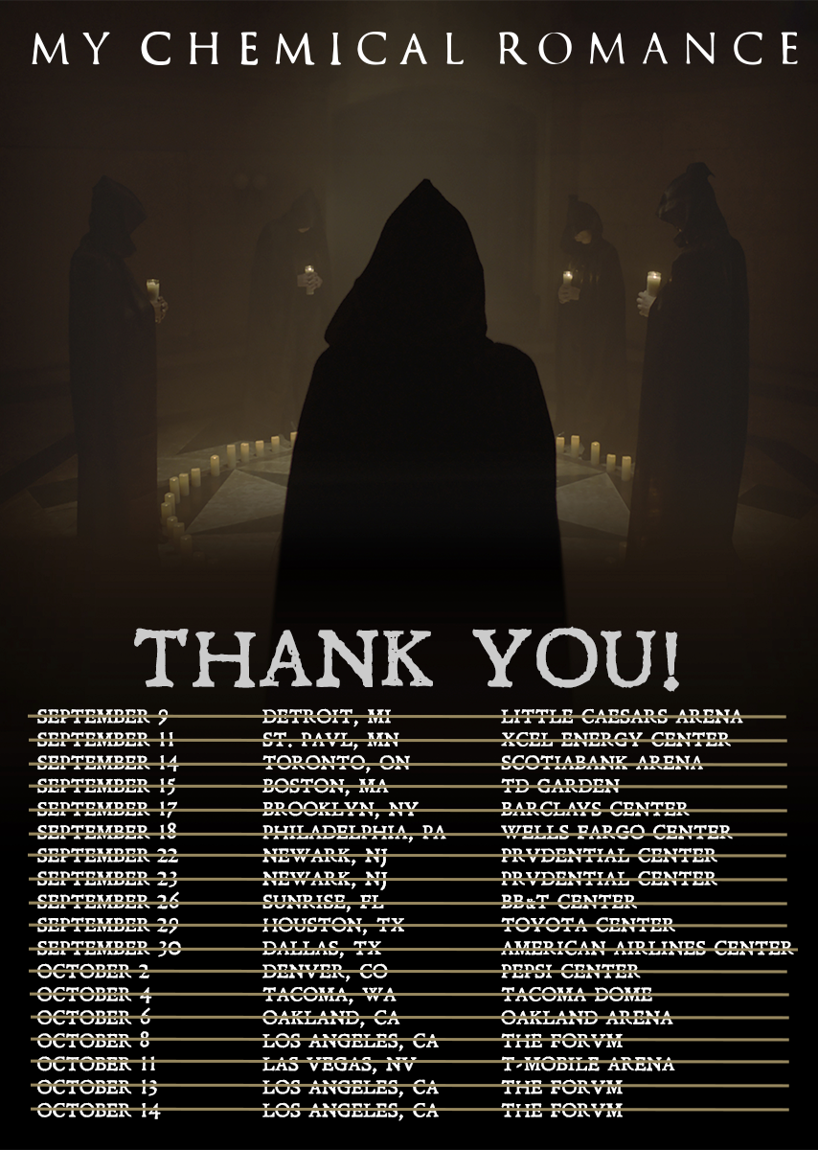

“It was the roar of the crowd that gave me heartache to sing.”
Disenchanted – My Chemical Romance

January 31, 2020 (Los Angeles, CA) –Although the band said there was no way they’d “come back again,” My Chemical Romance would like to thank their Killjoys across North America for selling out 228,600 tickets in under six hours. Fans from the U.S. and Canada acted quickly, as tickets went on sale today at 12 PM local time and were gone long before the day’s end….”you’ve worn out all your dance shoes, this time.”

For more information, please contact:

Bobbie Gale
MixedMediaWorks
323-363-2171
bobbie@mixedmediaworks.com

Laura Swanson
Warner Records
Laura.Swanson@warnerrecords.com

