MOTHER MOTHER RELEASE FINAL CHAPTER IN THE HAYLOFT SAGA
LISTEN HERE
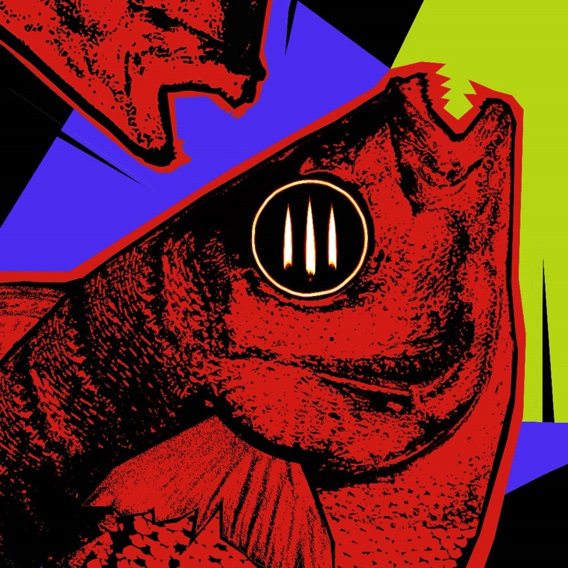
May 6, 2022 (Los Angeles, CA) – Canadian alt-rock sensation Mother Mother has released the final chapter in its incredible “Hayloft” saga. The new track “Hayloft II (SMASHUP)” is a mashup of “Hayloft” and “Hayloft II” and the last in a series of remixes for the global hit “Hayloft II,” - bringing the original tale of the young lovers to its fiery conclusion. Listen to “Hayloft II (SMASHUP)” HERE.
The new version came to fruition due to an overwhelming fan demand; the band responded to comments requesting the mashup, and posted a tease of the new music on TikTok, which quickly skyrocketed to over 20 million views. The track follows a prolific run of reimaginations of “Hayloft II” which have included the “Hayloft II (Burning Barn Acoustic)," along with the “DNMO Mix” and “Dark Verb Mix.”
Ahead of the track’s release, Mother Mother re-entered Billboard’s Emerging Artists chart this week at #40.
Currently, Mother Mother are in the middle of their sold-out Canadian tour. The band is also set to join Imagine Dragons as direct support on their European stadium tour this summer. Due to an overwhelming demand for tickets by their devoted fan base, the band will be returning to the US for another headline run this fall. The six-week jaunt will kick off in September and will see the band move into larger venues including Hollywood Palladium in Los Angeles and the Hammerstein Ballroom in New York, with special guests Sir Sly and Transviolet.
These tours follow up on a sold out American and European headline tour to start 2022, the latter postponed due to the pandemic. For more information on Mother Mother’s tour dates, click here.

Mother Mother 2022 North American Tour Dates

Sep 29 Revolution Concert House/Event Center Boise, ID
Sep 30 The Complex Salt Lake City, UT
Oct 01 The Fillmore Auditorium Denver, CO
Oct 03 Uptown Theater Kansas City, MO
Oct 04 The Fillmore Minneapolis Minneapolis, MN
Oct 06 The Pageant St. Louis, MO
Oct 07 Radius Chicago Chicago, IL
Oct 08 The Rave/ Eagles Club Milwaukee, IL
Oct 10 Hammerstein Ballroom New York, NY
Oct 12 House of Blues Boston Boston, MA
Oct 13 Roxian Theatre Pittsburgh, PA
Oct 14 The Fillmore Philadelphia Philadelphia, PA
Oct 15 Buffalo Riverworks Buffalo, NY
Oct 17 Echostage Washington, DC
Oct 18 The Ritz Raleigh, NC
Oct 19 Tabernacle Atlanta, GA
Oct 21 The Fillmore Miami Miami, FL
Oct 22 Jannus Live! St. Petersburg, FL
Oct 23 House of Blues Orlando Lake Buena Vista, FL
Oct 25 Fillmore New Orleans New Orleans, LA
Oct 26 Stubb’s Austin Austin, TX
Oct 28 Bayou Music Center Houston, TX
Oct 29 South Side Ballroom Dallas, TX
Oct 30 The Historic El Rey Theater Albuquerque, NM
Nov 01 Arizona Federal Theatre Phoenix, AZ
Nov 02 SOMA San Diego San Diego, CA
Nov 04 Brooklyn Bowl Las Vegas, NV
Nov 05 Hollywood Palladium Los Angeles, CA
Nov 06 The Masonic San Francisco, CA
Nov 08 McMenamins Crystal Ballroom Portland, OR
Nov 09 Showbox SoDo Seattle, WA

ABOUT MOTHER MOTHER:
Comprised of Ryan Guldemond, Molly Guldemond, Jasmin Parkin, Ali Siadat and Mike Young, the band had a whirlwind career to date; over 2 billion streams and views, more than 15 million monthly listeners and counting on digital platforms, and over 3.1 million Shazam searches. The band had a recent feature in Rolling Stone, a performance on The Late Late Show with James Corden, and made several appearances of late in Billboard’s Emerging Artist Chart, as well as topping Lyric Find’s global and US lyric search charts. In their native Canada, MOTHER MOTHER has had many top 10 singles on the alternative radio charts, including #1’s for weeks on end and the crown of most airplay for any alternative act at radio for multiple years running. Globally, the band’s avid fanbase continues to grow exponentially, as their presence on TikTok organically exploded during the fall of 2020 during lockdown. A variety of songs from O My Heart and Touch Up were used virally on the platform over 325 million times, resulting in millions of streams and new followers on streaming platforms and socials. Their new album INSIDE (Deluxe Edition) has racked up over 105 million global streams to date. MOTHER MOTHER will tour the world in 2022.

# # #
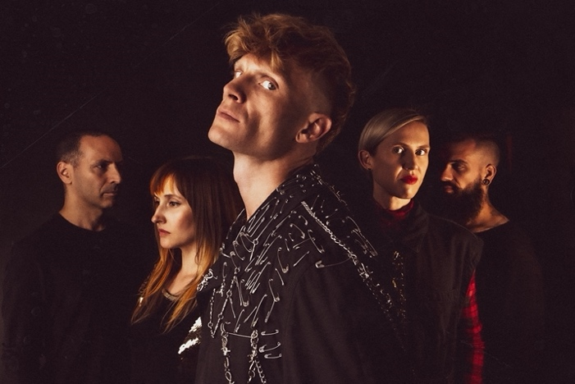

For further information, contact:

Rick Gershon at Warner Records
Rick.Gershon@warnerrecords.com

Regional: Jenny Huynh at Warner Records
Jenny.Huynh@warnerrecords.com

FOLLOW MOTHER MOTHER:
Official Site | Facebook | Twitter | Instagram | YouTube | Spotify | Press Materials
