MAC MILLER SHARES NEW SINGLE "DANG!" FEATURING ANDERSON .PAAK VIA ZANE LOWE ON BEATS 1

ANNOUNCES NEW ALBUM

THE DIVINE FEMININE DUE SEPTEMBER 16TH VIA WARNER BROS. RECORDS
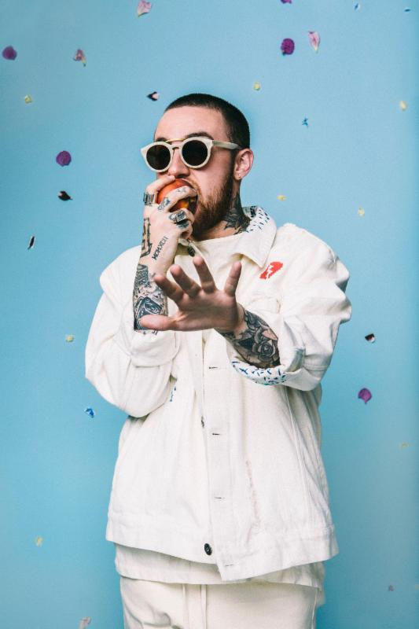

STREAM: "DANG! (feat. Anderson .Paak)" - http://youtu.be/HbDOdFRLV0U
After releasing his critically acclaimed GO:OD AM only 10 months ago, Mac Miller is back today to share the first taste of his forthcoming album The Divine Feminine. The album, which is set for release on September 16th via Warner Bros. Records, is being led out by the Anderson .Paak-assisted single "DANG!". The track is available for download immediately when you pre-order The Divine Feminine here.

To coincide with the new single and forthcoming album, Mac is also announcing a headlining North American tour that will launch following a hometown Pittsburgh show, headlining performance at this year's Los Angeles Fool's Gold Day Off and appearance at the inaugural Meadows Music & Arts Festival in New York. Presale tickets and exclusive VIP Meet & Greet packages for the tour will be available for fans to purchase on Mac's website starting at 10am local time, Wednesday, 8/3.

See below for more details about The Divine Feminine and Mac's upcoming tour dates. Stay tuned for more Mac Miller news soon.

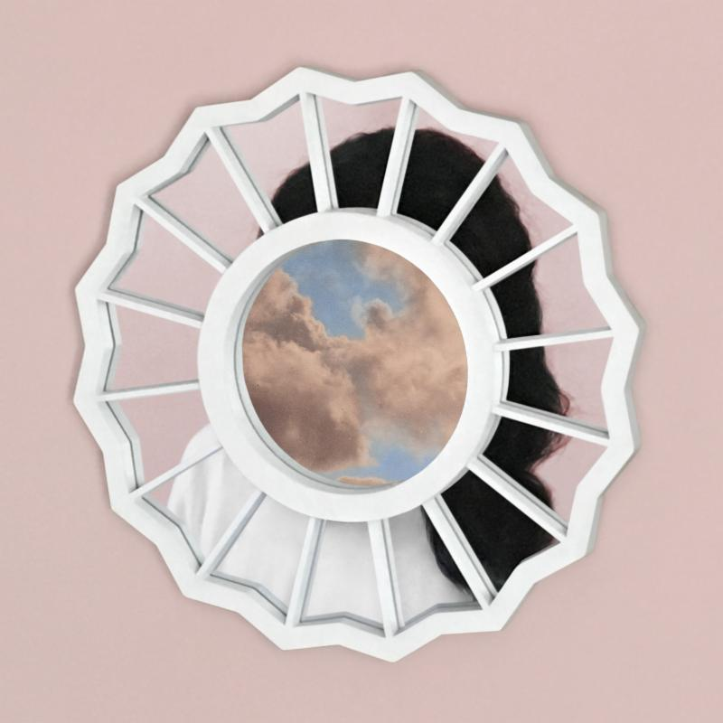

Mac Miller
The Divine Feminine
(Warner Bros. Records)
September 16, 2016

Tour Dates:
9/18 Pittsburgh, PA - Stage AE
9/25 Los Angeles, CA - Fool's Gold Day Off
10/02 New York, NY - The Meadows Music & Arts Festival
10/15 Orlando, FL - Carnage Festival
10/17 Atlanta, GA - Tabernacle
10/18 Birmingham, AL - Iron City
10/19 Louisville, KY - Palace Theatre
10/21 Memphis, TN - Minglewood Hall
10/22 Nashville, TN - War Memorial Auditorium
10/23 St. Louis, MO - The Pageant
10/25 Minneapolis, MN - First Avenue
10/26 Madison, WI - Orpheum Theatre
10/27 Milwaukee, WI - The Rave
10/29 Omaha, NE - Sokol Auditorium
10/31 Morrison, CO - Red Rocks Ampitheater
11/01 Magna, UT - The Great Saltair
11/02 Boise, ID - Revolution Center
11/04 Seattle, WA - Showbox SoDo
11/06 Vancouver, BC - Vogue Theatre
11/07 Portland, OR - Crystal Ballroom
11/09 Oakland, CA - Fox Theater
11/15 Tucson, AZ - The Rialto Theatre
11/16 Tempe, AZ - The Marquee
11/19 Dallas, TX - Bomb Factory
11/20 Houston, TX - Revention Music Center
11/21 Austin, TX - Emo's
11/28 Tulsa, OK - Cain's Ballroom
11/29 Kansas City, MO - Uptown Theater
12/01 Indianapolis, IN - Egyptian Ballroom
12/02 Grand Rapids, MI - Orbit Room
12/03 Royal Oak, MI - Royal Oak Music Theatre
12/05 Columbus, OH - Express Live Indoor Pavilion
12/06 Cleveland, OH - House of Blues
12/08 Toronto, ON - Sound Academy
12/11 Boston, MA - House of Blues
12/13 Silver Spring, MD - The Fillmore
12/16 Charlotte, NC - The Fillmore
12/17 Raleigh, NC - The Ritz
12/18 Baltimore, MD - Baltimore Sound Stage

For tools and Mac Miller inquiries, please visit http://press.wbr.com/macmiller

