MASTODON CELEBRATES 20 YEARS WITH
NEW SONG “FALLEN TORCHES” AVAILABLE NOW

LISTEN HERE
WATCH VISUALIZER HERE

MEDIUM RARITIES COLLECTION SET FOR SEPTEMBER 11TH RELEASE
VIA REPRISE RECORDS

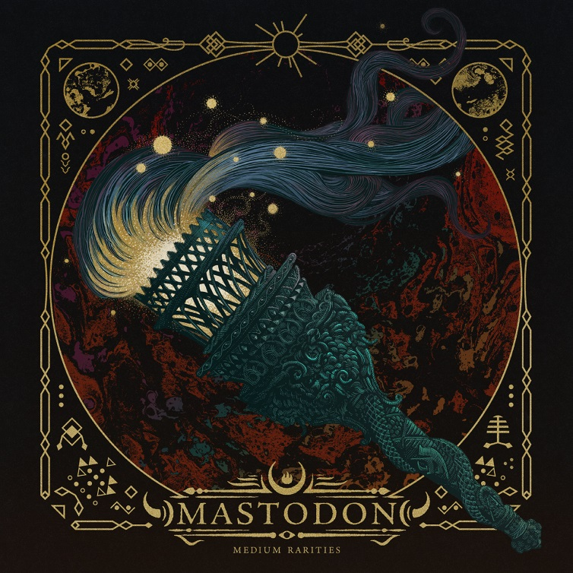
(Click here for hi-res artwork)

July 31, 2020 (Los Angeles, CA) – GRAMMY®-winning Atlanta hard rock juggernaut Mastodon turned 20 this year! Celebrating two decades together, the group will unleash a rarities collection, Medium Rarities, this September 11th, on CD and digital via Reprise Records. A pink vinyl edition will follow on October 16th. Among the many rare highlights included here is a new track “Fallen Torches,” recorded in 2019.

The band explains, “‘Fallen Torches’ is an unreleased track from Mastodon that will appear on Medium Rarities – a collection of rare tracks released digitally for the first time. This classic Mastodon track was recorded in Atlanta in 2019, originally planned to be released in support of a European tour, the track was delayed so the band could focus on the release of Stairway to Nick John, a tribute to their late, long time manager Nick John, with proceeds going to the Hirshberg Foundation for Pancreatic Cancer Research in his honor. ‘Fallen Torches’ is written by Mastodon and features guest vocals by longtime friend and collaborator Scott Kelly from the band Neurosis.”
Album pre-orders begin today and will include an instant download of “Fallen Torches.” Pre-order and pre-save here. Pre-order the limited edition pink vinyl edition here. Click here to view and share the “Fallen Torches” visualizer.

Medium Rarities presents a bevy of classic covers, soundtrack contributions, instrumentals, B-sides, and live recordings on one complete package for the very first time. Among an eclectic array of covers, the musicians tackle “A Commotion” by Feist, “A Spoonful Weighs A Ton” by The Flaming Lips, and “Orion” by Metallica. It also features soundtrack cuts such as “White Walker” [Game of Thrones] and “Cut You Up With A Linoleum Knife” [Aqua Teen Hunger Force]. Meanwhile, they get under the hood with instrumental versions of “Asleep in the Deep,” “Toe To Toes,” “Jaguar God,” and “Halloween.” 14 of these tracks have never been available on streaming platforms until now.

Another new Mastodon track “Rufus Lives” will be included in the forthcoming Orion Pictures film Bill & Ted Face The Music, expected to be released August 28th. Written, performed and produced by the band and recorded in their hometown of Atlanta, the track will also appear exclusively on the film’s official soundtrack album. Further details to be revealed shortly.

The anniversary celebration only continues. At the moment, Mastodon are hard at work on their anxiously awaited ninth full-length and first record since the GRAMMY® Award-winning Emperor of Sand in 2017.

Medium Rarities Tracklisting:
- Fallen Torches (Previously Unreleased)
- A Commotion (Feist Cover)
- Asleep in the Deep (Instrumental version)
- Capillarian Crest (Live)
- A Spoonful Weighs A Ton (The Flaming Lips Cover)
- Toe To Toes (Instrumental version)
- Circle of Cysquatch (Live)
- Atlanta (Feat. Gibby Haynes)
- Jaguar God (Instrumental)
- Cut You Up With A Linoleum Life (Aqua Teen Hunger Force)
- Blood & Thunder (Live)
- White Walker (Game of Thrones)
- Halloween (Instrumental version)
- Crystal Skull (Live)
- Orion (Metallica Cover)
- Iron Tusk (Live)

# # #

For all Mastodon inquiries, please contact:
Rick Gershon at Warner Records / Reprise Records
rick.gershon@warnerrecords.com

Follow Mastodon:
Website | Facebook | YouTube | Twitter | Instagram | Spotify

Press materials:
https://press.warnerrecords.com/mastodon/

