ALT-POP BREAKOUT MAUDE LATOUR DEBUTS NEW SONG + VIDEO “HEADPHONES”
LISTEN HERE – WATCH VIDEO HERE

SOLD-OUT NORTH AMERICAN TOUR BEGINS NEXT MONTH

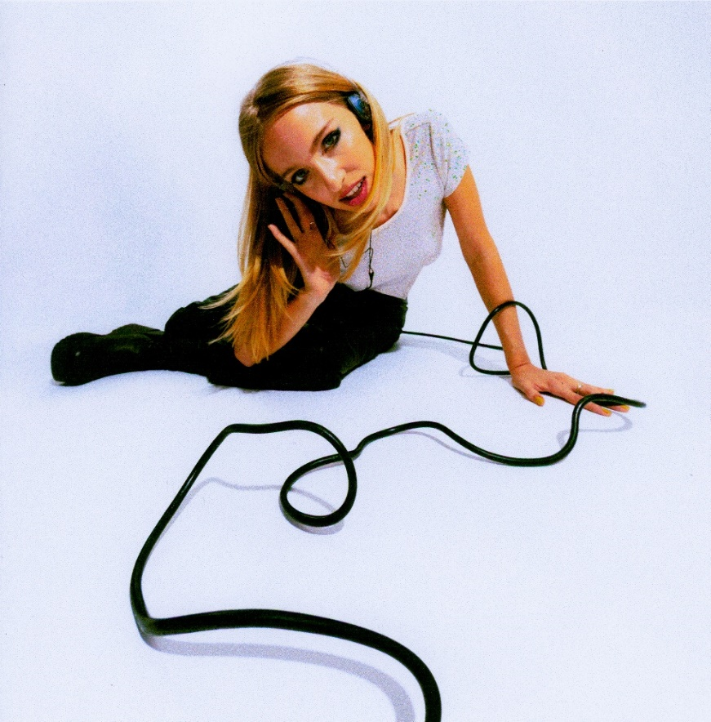

Named in Variety’s “Artists to Watch for the 2022 GRAMMYs”

“Maude Latour is making irresistibly catchy pop music” – Pigeons & Planes

“An intergalactic pop odyssey” – The FADER

“Maude Latour is taking notes from some of pop’s best” – Consequence of Sound

Named in PEOPLE’s “25 Emerging Musical Artists”

February 18, 2022 (Los Angeles, CA) – After amassing more than 30 million streams for her addictive alt-pop gems, rising breakout star Maude Latour confidently steps into her next chapter with new track and video “Headphones,” out now on Warner Records. Praised by Rolling Stone for its “pop-perfect sound,” the irresistible release comes just a few short weeks before Maude embarks on her first-ever nationwide headline tour – which sold out within minutes– including stops in Los Angeles, Toronto, Chicago, Nashville, and two nights at NYC’s Bowery Ballroom. Check out full dates below.

Listen to “Headphones” HERE and watch the colorful video HERE.
"‘Headphones’ starts exactly after where the ‘Strangers Forever’ EP left us -- heartbroken and experiencing loss, but slowly finding strength, as we say goodbye to a person of our past,” Maude explains. “‘Headphones’ is an opening of a new world; it is the first ray of light as the storm begins to end. I was lying on a hardwood floor, realizing I was truly alone in my head, no more romantic partner to lean on, when I first heard a voice in my head. It was my own. I wanted to learn to love myself, I wanted to grow within. ‘Headphones’ is that terrifying leap into our future, and into our deeper selves.”

The breakout artist—who hails from New York City (by way of London, Hong Kong, and Sweden)—first made waves back in 2019 with an independently released EP called Starsick. Her authenticity and emotionally nuanced lyrics immediately resonated with listeners, and she joined the Warner Records family in 2021. With a steady stream of viral hits, including “One More Weekend,” “Furniture,” and “Clean” from her recently released major label debut EP Strangers Forever, Latour has appeared on prestigious playlists including Spotify’s New Music Friday, Lorem, and Indie Pop, plus earned critical acclaim from the likes of The FADER, NYLON, Billboard, Refinery29, and FLAUNT Magazine.

Stay tuned for much more to come from Maude Latour in 2022.

UPCOMING TOUR DATES:
February 21 Washington, DC Songbyrd
February 23 Los Angeles, CA The Moroccan Lounge
March 11 Portland, OR Polaris Hall
March 12 Seattle, WA The Vera Project
March 14 San Francisco, CA Popscene
March 15 Los Angeles, CA The Roxy
March 18 Chicago, IL Subterranean
March 19 St. Paul, MN Amsterdam Bar & Hall
March 28 New York, NY Bowery Ballroom
March 29 New York, NY Bowery Ballroom
April 8 Toronto, ON The Garrison
April 9 Detroit, MI The Shelter
April 15 Cambridge, MA Sonia Live Music Venue
April 16 Cambridge, MA Sonia Live Music Venue
April 17 Washington, DC Black Cat
April 22 Atlanta, GA Center Stage Theater
April 23 Charlotte, NC Neighborhood Theatre

FOLLOW MAUDE LATOUR:
Press Assets | Website | TikTok | Twitter | Instagram | YouTube

For more information, please contact:
Patrice Compere | Patrice.Compere@warnerrecords.com
Darren Baber | Darren.Baber@warnerrecords.com
Ceri Roberts | Ceri.Roberts@warnerrecords.com
