**MAUDE LATOUR COMES “CLEAN” ON LATEST INDIE-POP GEM**

[**LISTEN HERE**](https://maudelatour.lnk.to/clean) **–** [**WATCH VIDEO HERE**](https://maudelatour.lnk.to/cleanvideo)

**NEW EP COMING SOON**

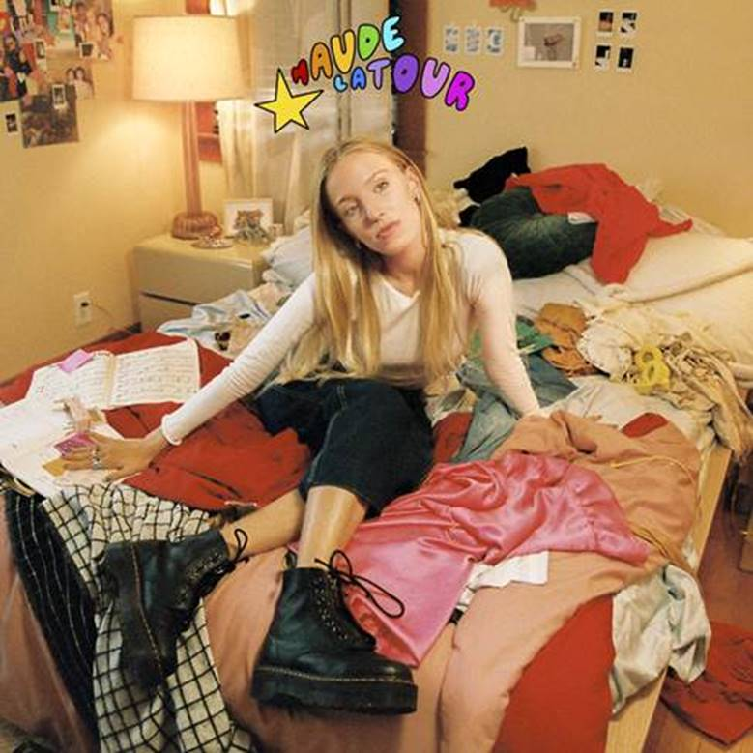

*"An intergalactic pop odyssey."****– The FADER***

*"disco-infused pop"****– NYLON***

*"Maude Latour is making irresistibly catchy pop music."* ***– Pigeons & Planes***

*“Maude Latour shines as a glimmering lighthouse of authenticity, guiding her very committed and rapidly-growing fanbase towards safety.”* ***– FLAUNT***

**August 13, 2021 (Los Angeles, CA) –** Today, New York’s alt-pop break-out **Maude Latour** reveals her latest indie-pop gem **“Clean”** via **Warner Records**. Listen to **“Clean”** [HERE](https://maudelatour.lnk.to/clean) and watch the music video [HERE](https://maudelatour.lnk.to/cleanvideo).

The upbeat, deliciously catchy alt-pop confessional encapsulates Latour’s strengths in just two minutes and thirty seconds: vividly relatable lyrics that take quick, thoughtful dips into existential territory, leaving the listener feeling both validated and intrigued. “Clean” affixes her quick-witted musings, as she interjects, *“I’m even tryna keep my room clean/Everyday I make my bed/Just to get you out my head/And I’m even wearin sunscreen/30 spf yeah ever since you left.”*

Originally written two years ago, **Latour** explains, *“The difference between 19 and 21 feels paradigmatic. When I was 19, this song was earnestly me working on myself, constantly promising to clean my room and temporarily taking good care of myself in spurts. Truly, I am an extremely messy person who is constantly involved in introspection and self-improvement, epiphanies, and inner thoughts. This song has become an even truer testament to how growing is painful. Sometimes you are trying your best, and it’s still messy, and it is still your best. Growth hurts—growing pains. I’m learning so much every single day."*

Now that she’s come ***“Clean***,***”*** expect a whole lot more from **Latour** as she readies her forthcoming new EP for release, coming soon.

**Latour** has quietly bubbled up as an alternative pop conversation-starter. She has gathered tens of millions of streams and claimed real estate on coveted playlists, including Spotify’s *“New Music Friday*,*”* *“Lorem*,*”* *“Indie Pop*,*”* and more.With the help of breakout singles, [**“One More Weekend”**](https://nam04.safelinks.protection.outlook.com/?url=https%3A%2F%2Fopen.spotify.com%2Ftrack%2F19YOJKCVvOL7v6B2Oe3UBc%3Fsi%3D2d95d8dc83974881&data=04%7C01%7CPatrice.Compere%40warnerrecords.com%7C369e9b1f46944e1a3d6c08d95b74ffc2%7C8367939002ec4ba1ad3d69da3fdd637e%7C0%7C0%7C637641380321687704%7CUnknown%7CTWFpbGZsb3d8eyJWIjoiMC4wLjAwMDAiLCJQIjoiV2luMzIiLCJBTiI6Ik1haWwiLCJXVCI6Mn0%3D%7C1000&sdata=6XxVsn9MrfGfuxuPDLZbYd%2Bg%2BhBromV7hi9ocizweKs%3D&reserved=0)and [**“Walk Backwards,”**](https://www.youtube.com/watch?v=OJYkGc02Iqw)she has amassed more than 30 million streams and counting, alongside universal critical acclaim from the likes of  ***[The FADER](https://nam04.safelinks.protection.outlook.com/?url=https%3A%2F%2Fwww.thefader.com%2F2019%2F11%2F14%2Fmaude-latour-lovesick&data=04%7C01%7CPatrice.Compere%40warnerrecords.com%7C369e9b1f46944e1a3d6c08d95b74ffc2%7C8367939002ec4ba1ad3d69da3fdd637e%7C0%7C0%7C637641380321687704%7CUnknown%7CTWFpbGZsb3d8eyJWIjoiMC4wLjAwMDAiLCJQIjoiV2luMzIiLCJBTiI6Ik1haWwiLCJXVCI6Mn0%3D%7C1000&sdata=mIKzc%2FDqI1PwywyLLDTgVQIhWrTGoisULLNxnL3nUA4%3D&reserved=0)***, [***NYLON***](https://nam04.safelinks.protection.outlook.com/?url=https%3A%2F%2Fnylon.com%2Fmaude-latour-ride-bike-premiere&data=04%7C01%7CPatrice.Compere%40warnerrecords.com%7C369e9b1f46944e1a3d6c08d95b74ffc2%7C8367939002ec4ba1ad3d69da3fdd637e%7C0%7C0%7C637641380321697697%7CUnknown%7CTWFpbGZsb3d8eyJWIjoiMC4wLjAwMDAiLCJQIjoiV2luMzIiLCJBTiI6Ik1haWwiLCJXVCI6Mn0%3D%7C1000&sdata=KdTT2tK0pqGlX9FSWHY79%2BTkdvvDoi7Q2CyewAgKOhU%3D&reserved=0), [***Billboard***](https://nam04.safelinks.protection.outlook.com/?url=https%3A%2F%2Fwww.billboard.com%2Farticles%2Fcolumns%2Fpop%2F8517510%2Fmaude-latour-starsick&data=04%7C01%7CPatrice.Compere%40warnerrecords.com%7C369e9b1f46944e1a3d6c08d95b74ffc2%7C8367939002ec4ba1ad3d69da3fdd637e%7C0%7C0%7C637641380321707691%7CUnknown%7CTWFpbGZsb3d8eyJWIjoiMC4wLjAwMDAiLCJQIjoiV2luMzIiLCJBTiI6Ik1haWwiLCJXVCI6Mn0%3D%7C1000&sdata=5y2fRw5cPR%2FKC3l22QXTO5HuERWt%2FWXvD0IPr3I6eTw%3D&reserved=0)**,** ***Pigeons & Planes******,*** [***Refinery29***](https://nam04.safelinks.protection.outlook.com/?url=https%3A%2F%2Fwww.refinery29.com%2Fen-us%2F2021%2F02%2F10306441%2Fnew-music-to-know-february-12-2021&data=04%7C01%7CPatrice.Compere%40warnerrecords.com%7C369e9b1f46944e1a3d6c08d95b74ffc2%7C8367939002ec4ba1ad3d69da3fdd637e%7C0%7C0%7C637641380321707691%7CUnknown%7CTWFpbGZsb3d8eyJWIjoiMC4wLjAwMDAiLCJQIjoiV2luMzIiLCJBTiI6Ik1haWwiLCJXVCI6Mn0%3D%7C1000&sdata=XSkxc3xgtWbBx5LCfvSrPh5spAIkCHgmuS1Qurlo6f8%3D&reserved=0),  and [***FLAUNT Magazine***](https://nam04.safelinks.protection.outlook.com/?url=https%3A%2F%2Fflaunt.com%2Fcontent%2Fmaude-latour&data=04%7C01%7CPatrice.Compere%40warnerrecords.com%7C369e9b1f46944e1a3d6c08d95b74ffc2%7C8367939002ec4ba1ad3d69da3fdd637e%7C0%7C0%7C637641380321717682%7CUnknown%7CTWFpbGZsb3d8eyJWIjoiMC4wLjAwMDAiLCJQIjoiV2luMzIiLCJBTiI6Ik1haWwiLCJXVCI6Mn0%3D%7C1000&sdata=tCp3%2BbB826KK68OG6Sn5pwnmvVniblShsXHMmepqSf0%3D&reserved=0)**.**

**More About Maude** **Latour**

The New Yorker spent a lot of time growing and learning from the city, which has influenced the music she makes. *"This city is what taught me independence, expression, creativity," she shares. "It's where I first truly stepped into myself. Since I was 13, this city has been my playground, and that has completely shaped who I am. I grew up fast and I grew up creating my own world with the paintbrushes and magic this city provides. I know it better than I know myself."* From exploring personal growth, to pondering existential dread to dealing with love, heart break, and all the in-betweens, what began as an act of personal freedom, created a community of followers who revel in speaking out and thus a revolution of support was born.

###

**FOLLOW MAUDE LATOUR:**

[Press Assets](https://press.warnerrecords.com/maudelatour/) | [Website](https://merch.maudelatour.com/) | [TikTok](https://www.tiktok.com/@maudelstatus?lang=en) | [Twitter](https://twitter.com/maudelstatus?lang=en) | [Instagram](https://www.instagram.com/maudelstatus/?hl=en) | [YouTube](https://www.youtube.com/channel/UCLf62P_jQF1qO_aJjYa68zA)

**For more information, please contact:**

Darren Baber / [Darren.Baber@warnerrecords.com](mailto:Darren.Baber@warnerrecords.com)

Ceri Roberts / [Ceri.Roberts@warnerrecords.com](mailto:Ceri.Roberts@warnerrecords.com)

Patrice Compere / [Patrice.Compere@warnerrecords.com](mailto:Patrice.Compere@warnerrecords.com)