**NEIL YOUNG’S SEMINAL *AFTER THE GOLD RUSH* 50TH ANNIVERSARY EDITION IS AVAILABLE NOW**

**VINYL BOX INCLUDES A 7” SINGLE, LITHO PRINT, AND NEW ARTWORK TO FOLLOW ON MARCH 19, 2021**

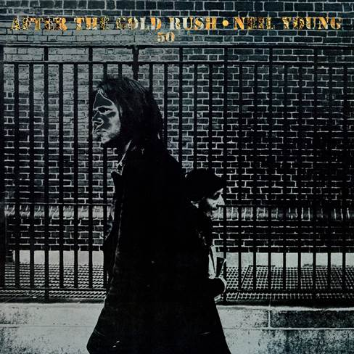

(Click [**here**](https://press.warnerrecords.com/wp-content/uploads/2020/10/gold-rush.png)for artwork)

**December 11, 2020 (Los Angeles, CA)** **—** Fifty years ago Reprise Records released **NEIL YOUNG’s** third solo album, ***AFTER THE GOLDRUSH*** to international critical praise. From that moment onward, there would be no looking back for Young. Originally released September 19, 1970, ***AFTER THE GOLDRUSH*** is cemented in the annals of music history—the album has often been rightly recognized as one of the finest ever made. The album peaked at number 8 on Billboard’ Top Pop Albums chart and yielded a pair of singles, **“Only Love Can Break Your Heart”** and **“When You Dance I Can Really Love.”** The collection combined Young’s poetic lyricism and wistful melodies, driven by both dreamy folk arrangements and ferocious rock ‘n’ roll. Today, this seminal album is released on CD and Digital in a 50th Anniversary Edition on hi-res audio thru [**NYA**](https://neilyoungarchives.com/) and hi-res downloads through the **[Xstream© Store](https://store.neilyoungarchives.com/)** at [**NYA**](https://neilyoungarchives.com/). The Deluxe Vinyl box set will follow on March 19, 2021.

The **50th Anniversary Edition vinyl box** set will pressed on 180g vinyl and individually numbered. The artwork for the album has been updated for this Anniversary Edition.  The cover is printed on special silver coated paper stock.  The set also includes a 7” single in a picture sleeve with two versions of album outtake **“Wonderin’.”**  Side A, originally included in ***The Archives Vol. 1: 1963-1972***, was recorded in Topanga, California, in March 1970, and Side B is a previously unreleased version recorded at Sunset Sound in Hollywood in August 1969. A litho print of the album’s front cover is exclusively included in this vinyl box set. The CD format of the 50th Anniversary Edition includes the new artwork and both versions of **“Wonderin’.”**Click [**here**](https://nam04.safelinks.protection.outlook.com/?url=http%3A%2F%2Fneilyoung.lnk.to%2FATGR50CD&data=04%7C01%7CRick.Gershon%40warnerrecords.com%7Cb6e84f72e3e34a0556ab08d87cf45d54%7C8367939002ec4ba1ad3d69da3fdd637e%7C0%7C0%7C637396737130993666%7CUnknown%7CTWFpbGZsb3d8eyJWIjoiMC4wLjAwMDAiLCJQIjoiV2luMzIiLCJBTiI6Ik1haWwiLCJXVCI6Mn0%3D%7C1000&sdata=%2FAi9KqmwcCSVKJC84pbvyLE8rd0WBci44aszq2leZ3Q%3D&reserved=0) to order CD and [**here**](https://nam04.safelinks.protection.outlook.com/?url=http%3A%2F%2Fneilyoung.lnk.to%2FATGR50Vinyl&data=04%7C01%7CRick.Gershon%40warnerrecords.com%7Cb6e84f72e3e34a0556ab08d87cf45d54%7C8367939002ec4ba1ad3d69da3fdd637e%7C0%7C0%7C637396737131003610%7CUnknown%7CTWFpbGZsb3d8eyJWIjoiMC4wLjAwMDAiLCJQIjoiV2luMzIiLCJBTiI6Ik1haWwiLCJXVCI6Mn0%3D%7C1000&sdata=IZronp3sSMAY%2F1rFiHyz7gxaC2gv7P4ayZ0%2Fhu%2BgQTY%3D&reserved=0) to pre-order vinyl and receive and instant download of **“Wonderin’.”**

The album has felt vital in each of the five decades since its release. In fact, its title track, with Young’s time-traveling and apocalyptic visions of California, places it firmly in the here and now. Young’s re-working of the song’s lyrics for live performances over the years casts that fact in a chilling clarity: *“Look at Mother Nature on the run in the 21st century.”* This **50th Anniversary Edition** is both a celebration for longtime fans, and a chance for new ears to take in its continued relevance.

***After the Gold Rush 50th Anniversary Edition* Tracklist:**1. Tell Me Why  
2. After the Gold Rush  
3. Only Love Can Break Your Heart  
4. Southern Man  
5. Till the Morning Comes  
6. Oh, Lonesome me  
7. Don’t Let It Bring You Down  
8. Birds  
9. When You Dance I Can Really Love  
10. I Believe In You  
11. Cripple Creek Ferry  
12. [Break]  
13. Wonderin’  
14. Wonderin’ (previously unreleased version)

**# # #**

For further information, contact **Rick Gershon** at Warner Records:

**Rick.Gershon@warnerrecords.com**

**Official Site/NYA:**

[**neilyoungarchives.com**](https://nam04.safelinks.protection.outlook.com/?url=https%3A%2F%2Fprotect-us.mimecast.com%2Fs%2FbALnBoUQbr0OS2&data=04%7C01%7CRick.Gershon%40warnerrecords.com%7Cb6e84f72e3e34a0556ab08d87cf45d54%7C8367939002ec4ba1ad3d69da3fdd637e%7C0%7C0%7C637396737131013582%7CUnknown%7CTWFpbGZsb3d8eyJWIjoiMC4wLjAwMDAiLCJQIjoiV2luMzIiLCJBTiI6Ik1haWwiLCJXVCI6Mn0%3D%7C1000&sdata=xvhD8D79IeBRyT8cHeIBHr5WkYWgRsslqlQ3TL60tZU%3D&reserved=0)

**Press materials:**

[**https://press.warnerrecords.com/neilyoung/**](https://nam04.safelinks.protection.outlook.com/?url=https%3A%2F%2Fpress.warnerrecords.com%2Fneilyoung%2F&data=04%7C01%7CRick.Gershon%40warnerrecords.com%7Cb6e84f72e3e34a0556ab08d87cf45d54%7C8367939002ec4ba1ad3d69da3fdd637e%7C0%7C0%7C637396737131023535%7CUnknown%7CTWFpbGZsb3d8eyJWIjoiMC4wLjAwMDAiLCJQIjoiV2luMzIiLCJBTiI6Ik1haWwiLCJXVCI6Mn0%3D%7C1000&sdata=A7za4PXzK8wW3VKPbdP6QOfzc9Cumw3EIOvIquwE4Tc%3D&reserved=0)

/var/folders/kf/v6dntks955j4xr91961zp0200000gp/T/com.microsoft.Word/WebArchiveCopyPasteTempFiles/cidimage003.jpg@01D4F910.A5DA5810