NEIL YOUNG’S ARCHIVES VOL. II: 1972-1976 BOX SET OUT TODAY

10-CD Box Set Covers a Wildly Productive Era of Young’s Legendary Career Featuring 131 Tracks—12 Previously Unreleased Songs, 49 New Versions of Classics—and Much More
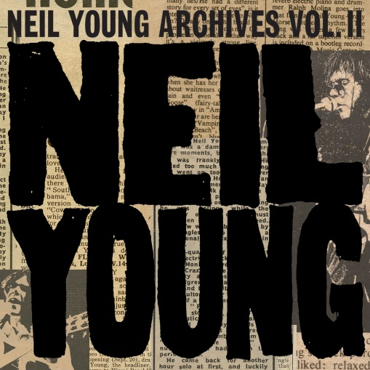
(Click here for Hi-res Images)

March 5, 2021 (Los Angeles, CA) — NEIL YOUNG’S long-awaited monumental box set Archives Volume II: 1972-1976 is finally out today via Reprise Records. Comprised of a whopping 131 tracks – many of which have never been heard until now — cover some of Young’s most fervent and turbulent years between 1972-1976. The initial run of the Deluxe Edition Box Sets sold out in under 24 hours, which prompted the demand for a second run available exclusively via The Greedy Hand Store at Neil Young Archives (NYA). Also out today is the Retail Edition of the set, available at both standard music retail outlets and via The Greedy Hand Store. Hi-res digital audio for all tracks are available from the Xstream© store at Neil Young Archives (NYA) and is also included with purchase of either edition at The Greedy Hand Store.
Archives Volume II: 1972-1976 focuses on a feverishly productive era of Young’s career when he was often accompanied by Crazy Horse. During that era, Young released some of his most visceral and stormy albums, including Time Fades Away, On the Beach, Tonight’s the Night, Zuma, and Long May You Run. The critically acclaimed Homegrown, finally released in June, is also part of this legacy. The new box set is the second installment in the definitive, comprehensive, chronological survey of Young’s legendary body of work.

Both editions of Archives Volume II: 1972-1976 contain 10 CDs with 131 tracks, including 12 songs never before released in any form and 49 unreleased versions of Young’s classics. They include studio and live recordings, both solo and with Crazy Horse (Odeon Budokan), The Stray Gators (Tuscaloosa), the Santa Monica Flyers (Roxy: Tonight's the Night Live), Crosby, Stills, Nash and Young, and The Stills Young Band. The deluxe edition comes in a towering vertical box and includes a 252-page hardbound book with hundreds of previously unseen photographs, additional archival materials, a partial tape database, a detailed description of the music, and a fold-out timeline of the period. The box set also includes an oversized Archives poster. Purchasers of the deluxe box set will also receive a 1-year subscription to NYA.

The retail edition of Archives Vol II: 1972-1976 includes the same 10 CDs as in the deluxe edition, the same oversized Archives poster, and a 24-page booklet (replacing the book). This edition is packaged in a cube-shaped slip-case box—smaller than the deluxe edition box.

Archives Volume II: 1972-1976 brings fans extensive documentation of a time in Young’s career that saw his music take heavier turns in both tone and subject matter. The LPs he crafted during this time, including the haunting “Ditch Trilogy”—Time Fades Away, On the Beach, and Tonight’s the Night—are dense with a darkness and wildness also reflected in Young’s electrifying live shows of the era. Previously, 2009’s Archives Volume I: 1963-1972 offered an unprecedented deep dive into Young’s early work, illuminating the road he traveled with The Squires and Buffalo Springfield, and exploring iconic albums like Harvest.

Only at NYA can you find Young’s music in the highest possible digital audio resolution alongside a seemingly infinite store of archival files. It’s also the home of Young’s virtual daily newspaper, The Times Contrarian and The Hearse Theater, where you can watch rare footage and stream live shows. NYA is a fittingly sprawling repository for Young; few artists—perhaps none—have explored such a vast spectrum of sounds and styles over more than half a century.

Archives Volume II: 1972-1976 track listing:
* = previously unreleased song
** = new unreleased version

Disc 1 (1972-1973)
Everybody’s Alone
- Letter From ‘Nam *
- Monday Morning **
- The Bridge **
- Time Fades Away **
- Come Along and Say You Will *
- Goodbye Christians on the Shore *
- Last Trip to Tulsa
- The Loner **
- Sweet Joni *
- Yonder Stands the Sinner
- L.A. (Story)
- L.A. **
- Human Highway **

Disc 2 (1973)
Tuscaloosa
- Here We Are in the Years
- After the Gold Rush
- Out on the Weekend
- Harvest
- Old Man
- Heart of Gold
- Time Fades Away
- Lookout Joe
- New Mama
- Alabama
- Don’t Be Denied

Disc 3 (1973)
Tonight’s the Night
- Speakin’ Out Jam **
- Everybody’s Alone **
- Tired Eyes
- Tonight’s the Night
- Mellow My Mind
- World on a String
- Speakin’ Out
- Raised on Robbery (Joni Mitchell song) *
- Roll Another Number
- New Mama
- Albuquerque
- Tonight’s the Night Part II

Disc 4 (1973)
Roxy: Tonight’s the Night Live
- Tonight’s the Night
- Mellow My Mind
- World on a String
- Speakin’ Out
- Albuquerque
- New Mama
- Roll Another Number
- Tired Eyes
- Tonight’s the Night Part II
- Walk On
- The Losing End **

Disc 5 (1974)
Walk On
- Winterlong
- Walk On
- Bad Fog of Loneliness **
- Borrowed Tune
- Traces **
- For the Turnstiles
- Ambulance Blues
- Motion Pictures
- On the Beach
- Revolution Blues
- Vampire Blues
- Greensleeves *

Disc 6 (1974)
The Old Homestead
- Love/Art Blues **
- Through My Sails **
- Homefires *
- Pardon My Heart **
- Hawaiian Sunrise **
- LA Girls and Ocean Boys *
- Pushed It Over the End **
- On the Beach **
- Vacancy **
- One More Sign **
- Frozen Man *
- Give Me Strength **
- Bad News Comes to Town **
- Changing Highways **
- Love/Art Blues **
- The Old Homestead
- Daughters *
- Deep Forbidden Lake
- Love/Art Blues **

Disc 7 (1974)
Homegrown
- Separate Ways
- Try
- Mexico
- Love Is a Rose
- Homegrown
- Florida
- Kansas
- We Don’t Smoke It No More
- White Line
- Vacancy
- Little Wing
- Star of Bethlehem

Disc 8 (1975)
Dume
- Ride My Llama **
- Cortez the Killer
- Don’t Cry No Tears
- Born to Run *
- Barstool Blues
- Danger Bird
- Stupid Girl
- Kansas **
- Powderfinger **
- Hawaii **
- Drive Back
- Lookin’ for a Love
- Pardon My Heart
- Too Far Gone **
- Pocahontas **
- No One Seems to Know **

Disc 9 (1976)
Look Out for My Love
- Like a Hurricane
- Lotta Love
- Lookin’ for a Love
- Separate Ways **
- Let It Shine **
- Long May You Run
- Fontainebleau
- Traces **
- Mellow My Mind **
- Midnight on the Bay **
- Stringman **
- Mediterranean *
- Ocean Girl **
- Midnight on the Bay **
- Human Highway **

Disc 10 (1976)
Odeon Budokan
- The Old Laughing Lady **
- After the Gold Rush **
- Too Far Gone **
- Old Man **
- Stringman **
- Don’t Cry No Tears **
- Cowgirl in the Sand **
- Lotta Love **
- Drive Back **
- Cortez the Killer **

# # #

For further information, contact Rick Gershon at Warner Records:
Rick.Gershon@warnerrecords.com

Official Site/NYA:
neilyoungarchives.com

Press materials:
https://press.warnerrecords.com/neilyoung/

