NEIL YOUNG & CRAZY HORSE OFFER INTIMATE GLIMPSE INTO
THE MAKING OF BARN
WATCH TRAILER HERE
The Film Will Play In Select Theaters December 9 – 11th

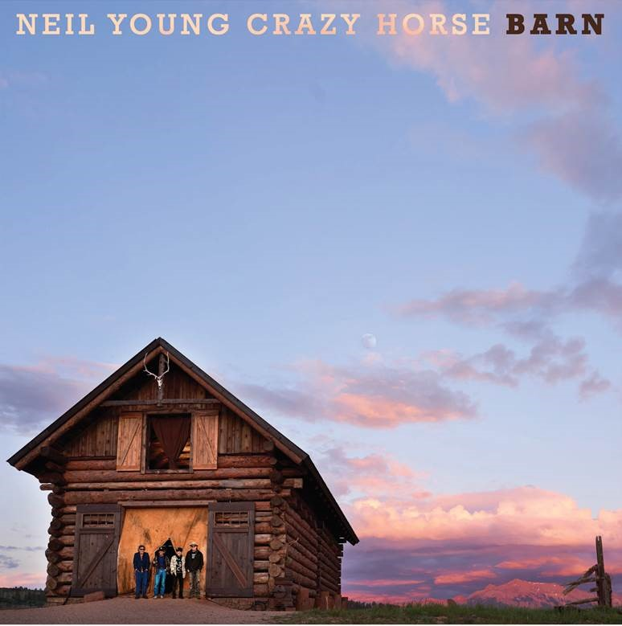
(Click here for Hi-res cover art)

December 1, 2021 — (Los Angeles, CA) Today, NEIL YOUNG is announcing an intimate behind-the-scenes documentary film to accompany his upcoming album BARN, the latest collaboration between the legendary songwriter and his frequent musical co-conspirators Crazy Horse. The film, also called BARN, directed by dhlovelife, will play in select theaters across North America December 9-11th. It will also be released as part of the deluxe edition of the album, as well as via stand-alone Blu-Ray on December 10 exclusively through The Greedy Hand Store at NYA. The BARN film will premier exclusively on AARP Members Only Access on demand beginning December 10th through January 10th Click here for details. On December 17th BARN will screen on AARP’s Music For Grownups platform. Click here for details.
BARN is available for pre-order today and is out December 10 via Reprise Records. Watch the trailer HERE.
The documentary will provide an unprecedented glimpse into Young and the Horse’s creative process, as they took to tape in Colorado’s Rocky Mountains during the COVID-19 pandemic. Kicking off with a note of gratitude from Young (“I’m so glad we’re fuckin’ here!”), the trailer shows what things were like as the legendary band got back into their element, in the wild, making music in a restored, 19th-century log barn under a full, glowing moon. The film captures the group—a 50-year-old musical family that includes, Billy Talbot, Ralph Molina and Nils Lofgren —building the powerful new record, but also their easy humor and enduring brotherhood.
Filmmaker dhlovelife describes the BARN film this way: “A documentary of the making of Neil Young and Crazy Horse recording BARN the album. BARN captures this legendary band in their element, in the wild, as they make music in a restored 19th century log barn under the full moon. Neil and the horse are a 50-year-old musical family and BARN catches a rare intimate glimpse of their easy humor, their brotherhood, and of course their music, created live, in their own unique spontaneous way.”

BARN was produced and mixed by Young and Niko Bolas (aka The Volume Dealers) and mastered by Chris Bellman at Bernie Grundman Mastering in Hollywood. The album will be available on vinyl, CD, cassette, Deluxe Edition (LP, CD, BD plus a set of six prints) and digital at Neil Young Archives (NYA). Labeled “a revolution in fandom” by The Guardian, NYA was the first totally immersive fan-experience website and remains the only portal for all things Neil. Only at NYA can you find Young’s music in the highest possible digital audio resolution alongside a seemingly infinite store of archival files. It is also the home of Young’s virtual daily newspaper, The Times Contrarian, and The Hearse Theater, where you can see rare footage and stream live shows. NYA is a fittingly sprawling repository for Young; few artists—perhaps none—have explored such a vast spectrum of sounds and styles over more than half a century.
The next track from BARN “Welcome Back,” will be released this Friday December 3rd on all DSP’s and on hi-res digital audio via Xstream through NYA. Click here to stream and here to view and share the video.
BARN in theaters 2021:
Dec 09 Chicago, IL Landmark Century Centre Cinema
Dec 09 Santa Monica, CA Laemmle at the Monica Film Center
Dec 09 New York, NY IFC Center
Dec 11 Toronto, ON Hot Docs Ted Rogers Cinema

# # #

For further information, contact Rick Gershon at Warner Records:
Rick.Gershon@warnerrecords.com

Follow Neil Young:
Official Site/NYA | Press Materials

