**NEIL YOUNG ANNOUNCES NEXT SET OF TITLES FROM HIS OFFICIAL BOOTLEG SERIES (OBS) COMING MAY 6TH ON CD/DIGITAL VIA SHAKEY PICTURES RECORDS VINYL TO FOLLOW ON JUNE 3RD**

**THREE MORE LIVE RECORDINGS OF LEGENDARY SHOWS BETWEEN 1971 – 1974**

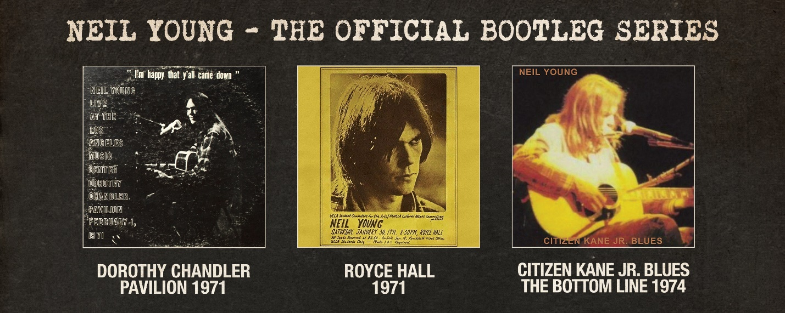

**March 25, 2022 – (Los Angeles, CA.)** [**Neil Young**](https://neilyoungarchives.com/) is set to deliver more rare live recordings from his extensive archives with the ***Neil Young Official Bootleg Series (OBS)*** which began last fall with the release of ***Carnegie Hall 1970* (OBS1)*.*** Pre-orders begin today for each of thesereleases and all will be available on CD and digitally **May 6th** via [**The Greedy Hand Store**](https://neilyoung.warnerrecords.com/) at[**Neil Young Archives**](https://neilyoungarchives.com), and all music retailers everywhere and most DSPs. The vinyl editions will follow on **June 3rd**. **NYA Greedy Hand Store** purchases on LP or CD come with a free hi-res digital audio download of the album that will arrive on May 6th.

The next three installments in the bootleg series as follows: **Royce Hall, 1971** was recorded January 30 on the UCLA campus, a solo acoustic gig. **Dorothy Chandler Pavilion, 1971** – also solo acoustic -- is the last US show of Young’s 1971 solo tour. **Citizen Kane Jr. Blues (Live at The Bottom Line),** from New York City 1974 is a surprise set. Where analog tape exists in Young’s archive, these concerts have been mixed properly, providing much higher quality recordings than have previously existed – **Royce Hall 1971** and **Dorothy Chandler Pavilion 1971** are from the original analog masters. If no tape exists, the original bootleg has been restored and remastered to bring listeners the best audio experience possible - **Citizen Kane Jr. Blues (Live at The Bottom Line),** from New York City 1974. These albums are available for pre-order now and will include and instant download track from each. Embed codes for hi-res players as follows:

**“Journey Through The Past”** from ***Royce Hall*** “Bootleg Series”

t1970_0130_04 <iframe src="[https://neilyoungarchives.com/embed?trackId=](https://nam04.safelinks.protection.outlook.com/?url=https%3A%2F%2Fneilyoungarchives.com%2Fembed%3FtrackId%3Dt2021_0622_04&data=04%7C01%7CRick.Gershon%40warnerrecords.com%7Ccc864ed6028043fd4d8c08d9f0c6f37b%7C8367939002ec4ba1ad3d69da3fdd637e%7C0%7C0%7C637805559560807125%7CUnknown%7CTWFpbGZsb3d8eyJWIjoiMC4wLjAwMDAiLCJQIjoiV2luMzIiLCJBTiI6Ik1haWwiLCJXVCI6Mn0%3D%7C3000&sdata=SxA88jtFjU%2Fvt4bUKJMgAmz%2BgC%2BqWZLwbnO%2BwRrFy8Y%3D&reserved=0)t1970_0130_04" width="720" height="320" style="border:0;"></iframe>

**“Don’t Let It Bring You Down”** from ***Dorothy Chandler Pavilion*** “Bootleg Series”

t1971_0201_09

<iframe src="[https://neilyoungarchives.com/embed?trackId=](https://nam04.safelinks.protection.outlook.com/?url=https%3A%2F%2Fneilyoungarchives.com%2Fembed%3FtrackId%3Dt2021_0622_04&data=04%7C01%7CRick.Gershon%40warnerrecords.com%7Ccc864ed6028043fd4d8c08d9f0c6f37b%7C8367939002ec4ba1ad3d69da3fdd637e%7C0%7C0%7C637805559560807125%7CUnknown%7CTWFpbGZsb3d8eyJWIjoiMC4wLjAwMDAiLCJQIjoiV2luMzIiLCJBTiI6Ik1haWwiLCJXVCI6Mn0%3D%7C3000&sdata=SxA88jtFjU%2Fvt4bUKJMgAmz%2BgC%2BqWZLwbnO%2BwRrFy8Y%3D&reserved=0)t1971_0201_09" width="720" height="320" style="border:0;"></iframe>

**“Revolution Blues”** from ***Citizen Kane Jr. Blues*** “Bootleg Series”

<iframe src="[https://neilyoungarchives.com/embed?trackId=](https://nam04.safelinks.protection.outlook.com/?url=https%3A%2F%2Fneilyoungarchives.com%2Fembed%3FtrackId%3Dt2021_0622_04&data=04%7C01%7CRick.Gershon%40warnerrecords.com%7Ccc864ed6028043fd4d8c08d9f0c6f37b%7C8367939002ec4ba1ad3d69da3fdd637e%7C0%7C0%7C637805559560807125%7CUnknown%7CTWFpbGZsb3d8eyJWIjoiMC4wLjAwMDAiLCJQIjoiV2luMzIiLCJBTiI6Ik1haWwiLCJXVCI6Mn0%3D%7C3000&sdata=SxA88jtFjU%2Fvt4bUKJMgAmz%2BgC%2BqWZLwbnO%2BwRrFy8Y%3D&reserved=0)t1974_0516_06" width="720" height="320" style="border:0;"></iframe>

The original bootleg artwork has also been replicated wherever possible, lending each release that treasured collector’s vibe and conjuring the era they were first created in. The ***Dorothy Chandler Pavilion, 1971*** album cover, for example, features the worn and faded ring of an LP.

**Neil Young Official Bootleg Seriestrack listings**

**OBS 3: *Dorothy Chandler Pavilion***

**(Los Angeles: February 1, 1971)**

1. On the Way Home
2. Tell Me Why
3. Old Man
4. Journey Through the Past
5. Cowgirl in the Sand
6. Heart of Gold
7. A Man Needs a Maid
8. Sugar Mountain
9. Don't Let It Bring You Down
10. Love in Mind
11. The Needle and the Damage Done
12. Ohio
13. See the Sky About to Rain
14. I Am a Child
15. Dance Dance Dance

**OBS 4: *Royce Hall***

**(Los Angeles: January 30, 1971)**

1. On the Way Home
2. Tell Me Why
3. Old Man
4. Journey Through the Past
5. Cowgirl in the Sand
6. Heart of Gold
7. A Man Needs a Maid
8. See the Sky About to Rain
9. Sugar Mountain
10. Don't Let It Bring You Down
11. Love in Mind
12. The Needle and the Damage Done
13. Ohio
14. Down by the River
15. Dance Dance Dance
16. I Am a Child

**OBS 5: *Citizen Kane Jr. Blues (Live The Bottom Line)***

**(NYC: May 16, 1974)**

1. Pushed It Over The End
2. Long May You Run
3. Greensleeves
4. Ambulance Blues
5. Helpless
6. Revolution Blues
7. On the Beach
8. Roll Another Number (For the Road)
9. Motion Pictures
10. Pardon My Heart
11. Dance Dance Dance

**# # #**

For further information, contact **Rick Gershon** at Warner Records:

818-953-3473 / **Rick.Gershon@warnerrecords.com**

**Official Site/NYA:**

[**neilyoungarchives.com**](https://protect-us.mimecast.com/s/bALnBoUQbr0OS2)

**Press materials:**

[**https://press.warnerrecords.com/neilyoung/**](https://press.warnerrecords.com/neilyoung/)

 