NEIL YOUNG WITH CRAZY HORSE RELEASE COLORADO,
THEIR FIRST NEW ALBUM IN SEVEN YEARS OUT TODAY
VIA REPRISE RECORDS

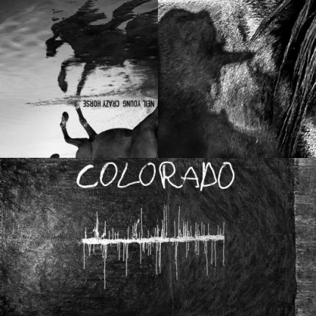

(COLORADO Cover Art hi-res link here)

October 25, 2019 (Los Angeles, CA) – For the first time in seven years, Neil Young has reunited with his most beloved and enduring band Crazy Horse and are proud to announce their new album COLORADO today via Reprise Records. This is the first new music since 2012’s critically acclaimed PSYCHEDELIC PILL and is arguably their most important and timely body of work to date. Young, along with Ralph Molina (drums, vocals), Billy Talbot (bass, vocals) and Nils Lofgren (guitars, vocals, pump organ), recorded 11 tracks mostly live in the studio in the Rocky Mountains of Colorado. The end results are sonically stunning and as real as it gets; the listener will feel what it’s like to be on the studio floor with the band during the actual recording. As for the songs themselves, this is pure Neil at his finest and as stylistically diverse as one might expect once The Horse is out of the barn. Some of the songs have already been performed live during Young’s recent live shows and have already become fan favorites. From the classic, familiar feel of “She Showed Me Love,” to the gentle piano balladry of “Green Is Blue” with its lyrical images that recall disturbing images of extreme climate change. “Shut It Down,” the album’s next radio track, rocks hard and offers a reset solution to our country’s current state of affairs. “Milky Way,” originally shared with the world weeks ago will also strike a familiar chord. The anthemic and inspiring “Rainbow Of Colors” reminds us that “there’s a rainbow of colors in the old USA, no one’s gonna white wash those colors away.”

COLORADO was produced by Young and John Hanlon, with mastering by Chris Bellman at Bernie Grundman Mastering, Hollywood. The album will be available on 12” vinyl + 7” package, CD, digital and hi-resolution streaming from neilyoungarchives.com & Amazon Music HD. The bonus single -- which is exclusive to the vinyl package only--contains two non-album tracks, “Rainbow Of Colors (live),” recorded live by Neil Young solo and was the first-ever public performance of this powerful song. The flip side “Truth Kills,” is a studio track by Young with Crazy Horse from the Mountaintop sessions. Click here to purchase and stream.

COLORADO Track listing:
Side 1
Think Of Me
She Showed Me Love

Side 2
Olden Days
Help Me Lose My Mind
Green Is Blue
Shut It Down

Side 3
Milky Way
Eternity
Rainbow Of Colors (studio version)
I Do

Side 4
Etched artwork

Bonus 7” Single:
A-Side:
Rainbow Of Colors (solo, live in Portland, OR May 17, 2019)
B-Side:
Truth Kills (Neil Young with Crazy Horse – studio)

Additionally, a book co-authored by Young and Phil Baker titled, TO FEEL THE MUSIC: A
Songwriters Mission To Save High Quality Audio, was published in September by BenBella
Books. This is a memoir about Young’s single most passionate pursuit: bringing high-quality audio back
to music lovers, who have been forced to settle for compressed, digital files that rob songs of their original
warmth. Click here for further information.

# # #
For further information, contact Rick Gershon at Reprise / Warner Records Publicity:
818-953-3473 / rick.gershon@warnerrecords.com

Official Site/NYA:
neilyoungarchives.com

Press materials:
http://press.warnerrecords.com/neilyoung

