NEIL YOUNG ANNOUNCES BLISTERING LIVE ALBUM AND FILM
WAY DOWN IN THE RUST BUCKET SET FOR FEBRUARY 26TH RELEASE
VIA REPRISE RECORDS

Never Before Released Set Captures Young And Crazy Horse’s Electrifying 1990 Show In Santa Cruz, California And Includes Live Versions of Songs from Ragged Glory

LISTEN HERE

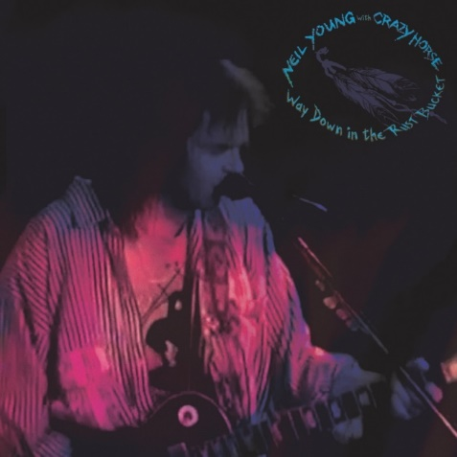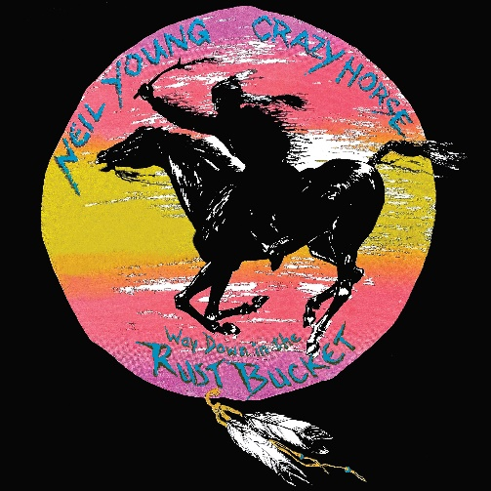
(Click here for hi-res CD artwork- L) (Click here for hi-res Vinyl artwork - R)

January 15, 2021 (Los Angeles, CA) —Today, NEIL YOUNG announces the release of Way Down in the Rust Bucket, a never-before released, incendiary and essential live album and concert film documenting a legendary 1990 show with Crazy Horse in Santa Cruz, California. Available for pre-order today and out on February 26, 2021, Way Down in the Rust Bucket features the debut public performances and much of the songwriter’s grungy, cranked-up 1990 album, Ragged Glory. Pre-order now and receive and instant download of “Country Home.” Click here to stream the track.
Vinyl, CD and Deluxe box sets will be available via The Greedy Hand Store at Neil Young Archives and music retailers everywhere and digitally via NYA and all DSP’s. Purchasers of Way Down In The Rust Bucket from the Greedy Hand Store will also receive free hi-res digital audio downloads from the Xstream Store © at NYA.
After recording Ragged Glory at Broken Arrow Ranch in the spring of 1990 and releasing it that September, Young and Crazy Horse took the stage at The Catalyst in Santa Cruz on November 13 to unleash the songs upon a live audience. In true Crazy Horse fashion, the incendiary show ran across three sets and over three hours, with songs like “Love and Only Love” and “Like a Hurricane” hypnotically stretching past ten minutes. The Catalyst gig also marked the first time “Danger Bird”—a cut from Young’s 1975 album Zuma—was played for a live audience, thundering on into psychedelic six-string fireworks. Other live debuts on Way Down in the Rust Bucket include “Surfer Joe and Moe the Sleaze,” “Love to Burn,” “Farmer John,” “Over and Over,” “Fuckin’ Up,” “Mansion on the Hill,” and “Love and Only Love.”
Way Down in the Rust Bucket—which is #11.5 in Neil Young’s Performance Series—will be released in a number of variations. A deluxe edition box set will contain a DVD of the electrifying live concert—directed by Bernard Shakey and produced and directed for Shakey Pictures and Upstream Multimedia by LA Johnson—alongside four LPs and two CDs. The DVD contains one additional performance of “Cowgirl In The Sand” (13 minutes worth!) which does not appear on the vinyl or CD editions. Other versions will include a 4LP vinyl box set and a 2CD set.

Way Down in the Rust Bucket will also be available digitally from the Xstream Store © at Neil Young Archives and all major DSPs. Only at NYA can you find Young’s music in the highest possible digital audio resolution alongside a seemingly infinite store of archival files. It’s also the home of Young’s virtual daily newspaper, The Times Contrarian, and The Hearse Theater, where you can see rare footage and stream live shows. NYA is a fittingly sprawling repository for Young; few artists—perhaps none—have explored such a vast spectrum of sounds and styles over more than half a century. Way Down in the Rust Bucket is a worthy reminder of all the greatness he has up his sleeves.

Way Down in the Rust Bucket Track Listing:
1. Country Home
2. Surfer Joe and Moe the Sleaze
3. Love to Burn
4. Days That Used to Be
5. Bite the Bullet
6. Cinnamon Girl
7. Farmer John
#. Cowgirl In The Sand (exclusive to the DVD ONLY)
8. Over and Over
9. Danger Bird
10. Don’t Cry No Tears
11. Sedan Delivery
12. Roll Another Number (For the Road)
13. Fuckin’ Up
14. T-Bone
15. Homegrown
16. Mansion on the Hill
17. Like a Hurricane
18. Love and Only Love
19. Cortez the Killer

# # #

For further information, contact Rick Gershon at Warner Records:
Rick.Gershon@warnerrecords.com

Official Site/NYA:
neilyoungarchives.com

Press materials:
https://press.warnerrecords.com/neilyoung/

