OMAR APOLLO SHARES NEW SONG "DOS UNO NUEVE"

LISTEN HERE

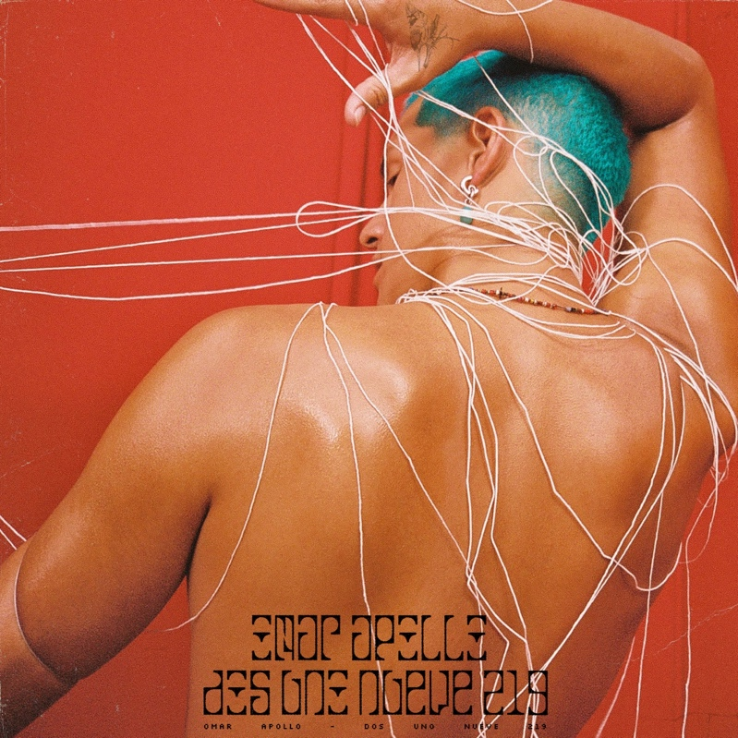

"sleek, soulful, heartache-infused love songs" - NPR

"A triple threat of an artist with plenty to offer" - Pitchfork

"lovelorn songs that reconcile the sultry sounds of D'Angelo, Prince, and Frank Ocean with Mexican soul and traditional corridos" - Rolling Stone

September 28, 2020 (Los Angeles, CA) - Shortly after releasing "Kamikaze" earlier this month, Omar Apollo is back to share a new song. "Dos Uno Nueve," titled 219 after the area code of his home state of Indiana, is the singer's fresh take on a classic Mexican corrido, with Apollo singing about his past hardships, his newfound success, and the growth yet to come. He performed the track live for the first time with Regional Mexican collective Yellow Room Music and members of the Los Angeles Philharmonic last week at Solidarity For Sanctuary, a festival in celebration of Selena, the Queen of Tejano music, meant to draw attention to the importance of voting, immigrant rights, and Black and Brown solidarity.

Speaking on the inspiration behind the song, Apollo says: “'219' is where I'm from and it will always have a place in my heart. Growing up, I dealt with a lot of obstacles that shaped my personality. My life is constantly changing; and as I’m adjusting to this new lifestyle of traveling, meeting people, and making music for a living, I’ll always love coming home to Indiana."

"Dos Uno Nueve" follows "Kamikaze" and the self-written and self-produced "Stayback," which The FADER called "his downright funkiest work to date," and which received a remix featuring Parliament-Funkadelic's Bootsy Collins.

Listen to "Dos Uno Nueve" above and stay tuned for more from Omar Apollo coming soon.

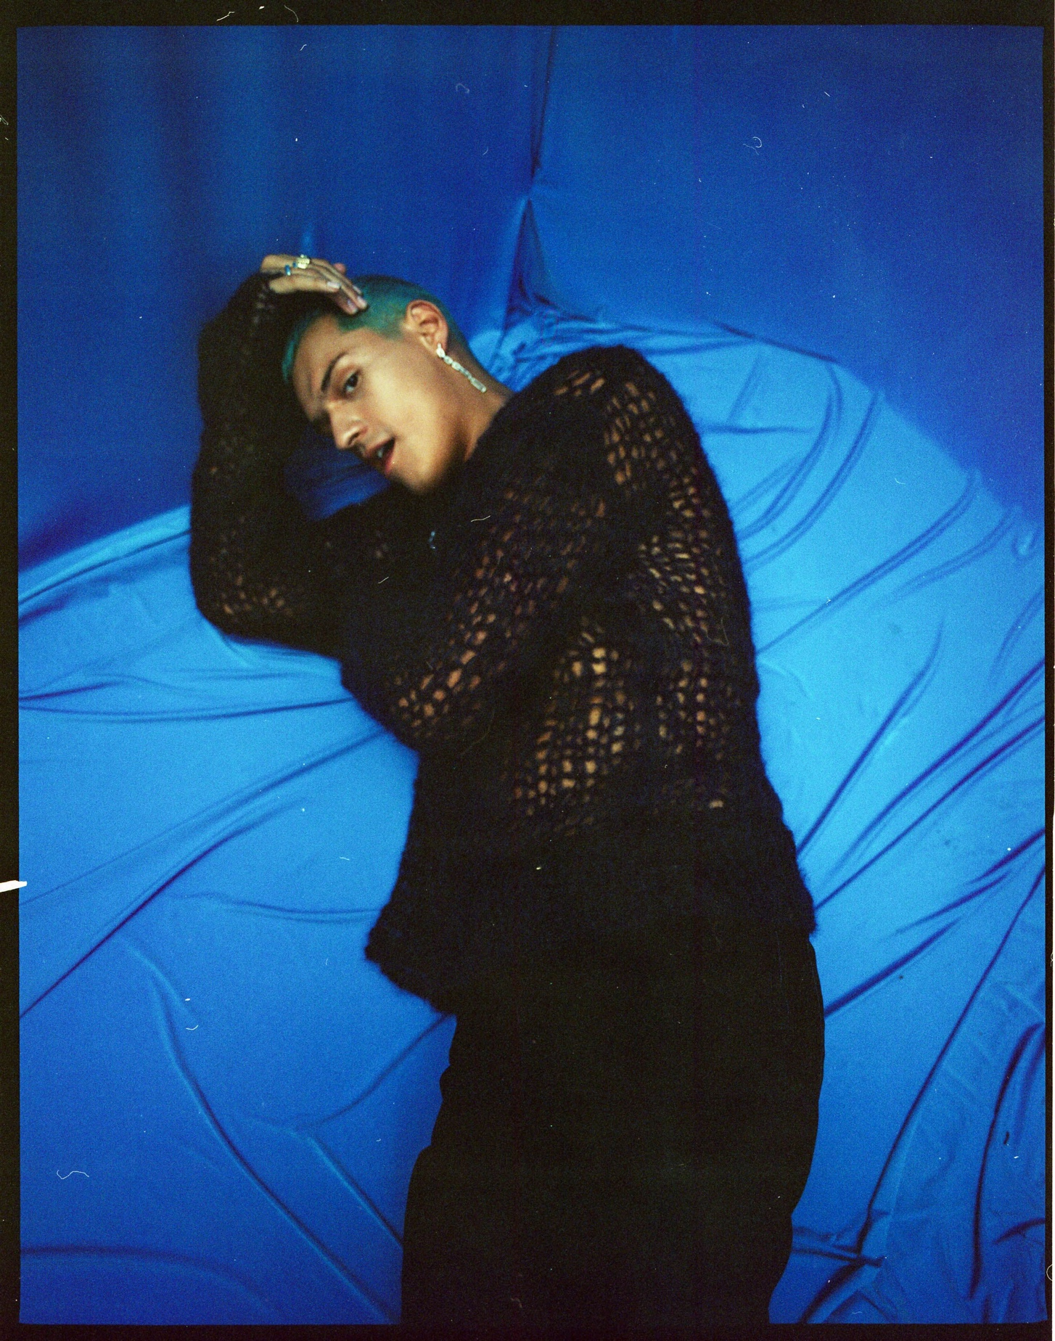

ABOUT OMAR APOLLO:

Since his 2018 critically-acclaimed debut EP Stereo, Omar Apollo has continued to ascend as an undeniable talent to watch, becoming one of today's brightest breakout stars and one of the most talked about new artists of the last couple of years. Last year he released his second EP Friends, and Rolling Stone named him an Artist You Need To Know, Pitchfork featured him as a Rising artist, he made his late-night television debut on Late Night with Seth Meyers, and he had two headlining North American tours which included stops at Tyler, The Creator's Camp Flog Gnaw Carnival and Tropicalía Festival. He was also part of YouTube's Foundry International artist development program, with past alumni including Cuco, ROSALÍA, Gunna, Chloe X Halle, and Dua Lipa. In late 2019, he released a pair of singles with Kenny Beats - "Frio" and "Hit Me Up" - the former showcasing Spanish lyrics and playing off of Dembow music, the latter of which featured Dominic Fike. More recently, he released "Imagine U" which was also co-produced by Kenny Beats and was described by Uproxx as "an alluring, melodic anthem about modern heartbreak."

Follow Omar Apollo:
Instagram | Twitter | Website | Press Site

For more information, please contact:
Yash Zadeh | Warner Records
Yashar.Zadeh@warnerrecords.com

