GLOBAL POP SUPERSTAR ANNE-MARIE RELEASES SOPHOMORE ALBUM ‘THERAPY’ - LISTEN HERE

VIDEO FOR NEW SINGLE “KISS MY (UH OH)” WITH
LITTLE MIX OUT NOW - WATCH HERE

GLOBAL LIVESTREAM THERAPY: THE LIVE EXPERIENCE ON AUGUST 7TH – TICKETS AVAILABLE HERE

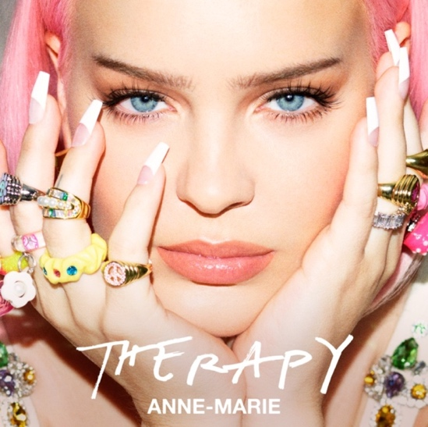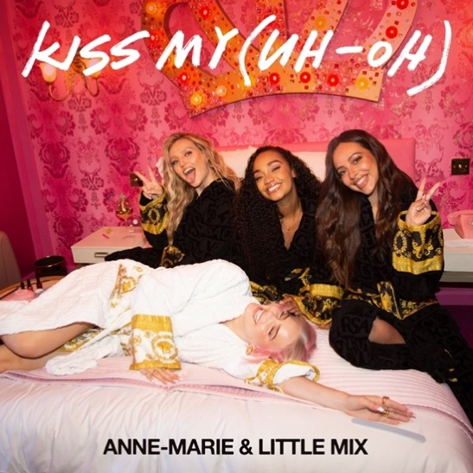

July 23, 2021 (Los Angeles, CA) – Global pop superstar Anne-Marie releases her highly anticipated sophomore album Therapy today via Warner Records – listen HERE. The album includes her new single “Kiss My (Uh-Oh)” with Little Mix. Anne-Marie and renowned girl group Little Mix reunite with director Hannah Lux Davis for the “Bridesmaids” inspired video. Brimming with laughter and chaos, the video trails the group of friends living life to the fullest – watch HERE.

A long-awaited collaboration that’s generated huge excitement amongst both Anne-Marie and Little Mix fanbases, “Kiss My (Uh Oh)” has all the ingredients to become the break-up anthem of summer ’21. Sampling Lumidee’s early 00’s R&B classic “Never Leave You (Uh Oh),” the slick production and all-out, empowering track documents the liberating feeling that comes with walking away from a toxic relationship - a narrative that has seen protagonist Anne-Marie earn huge success following the releases of “Ciao Adios,” “FRIENDS,” and “Alarm.”
Therapy is the follow-up to her multi-platinum 2018 debut, Speak Your Mind, which was the UK’s biggest-selling debut release of that year and spawned two global anthems – “2002,” written by Ed Sheeran, and the Marshmello collaboration “FRIENDS,” which reached #2 on the U.S. Top 40 Radio Charts. Therapy is a collection of twelve songs that embody Anne-Marie’s characterful artistry, self-effacing attitude, and beautiful honesty; attributes that have not only catapulted the Essex-born star to platinum status in the UK to the USA and everywhere in-between, but ones that have seen her reign supreme as a fearless Gen Z role model.

The album includes “Kiss My (Uh-Oh)” along with previously released collaborations “Our Song” with Niall Horan, "Way Too Long" with Nathan Dawe & Mostack, and "Don't Play" with KSI & Digital Farm Animals. Anne-Marie also teamed up with Ed Sheeran and Max Martin to co-write “Beautiful” which was released last week. Other co-writes on the album come from Kamille (Little Mix, Mabel), TMS (Dua Lipa, Lewis Capaldi), Blake Slatkin (The Kid Laroi, 24kGoldn), Plested (Lewis Capaldi), MNEK, Raye and Nathan Dawe.

Next up, Anne-Marie will launch her first-ever global livestream, Therapy: The Live Experience, on August 7. She’s promising an unforgettable set highlighted by fan favorites and anthems from Therapy. Tickets can be purchased – HERE.
Anne-Marie has become one of the globe’s most successful pop stars since her breakthrough in 2016. She has over 5 billion streams to her name, a platinum debut album alongside five Top 10 UK singles and two Billboard Hot 100 hits. She has garnered dozens of award nominations, sold out her global headline tour and supported Ed Sheeran in stadiums everywhere. In 2020, alongside charitable work and recording, Anne-Marie released her first-ever documentary titled ‘How To Be Anne-Marie’ exclusively with YouTube. She hasn’t slowed down in 2021, her January release "Don't Play" with KSI and Digital Farm Animals spent twelve weeks inside the Top 10 of the UK’s Official Singles Chart and is the biggest UK song of 2021 so far by a female artist, she collaborated with Nathan Dawe and MoStack on the feel-good "Way Too Long," Niall Horan on the epic collab “Our Song,” and made her debut as the new, and winning, judge on The Voice UK.
TRACKLISTING:
- x2
- Don’t Play (with KSI & Digital Farm Animals)
- Kiss My (Uh-Oh) (with Little Mix)
- Who I Am
- Our Song (with Niall Horan)
- Way Too Long (with Nathan Dawe & Mostack)
- Breathing
- Unlovable (with Rudimental)
- Beautiful
- Tell Your Girlfriend
- Better Not Together
- Therapy

Follow Anne-Marie
Official | Instagram | Twitter | Facebook | YouTube | Tik Tok | Press Materials

For more information, please contact:
Darren Baber | Warner Records
Darren.Baber@warnerrecords.com

