RISING POP STAR BENSON BOONE RELEASES
HEARTFELT NEW SINGLE “IN THE STARS” –
LISTEN HERE

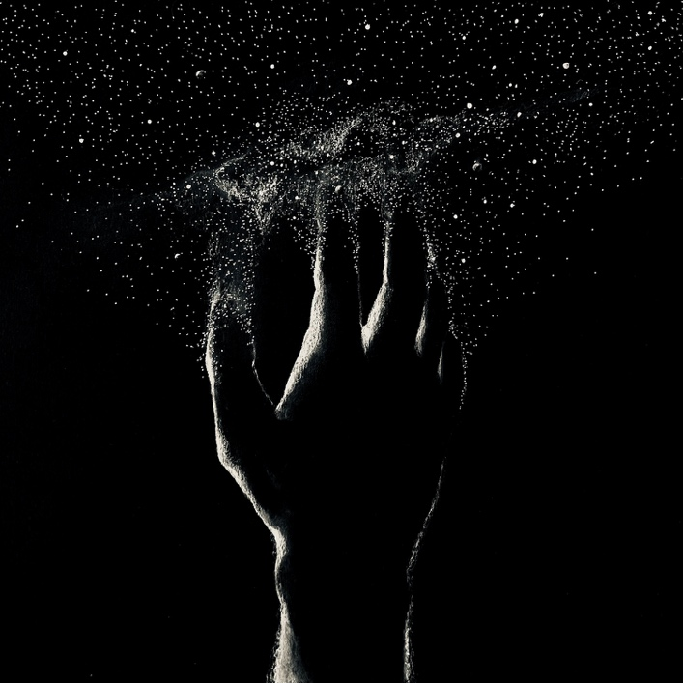

April 29, 2022 (Los Angeles, CA) – Today, breakout pop star Benson Boone returns with a heartfelt new single “In The Stars” out now via Night Street Records/Warner Records. Listen HERE. With the hand-drawn cover art and ability to evoke grief through his lyricism, the ballad finds Boone at his most vulnerable and authentic state.

The budding superstar opens the song with a trip down memory lane about a loved one that’s passed. “Sunday mornings were your favorite, I used to meet you down on Woods Creek Road,” he sings. Recalling his fond history, Boone continues to mourn his loss in the climactic chorus as he yearns, “Now you’re in the stars, and six feet’s never felt so far. Here I am alone between the heavens and the embers.”

About the song, Boone shared, “I wrote this song about losing someone that I loved very much. My great grandma was 97 years old and I was very close with her when she passed. This song is about all the beautiful memories that we hope to keep from our passed loved ones.”

“In The Stars” follows Boone’s previous feel-good release “ROOM FOR 2” and his international hit debut single “GHOST TOWN.” Inspired by a friend’s toxic relationship, “GHOST TOWN” was an instant streaming phenomenon. The soaring single charted in countries as widespread as Australia, Canada, Denmark, the UK, Sweden, and Norway, where it reached #1. In the US, it became the rising hitmaker’s first entry on the Billboard Hot 100 and entered Top 25 at both Top 40 and Hot AC radio.

The singer/songwriter—who was discovered and signed by Imagine Dragons superstar Dan Reynolds to Night Street Records in partnership with Warner Records—has previously delivered spectacular live renditions of “GHOST TOWN” on The Ellen DeGeneres Show, The Kelly Clarkson Show, and Late Night with Seth Meyers. Boone has garnered nearly 250M global streams to date, as well as praise from Billboard, who lauded his “restrained vocals” and Consequence, who dubbed the newcomer “an exciting new voice.” With the release of “In The Stars” and a music video coming soon, Boone is well on his way to becoming a household name.

Photo credit: Mark Owens

###

FOLLOW BENSON BOONE:
TikTok | Instagram | Twitter | Facebook | YouTube

For more information, please contact:
Darren Baber | Warner Records
Darren.Baber@warnerrecords.com

