DAVID GUETTA & MORTEN REWORK THE FLEETWOOD MAC
CLASSIC “DREAMS” FEATURING LANIE GARDNER

LISTEN HERE

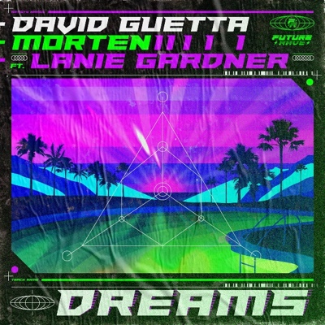

December 4th, 2020 (Los Angeles, CA) - After eight monstrous Future Rave collaborations racking up over 140 million streams, David Guetta and MORTEN are back with a rework of Fleetwood Mac’s all-time classic “Dreams,” featuring rising star Lanie Gardner. They bring the 1970’s standard onto the modern dancefloor, drenched with emotion. Guetta discovered Lanie’s cover of “Dreams” on YouTube which has over 7 million views and counting. He immediately fell in love with Lanie’s rendition and invited her to feature on the Future Rave remix. She delivered a powerful performance that is paired perfectly with David and Morten’s razor-sharp production.

Gardner’s smooth-as-silk, soulful vocal strains are drenched in sustained bass tones and a dizzying synth arpeggio that slowly reveals itself. The track builds powerfully and imperceptibly to its crescendo as a stuttering, bleeping riff cuts through the mix, recalling classic ‘90s trance bangers. The drop lays on a crisp beat, punctuating the brooding bass perfectly. Another enormous breakdown pushes us to the final stretch, where the groove and the vocals finally unite in an ecstatic release of tension.

This is Guetta’s first cover since 2014’s “Shot Me Down” featuring Skylar Gray — his rework of Nancy Sinatra’s sultry “Bang Bang,” which has amassed 760 million streams to date. This one has all the hallmarks of another Guetta smash with the addition of Danish DJ/Producer superstar MORTEN, and which looks set to introduce Fleetwood Mac’s classic to a new generation.

Guetta recently delivered an incredible set for the DJ Mag Top 100 DJs ceremony livestream, with every single track in his set produced or remixed by him. It marked a new era in his career, showing a huge global audience what his Future Rave sound is all about. The thousands of positive comments on the YouTube stream showed that he is winning many new fans as well as delighting old ones. His latest global smash “Let’s Love” with Sia recently hit #1 on the U.S. Dance Radio Chart, #2 on the European Radio Chart, #6 on the Shazam Global Chart and is nearing 100 million audio and video streams.

Follow David Guetta:
Official | Twitter | Instagram | Facebook | Press Materials

Follow MORTEN:
Official | Twitter | Instagram | Facebook

Follow Lanie Gardner:
Twitter | Instagram | Facebook

For all media inquiries, please contact:
Darren Baber / Warner Records
darren.baber@warnerrecords.com

