Release New Single “in the wake of your leave”

New Album angel in realtime. Out February 25th

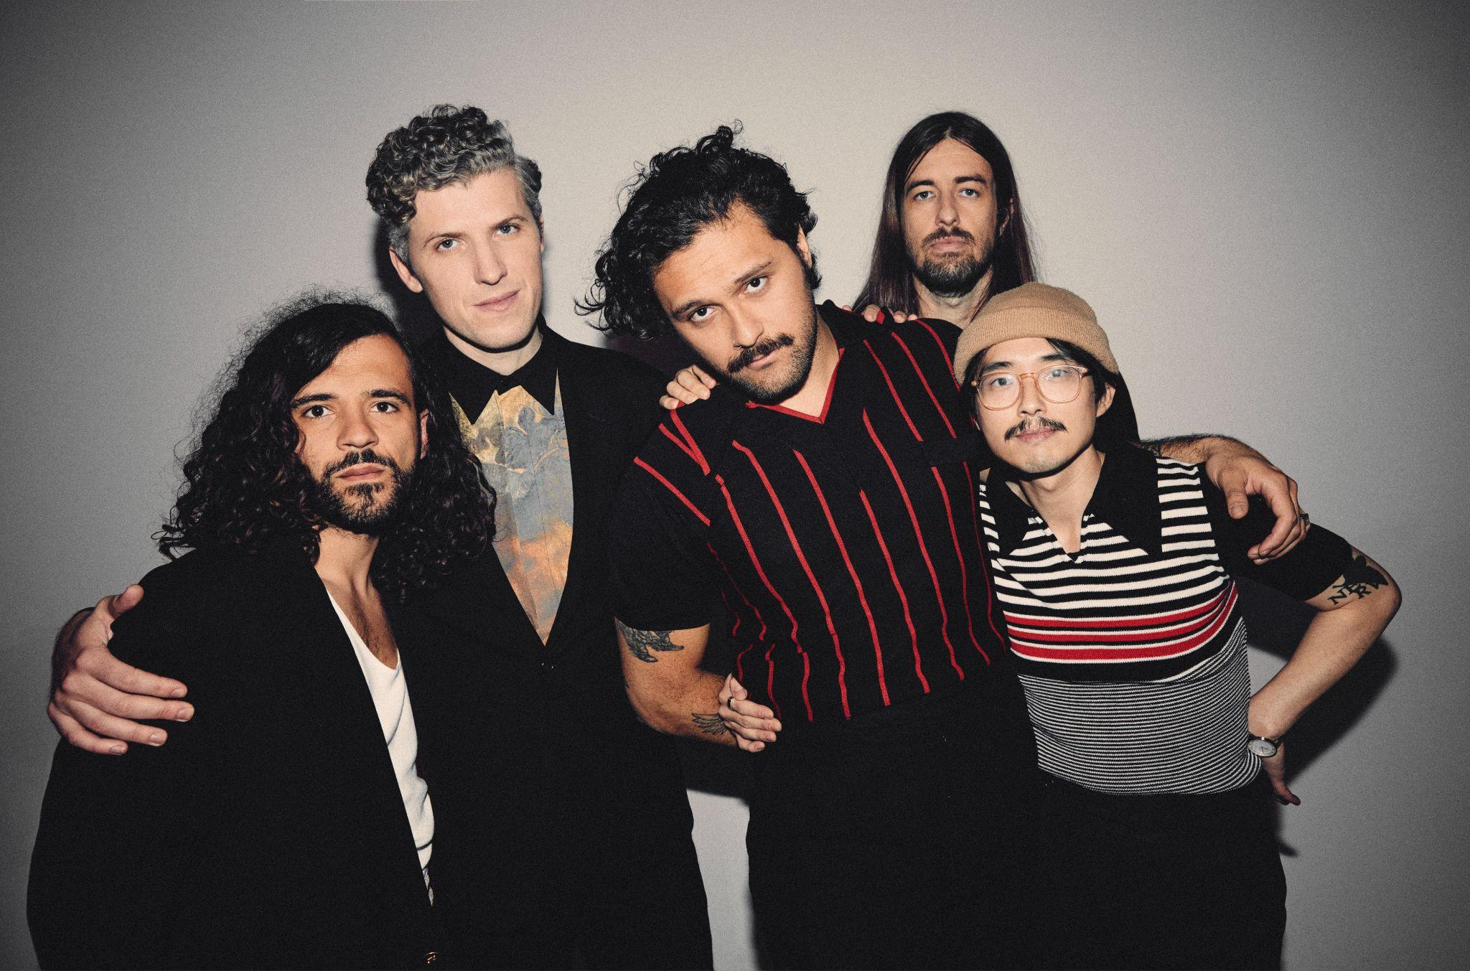
(Download high-res photo by Edward Cooke HERE)

January 7, 2022 -- (Los Angeles, CA.) -- Gang of Youths ended 2021 with a bang, returning to late night TV with their performance of “angel of 8th ave” on The Late Show with Stephen Colbert as well as a run of sold out shows overseas. Now the band again pick up the pace for a huge year ahead by sharing their new single “in the wake of your leave.” The track is the latest to build momentum ahead of the release of their highly anticipated new album angel in realtime. on February 25th. Listen here / watch the visualizer here.

Collectively, angel in realtime. charts the waves of emotions that flooded over frontman Dave Le’aupepe following the loss of his father. Overwhelmed, Le’aupepe uses songwriting as an eloquent and poignant outlet for his grief. “in the wake of your leave” converts sorrow into a song that burns with life-affirming, passion – from its exuberant rush to its bright, colossal melodies and its addictive, radio-friendly hook. And in one of the band’s most striking hallmarks, it still shimmers with a remarkable attention to detail: the elegiac backing harmonies of the Auckland Gospel Choir; the percussion provided by a collective of drummers from the Cook Islands.

Of the song, Dave Le’aupepe says, “I wanted to reflect on how I became dependent on grief for solace and inspiration. The cycle from numbness to acceptance to yearning plays a role in my approach to grieving my dad’s death. As a result, most of the time, I feel a bit futile as a person.”

The album’s conceptual themes are amplified by Gang of Youths’ ever more ambitious musical approach. Their influences range from American minimalism and contemporary classical, to drawing upon the legacy of Britain’s alternative/indie scenes, such as drum ‘n’ bass to the most transcendent moments of Britpop. It’s equally rooted in Le’aupepe’s Polynesian heritage, featuring samples from David Fanshawe’s recordings of indigenous music from the Polynesian islands and the wider South Pacific, as well as contributions from a cast of talented Pasifika and Māori vocalists and instrumentalists.

angel in realtime. is available to pre-order here. Formats include digital, double white vinyl and CD, while HMV and select independent stores offer a special edition of the vinyl which feature an alternate cover. Gang of Youths recently filmed live versions of album track “the man himself” as well as fan favorite “Magnolia” from the band’s 2015 debut album, The Positions. Gang of Youths recently announced a North American tour in April and May ahead of summer festival season.

“Gang of Youths is one of the best live acts doing the rounds right now. One of the best rock bands, period.” - Billboard

“A band who always swing for the fences.” – The Guardian

“Le’aupepe has embraced indigenous music native to his family’s Polynesian culture, as well as the hip-hop and dance sounds that he grew up on.” – UPROXX

angel in realtime. tracklist:

- you in everything
- in the wake of your leave
- the angel of 8th ave.
- returner
- unison
- tend the garden
- the kingdom is within you
- spirit boy
- brothers
- forbearance
- the man himself
- hand of god
- goal of the century

2022 North American tour dates:
Apr 21: Madison, WI Majestic Theatre
Apr 22: Indianapolis, IN The Vogue
Apr 24: Columbus, OH Newport Music Hall
Apr 25: Louisville, KY Mercury Ballroom
Apr 27: Carrboro, NC Cat’s Cradle
Apr 28: Charlotte, NC The Underground
May 1: Nashville, TN The Basement East
May 3: Chicago, IL Metro
May 4: Detroit, MI Shelter
May 6: Toronto, ON Danforth Music Hall
May 7: Montreal, QC L’Astral
May 9: Boston, MA Paradise Rock Club
May 10: Brooklyn, NY Brooklyn Steel
May 12: Philadelphia, PA Theatre of the Living Arts
May 13: Washington, DC Union Stage
May 16: San Francisco, CA The Fillmore
May 18: Los Angeles, CA Belasco Theater
May 20: Las Vegas, NV 24 Oxford
May 21: Phoenix, AZ Crescent Ballroom
May 23: Austin, TX Scoot Inn
May 24: Dallas, TX The Echo Lounge & Music Hall
May 26: Tulsa, OK Cain’s Ballroom

Sep 13: Milwaukee, WI The Rave II
Sep 14: Minneapolis, MN First Avenue - Mainroom
Sep 16: St. Louis, MO Delmar Hall
Sep 17: Lawrence, KS The Bottleneck
Sep 19: Englewood, CO Gothic Theatre
Sep 20: Salt Lake City, UT Urban Lounge
Sep 22: Portland, OR Revolution Hall
Sep 23: Vancouver, BC Rickshaw Theatre
Sep 25: Seattle, WA Neumos
Sep 27: Sacramento, CA Ace of Spades

Contacts:
Grandstand Media
Kate Jackson katej@grandstandhq.com
Katie Nelson katien@grandstandhq.com

Warner Records
Rick Gershon Rick.Gershon@warnerrecords.com
Jenny Huynh Jenny.Huynh@warnerrecords.com

Follow Gang of Youths:
Official website | Instagram | Facebook | Twitter | Spotify | Apple Music | YouTube | Tik Tok | Press Materials

