Share their new track “spirit boy”
Listen HERE

From the eagerly anticipated new album
angel in realtime. out on Friday, February 25

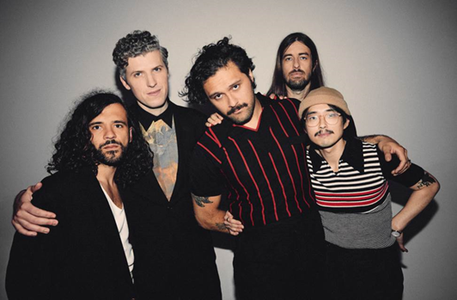
(Click here for Hi-res image by Ed Cooke)

February 23, 2022 – (Los Angeles, CA.) – Today, Gang of Youths provide a final taster of the album angel in realtime. before its release on Friday, sharing the brand-new track “spirit boy.” The band’s last single “in the wake of your leave,” has debuted on the Billboard AAA charts and was praised by BBC’s Jack Saunders as “one of the most stunning examples of just how good their new record is going to be.” The band’s current rising status has also included a string of sold-out headline shows, an arena tour with Sam Fender, and a NME cover feature. Click HERE to stream “spirit boy.”

The album features all the big moments that have soundtracked Gang of Youths’ rise, including “the angel of 8th ave.,” “unison,” “the man himself,” “tend the garden,” and “in the wake of your leave.” The album’s previously unreleased tracks provide plenty more, with an experimental hybrid of contemporary American minimalism, and electronica on “you in everything,” the 2-step and big beat rhythms of “the kingdom is within you,” and the cathartic conclusion provided by the sweeping, multi-textured “goal of the century.”

New single “spirit boy” is the beating heart of angel in realtime. The song features Shane McLean, a musician specializing in Taonga Pūoro (the traditional instrumentation and music culture of the Māori people) and contributes spoken word. Le’aupepe recalls:

“We were fortunate to have Shane McLean, an outstanding musician and Taonga Pūoro facilitator, write and perform a spoken verse in Te Reo Māori. A wonderful Māori woman performed “rongoā” on me — a sacred healing practice. It was a transformative experience, and I’m still not quite sure why. There was a moment when this wonderful woman looked at me and said “you’re a wairua boy” — wairua in Te Reo means something like “spirit”.

Dave Le’aupepe has channelled every drop of emotion into Gang of Youths’ most personal album to date. For the band, which features multi-instrumentalists Jung Kim, Tom Hobden, Max Dunn and Donnie Borzestowski, the decision to rent an old warehouse space in Hackney, London and self-produce the record was absolutely vital.

The record also pays tribute to Le’aupepe’s family heritage, firstly with the band’s pre-pandemic trip to Aotearoa to record with Pasifika and Māori instrumentalists the Anuanua Drummers from the Cook Islands, Shane McClean and the Auckland Gospel Choir. These recordings, together with the extensive sampling of composer and explorer David Fanshawe’s late 1970s field recordings of indigenous Pasifika music give the record a distinctive sense of time and place. When you add to this the 42-piece string section Hobden and Le’aupepe travelled to Budapest to record, the album effectively spans 50 years of collective recording and as many as 7 countries.

angel in realtime. includes other singles such as Top 10 US Radio hit “the angel of 8th ave.”, and “the man himself” and the most recent track “in the wake of your leave.” Collectors and hardcore fans can grab a double-white vinyl edition of the album with an alternate sleeve from key indie stores, or a selection of bundles and merch which are packaged with a signed art card.

Gang of Youths will commence a major North American tour in April. Tickets are on sale now and a full rundown of dates can be found below.

2022 North American tour dates:
Apr 21: Madison, WI Majestic Theatre
Apr 22: Indianapolis, IN The Vogue
Apr 24: Columbus, OH Newport Music Hall
Apr 25: Louisville, KY Mercury Ballroom
Apr 27: Carrboro, NC Cat’s Cradle
Apr 28: Charlotte, NC The Underground
May 1: Nashville, TN The Basement East
May 3: Chicago, IL Metro
May 4: Detroit, MI Shelter
May 6: Toronto, ON Danforth Music Hall
May 7: Montreal, QC L’Astral
May 9: Boston, MA Paradise Rock Club
May 10: Brooklyn, NY Brooklyn Steel
May 12: Philadelphia, PA Theatre of the Living Arts
May 13: Washington, DC Union Stage SOLD OUT
May 16: San Francisco, CA The Fillmore
May 18: Los Angeles, CA Belasco Theater
May 20: Las Vegas, NV 24 Oxford
May 21: Phoenix, AZ Crescent Ballroom
May 23: Austin, TX Scoot Inn
May 24: Dallas, TX The Echo Lounge & Music Hall
May 26: Tulsa, OK Cain’s Ballroom

Sep 13: Milwaukee, WI The Rave II
Sep 14: Minneapolis, MN First Avenue - Mainroom
Sep 16: St. Louis, MO Delmar Hall
Sep 17: Lawrence, KS The Bottleneck
Sep 19: Englewood, CO Gothic Theatre
Sep 20: Salt Lake City, UT Urban Lounge
Sep 22: Portland, OR Revolution Hall
Sep 23: Vancouver, BC Rickshaw Theatre
Sep 25: Seattle, WA Neumos
Sep 27: Sacramento, CA Ace of Spades

angel in realtime. tracklist:

- you in everything
- in the wake of your leave
- the angel of 8th ave.
- returner
- unison
- tend the garden
- the kingdom is within you
- spirit boy
- brothers
- forbearance
- the man himself
- hand of god
- goal of the century

Contacts:

Grandstand Media
Kate Jackson katej@grandstandhq.com
Katie Nelson katien@grandstandhq.com

Warner Records
Rick Gershon Rick.Gershon@warnerrecords.com
Jenny Huynh Jenny.Huynh@warnerrecords.com

Follow Gang of Youths:
Official website | Instagram | Facebook | Twitter | Spotify | Apple Music | YouTube | Tik Tok
Press Materials

