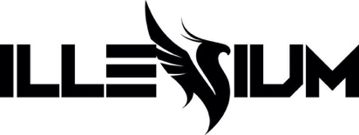
ILLENIUM REUPS & RECHARGES FALLEN EMBERS WITH DELUXE EDITION – LISTEN HERE
FEATURES 5 NEW TRACKS INCLUDING “WOULDN’T CHANGE A THING” FEATURING THIRTY SECONDS TO MARS

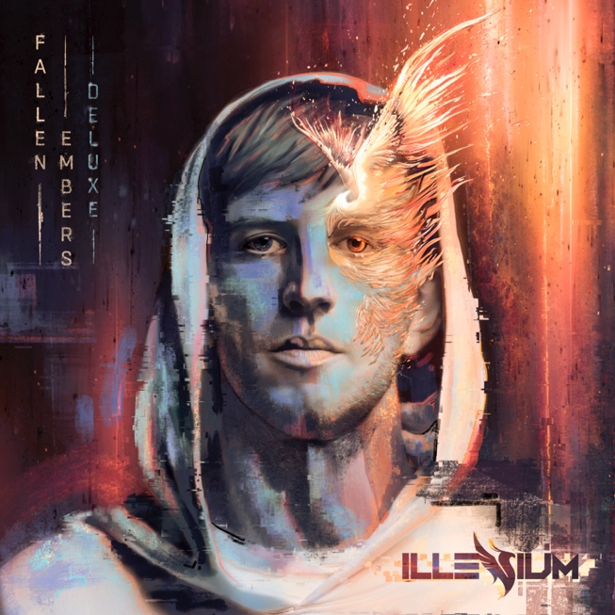
October 22, 2021 (Los Angeles, CA) – Today, multiplatinum cross-genre phenomenon, artist, producer, and DJ ILLENIUM unveils the Deluxe Edition of his 2021 fourth full-length album, FALLEN EMBERS via Warner Records – listen HERE. This marks ILLENIUM’s inaugural release under his newly minted deal with Warner Records.

For the Deluxe Edition, he notably reupped, reloaded, and recharged this opus with five new songs, including the previously released single “Wouldn’t Change A Thing” [feat. THIRTY SECONDS TO MARS] – which marked the first new music from THIRTY SECONDS TO MARS in three years. The song has already garnered over 1 million streams and counting since its release last Friday.

Among the new material, Virtual Riot expands “Blame Myself” [with Tori Kelly] with a new Remix, heightening the tension and release with an unpredictable glitchy breakdown. From the frenetic bounce of “Hurt Like This” to the guitar-laden crunch of “Superhero,” ILLENIUM presents the most complete and comprehensive vision of Fallen Embers now.

Continuing a historic run of dates this year, ILLENIUM takes over Masonic Temple Theatre in Detroit, MI as part of his latest headline tour. This leg will be highlighted by a four-night stand at Bill Graham Civic Auditorium in San Francisco November 24-28 and back-to-back shows at The Armory in Minneapolis, MN December 10-12.

Check out the full confirmed itinerary below.

Tallying over 400 million streams, the original FALLEN EMBERS boasted a series of anthems, including “Nightlight” (150M global streams), “Hearts on Fire” with Dabin feat. Lights (60M global streams), “First Time” feat. iann dior (50M global streams), “Sideways” with Valerie Broussard and Nurko (25M global streams), and “Heavenly Side” with Matt Maeson (5M global streams).

Impressively, his career total streams have now eclipsed 5 billion and counting.
Earlier this year, ILLENIUM performed a four-set show at The Las Vegas Raiders’ Allegiant Stadium, making him the first artist to ever perform at the venue. The first three sets at the show commemorated his previous 3 albums – Ashes, Awake, and Ascend. The night ended with a final set, bringing closure to the story of the previously mentioned albums and starting a new one with Fallen Embers. Throughout the summer, he also shined at festivals such as Lollapalooza, Breakaway Music Festival, Life Is Beautiful, and more.
Now, he illuminates electronic music brighter than ever with Fallen Embers Deluxe Edition and much more to come.
Get ready!
FALLEN EMBERS (DELUXE) TRACKLISTING:
- Wouldn’t Change A Thing (feat. Thirty Seconds To Mars)
- Blame Myself (feat. Tori Kelly) [ILLENIUM & Virtual Riot Remix]
- Hurts Like This (feat. Banners)
- Superhero (feat. William Black & Alna)
- I See You (feat. Said The Sky)
- Blame Myself (feat. Tori Kelly)
- Heavenly Side (feat. Matt Maeson)
- Fragments (feat. Natalie Taylor)
- Sideways (feat. Valerie Broussard & Nurko)
- First Time (feat. iann dior)
- U & Me (feat. Sasha Sloan)
- Nightlight (feat. Annika Wells)
- Hearts on Fire (feat. Dabin & Lights)
- Lay It Down (feat. Krewella & SLANDER)
- Losing Patience (feat. nothing,nowhere.)
- In My Mind (feat. Excision & HALIENE)
- Paper Thin (feat. Tom DeLonge, Angels & Airwaves)
- Crazy Times (feat. Said The Sky & Rock Mafia)
- Brave Soul (feat. Emma Grace)

TOUR DATES
10/29 San Diego, CA Dream Eaters
11/6 Los Angeles, CA Head In The Clouds Festival
11/24 San Francisco, CA Bill Graham Civic Auditorium
11/26 San Francisco, CA Bill Graham Civic Auditorium
11/27 San Francisco, CA Bill Graham Civic Auditorium
11/28 San Francisco, CA Bill Graham Civic Auditorium
12/03 Cancun, Mexico Ember Shores
12/09 Kansas City, MO Cable Dahmer Arena
12/10 Minneapolis, MN The Armory
12/11 Minneapolis, MN The Armory
12/12 Minneapolis, MN The Armory
12/30 Dallas, TX Lights All Night
12/30 Philadelphia, PA Hijinx Festival

Photo credit: Brian Ziff

Follow ILLENIUM:
Official | Instagram | Twitter | Tik Tok | YouTube | Press Materials

For more information, contact:
Darren Baber | Warner Records
Darren.Baber@warnerrecords.com

Regional: Jenny Huynh | Warner Records
Jenny.Huynh@warnerrecords.com

