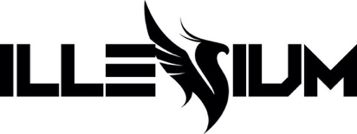
GRAMMY® AWARD NOMINATED ILLENIUM TELLS THE
“STORY OF MY LIFE” ON NEW SINGLE FEATURING SUECO & TRIPPIE REDD – LISTEN HERE

RECEIVES FIRST CAREER GRAMMY® AWARD NOMINATION FOR FALLEN EMBERS IN BEST DANCE/ELECTRONIC ALBUM CATEGORY

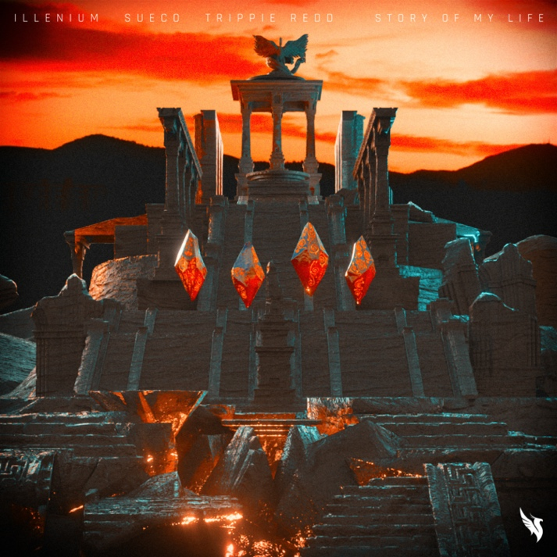
December 3, 2021 (Los Angeles, CA) – Today, GRAMMY® Award-nominated multiplatinum cross-genre phenomenon, artist, producer, and DJ ILLENIUM & Sueco unleash a new single entitled “Story of My Life” [feat. Trippie Redd] via Warner Records – listen HERE. Watch the visualizer HERE.

He initially started to perform the track live earlier this year, and it’s already become a fan favorite. He further stoked anticipation for its official release by sharing the Heavy Edit on Wednesday. On the track, glassy guitar echoes through ILLENIUM’s instantly recognizable and ethereal production. Sueco carries a hypnotic melody before the chantable chorus takes hold and Trippie Redd pulls up with an otherworldly and emotionally charged cameo of his own.

In other big news, ILLENIUM garnered his first-ever GRAMMY® Award nomination in the category of Best Dance/Electronic Album. To date, the record has gathered 400 million cumulative streams and counting. It follows on the heels of his nod for Favorite Electronic Artist at the American Music Awards.

This weekend, he headlines his own sold-out Ember Shores Festival in Cancun, Mexico. This ILLENIUM-led extravaganza kicks off tonight and concludes Sunday December 5th. He recently headlined a sold out four-night stand at Bill Graham Civic Auditorium in San Francisco November 24-28 and will perform a trio of shows at The Armory in Minneapolis, MN December 10-12. Throughout the summer, he shined at festivals such as Lollapalooza, Breakaway Music Festival, Life Is Beautiful, and more.

Dancing Astronaut summed up his year best, “It seems ILLENIUM is on a mission to make an unassailable case for Artist of the Year in 2021.”

ILLENIUM recently unveiled the Deluxe Edition of his 2021 fourth full-length album, FALLEN EMBERS via Warner Records – listen HERE. It marked ILLENIUM’s inaugural release under his newly minted deal with Warner Records. For the Deluxe Edition, he notably reupped, reloaded, and recharged this opus with five new songs, including “Wouldn’t Change A Thing” [feat. THIRTY SECONDS TO MARS] – which marked the band’s first new music from THIRTY SECONDS TO MARS in three years. The song has already garnered over 10 million streams and counting. Impressively, his career total streams have now eclipsed 5 billion and counting.

TOUR DATES
12/03 Cancun, Mexico Ember Shores
12/09 Kansas City, MO Cable Dahmer Arena
12/10 Minneapolis, MN The Armory
12/11 Minneapolis, MN The Armory
12/12 Minneapolis, MN The Armory
12/30 Dallas, TX Lights All Night
12/30 Philadelphia, PA Hijinx Festival

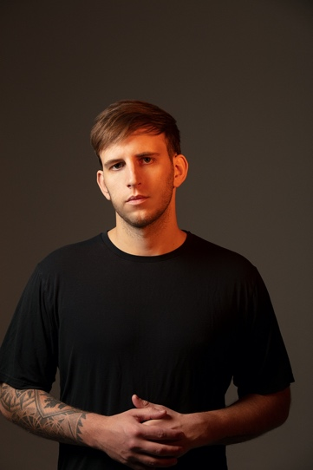
Photo credit: Brian Ziff

Follow ILLENIUM:
Official | Instagram | Twitter | Tik Tok | YouTube | Press Materials

For more information, contact:
Darren Baber | Warner Records
Darren.Baber@warnerrecords.com

Regional: Jenny Huynh | Warner Records
Jenny.Huynh@warnerrecords.com

