MASTER KG, DAVID GUETTA & AKON
JOIN FORCES FOR THEIR NEW SINGLE “SHINE YOUR LIGHT”
LISTEN HERE

FOLLOW UP TO MASTER KG’S GLOBAL PHENOMENON “JERUSALEMA”

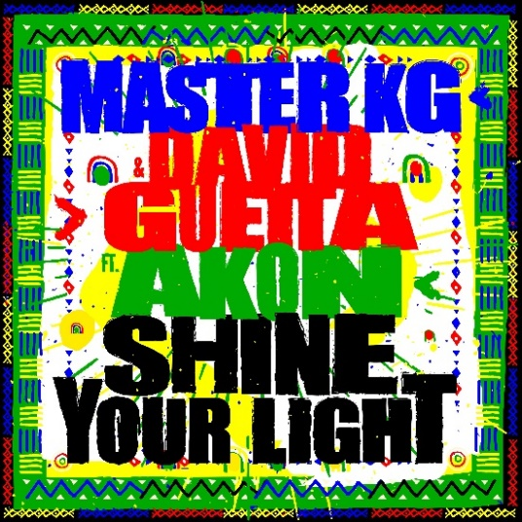

May 28, 2021 (Los Angeles, CA) – Producer, songwriter and DJ Master KG joins forces with David Guetta and Akon for brand new track “Shine Your Light,” out today via Warner Records – listen HERE.

On “Shine Your Light,” Master KG and David Guetta have spun a fresh approach to the feel-good blend of uplifting lyricism, exuberant Afro-house rhythms and sun-kissed vibes that made Master KG’s global phenomenon “Jerusalema” so memorable around the world. The jubilant atmosphere of the song is enhanced with Akon’s signature touch, singing “having a good time dancing and laughing,” he gets to the heart of the song with his uplifting lyrics and flawless delivery.

Of “Shine Your Light,” Master KG says, “I am blessed and excited to have collaborated with not one but two legends in David Guetta and Akon. ‘Shine Your Light,’ is special for me because it not only combines our different styles of music, but also spreads a positive message. Join us as we unite the world with love through music once again. Wanitwa Mosss”

David Guetta adds, “I am thrilled to have been able to collaborate with Master KG, and I’m so pleased to get to work with my long-time friend Akon again! My hope is that ‘Shine Your Light’ brings joy to listeners around the world as we join each other on the dance floor once again.”

In 2019, Master KG released his viral hit “Jerusalema,” which went on to accumulate 800 million combined streams worldwide, as well as 7 billion views on TikTok for its vibrant dance challenge, becoming a global cultural phenomenon. The viral movement captured the imagination of people everywhere from Angola to Israel to Italy and iconic stars such as Cristiano Ronaldo and Janet Jackson showed support. The South African president Cyril Ramaphosa even encouraged his nation to join the fun. The success of “Jerusalema” propelled the producer, songwriter from the innovator of Bolobedu, a South African twist on house music, to a major force in music. He has taken African culture to new audiences with “Jeruselema,” powering to #1 on the global Shazam chart for 8 weeks and hitting the Top 5 on European airplay charts. He won International Song of the Year at the NRJ Music Awards where he was also nominated for Best International Newcomer. He also won the 2020 EMA for Best African Act and was nominated at the UK’s MOBO Awards.

David Guetta is one of music’s biggest names with over 51 million monthly listeners on Spotify. He has delivered a succession of global hits including “Titanium” featuring Sia, “Hey Mama” featuring Nicki Minaj, Bebe Rexha & Afrojack, and “Sexy Chick” featuring Akon. “Titanium” alone has exceeded a billion streams. David has won two Grammy Awards and has collaborated the biggest names in music with everyone from Justin Bieber to Rihanna and Avicii.

R&B singer Akon broke globally in the early 2000s with smash hits such as “Lonely,” “Smack That” and “I Wanna Love You” and has garnered over 45 million album sales and five Grammy nominations. He has also made over 300 guest features for global icons including Michael Jackson, Lady Gaga, Eminem and more.

# # #

Follow Master KG
Instagram | Twitter | YouTube | Facebook | TikTok

Follow David Guetta
Instagram | Twitter | YouTube | Facebook | TikTok

Follow Akon
Instagram | Twitter | YouTube | Facebook | TikTok

For more information, contact:
Darren Baber | Warner Records
Darren.Baber@warnerrecords.com

Max Frieser | Infamous PR
mfrieser@infamouspr.com

Carling Farley | Infamous PR
cfarley@infamouspr.com

