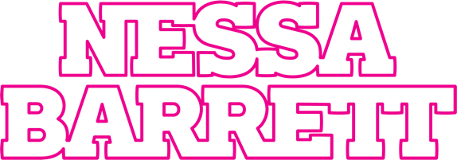

DARK POP’S NEW QUEEN NESSA BARRETT SERVES UP DEBUT PRETTY POISON EP
SET TO PERFORM BREAKING SINGLE “i hope ur miserable until ur dead” ON LATE NIGHT WITH SETH MEYERS ON SEPT. 15th

LOS ANGELES AND NEW YORK FALL CONCERT DATES SOLD OUT!

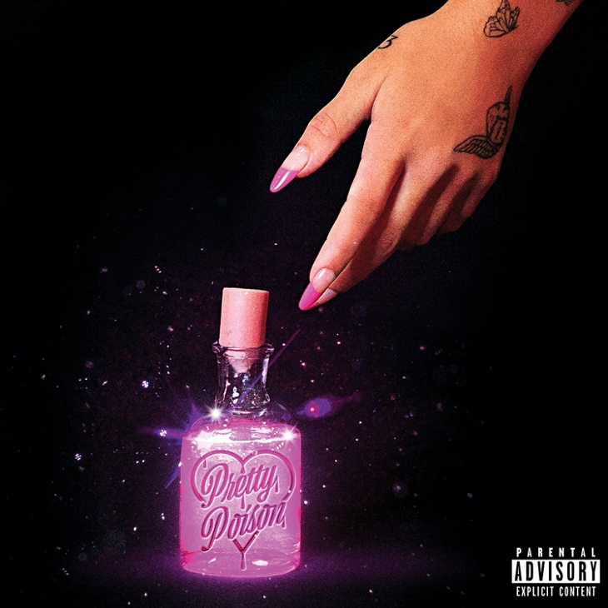
September 10, 2021 (Los Angeles, CA) – It’s finally here! Rising singer-songwriter and dark pop’s new queen Nessa Barrett reveals her anxiously awaited debut pretty poison EP today via Warner Records. Listen to pretty poison—HERE. Along with the EP, Nessa unveils a hot accompanying visual for “keep me afraid” – watch the video HERE.

The pretty poison EP is preceded by the rapidly breaking single “i hope ur miserable until ur dead.” Right out of the gate, it was at #8 on Spotify and trended at #9 on YouTube in addition to debuting in the Top 40. Not to mention, she made her very first entry on the Billboard Hot 100. Upon impact, it also stood out as the #1 Most Added at Alternative Radio and is rapidly climbing the chart ahead of its Top 40 impact on September 13th.

To celebrate the arrival of the EP, Nessa Barrett will deliver what promises to be an unforgettable performance of “i hope ur miserable until ur dead” on NBC’s Late Night with Seth Meyers on Wednesday, September 15. Be sure to tune in!

Additionally, she has sold out all of her upcoming debut tour dates in Los Angeles and New York in November. Check out the itinerary below.

Fall under the spell of Nessa’s pretty poison now…

About the EP, Nessa shared, “‘pretty poison’ tells the story of my life over the past year since moving to LA, experiencing fame & dealing with social media, toxic friendships/relationships, my mental health & personal struggles and falling in love with someone who really understands me. i’ve been working so hard on the music, visuals & have put my heart/soul into this project. so excited to finally share it with the world!”

These seven tracks show every side of her. Illuminating the scope of her signature style, she leans into a lullaby melody on the darkly catchy “grave,” while “i wanna die” feels tailormade for the closing credits of a classic nineties slasher flick. Her jazzy intonation adds raw emotion to “scare myself” as she admits, “Sometimes I even scare myself.” Over wobbling distortion on the title track “pretty poison,” she urges, “Say my name, say my name like you know it’s holy.”

Meanwhile, she continues to attract critical acclaim. Of “i hope ur miserable until ur dead,” Ones To Watch claimed it’s “a track more than ready to cement the rapidly rising star as the next vicious pop-punk star.” The Line of Best Fit recently hailed Nessa as “On The Rise,” going on to rave, “She is the architect of her own, grunge-indebted netherworld, leaning into the pop-punk revival close enough to brush shoulders with it, and yet retaining an extraordinary sense of self that belies her nineteen years.”

Nessa broke out big this year with her collaboration with jxdn “la di die,” produced by the legendary Travis Barker. The hit single has amassed over 200 million streams, cracked the Top 15 at alternative radio and reached #27 at top 40 radio. The duo made their late-night television debut performance with “la di die” on Jimmy Kimmel Live! and also performed on The Ellen Degeneres Show. The song has received widespread acclaim from MTV, Elite Daily, Buzzfeed and Nylon declared, “As the last line of ‘la di die’ says: She’s gonna be a superstar.”

TOUR DATES:
11/5 Los Angeles, CA Moroccan Lounge (SOLD OUT)
11/6 Los Angeles, CA Moroccan Lounge (SOLD OUT)
11/15 Brooklyn, NY Baby’s All Right (SOLD OUT)
11/16 Brooklyn, NY Baby’s All Right (SOLD OUT)

pretty poison TRACKLISTING

- pretty poison
- keep me afraid
- i hope ur miserable until ur dead
- grave
- scare myself
- i wanna die
- sincerely
# # #

Follow Nessa Barrett:
Official | Instagram | Twitter | Facebook | YouTube | Press Materials

Nessa Barrett contact:
Darren Baber | Warner Records
Darren.Baber@warnerrecords.com
