SOFÍA VALDÉS SHARES NEW SINGLE “WISH YOU WELL”

NORTH AMERICAN TOUR WITH BOY PABLO THIS FALL

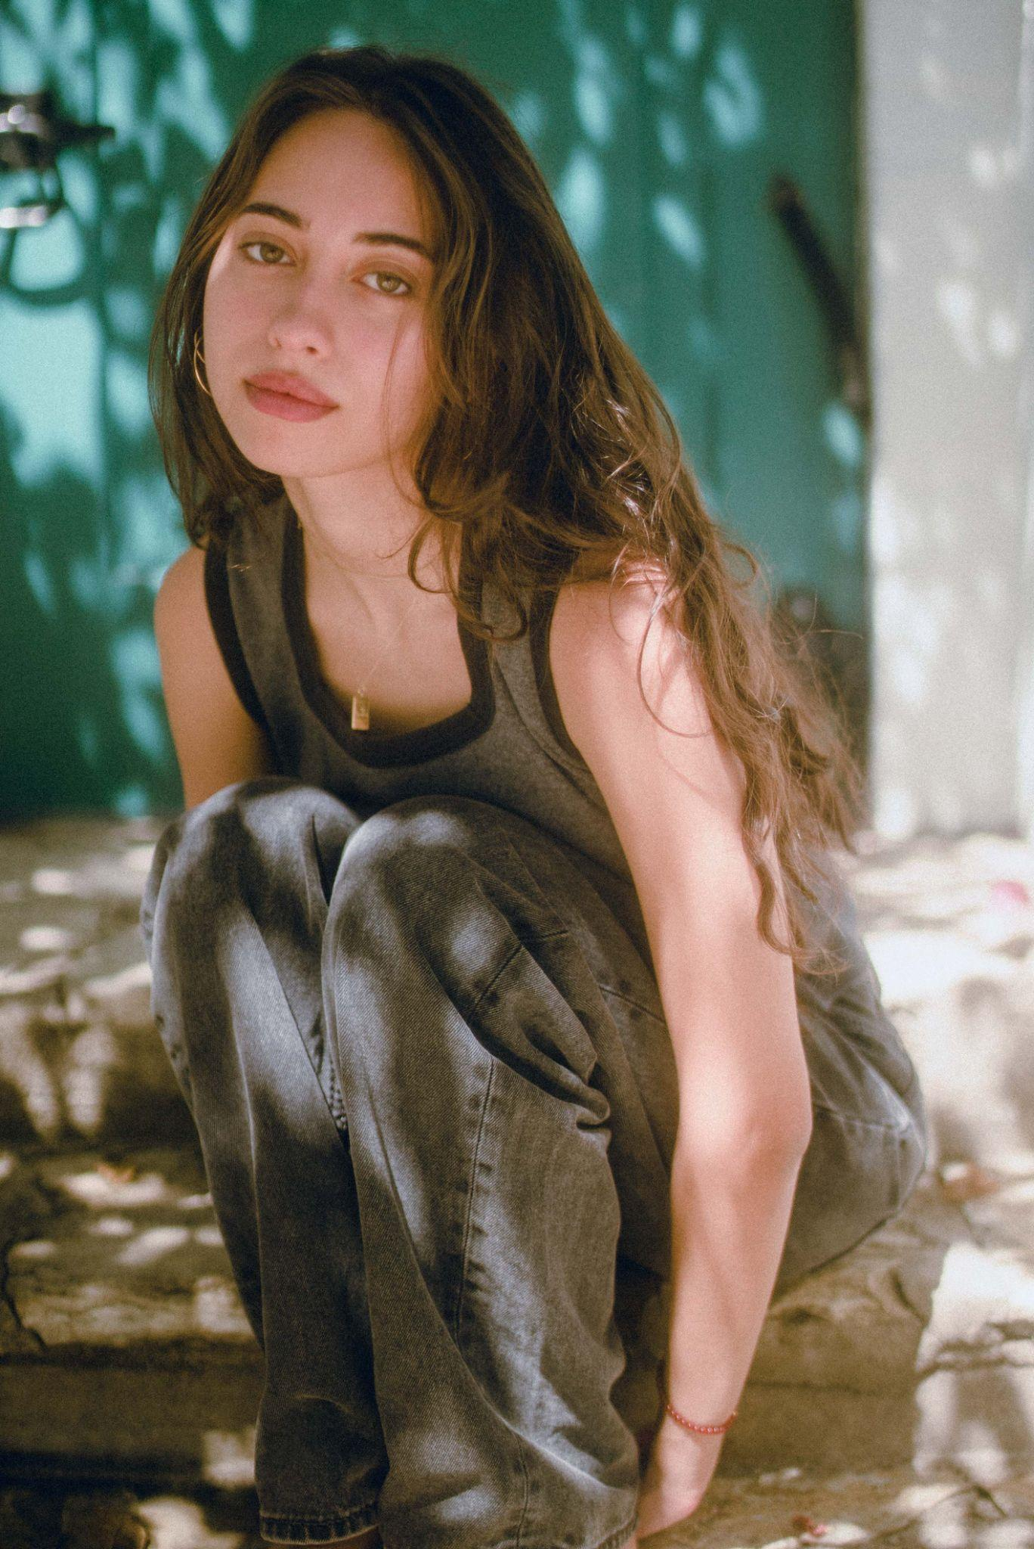

“an eclectic singer-songwriter who’s a total vibe.” - BILLBOARD

“Valdés crafts music that feels like it was somehow made using beach sand and turquoise water, her voice a comforting breeze over smooth melodies.” - INTERVIEW MAGAZINE

“Valdés’ music is often subtle, calm—cozy, even. But still waters run deep.” - AMERICAN SONGWRITER

September 24, 2021 (Los Angeles, CA) – Following her debut EP Ventura, Panamanian singer/songwriter Sofía Valdés releases a new single today, “Wish You Well” via Warner Records. The dynamic new track comfortably sits within the familiarly dreamy world of Valdés’ own creation. Nodding to the flowing spirit of her last project Ventura, Sofía shares the darker side of friendships through her cheeky lyricism. “Wish you well is about a close friend of mine in a moment where I had felt betrayed by them. I don’t feel that way about them but it was written about that moment in anger, those 30 minutes while writing this song it where a full release/let go process for me. It’s about someone you grow up with and then you grow apart when you felt like you were going to be together forever. P.s (I don’t want anyone to burn in hell, that line was meant to be a joke but we never took it off the song),” says Sofía. Coming off the heels of North American festival performances at Lollapalooza, Austin City Limits, and Outside Lands, Valdés will join Boy Pablo for their North American tour this fall - full list of dates below.

A 20-year-old singer/songwriter born and bred in Panama, Sofía Valdés creates the kind of emotionally honest and beautifully original pop music that could only come from years of exploration. On her debut EP Ventura, Valdés alchemizes those inspirations into a sound all her own, gracing each track with her indelible songwriting and beguiling voice. Her hit single from the EP, “Handful of Water” currently has 1.3M+ streams across platforms. Her story was heard far and wide ultimately landing her praise from press such as W Magazine, Interview Magazine, V Magazine, ColorsxStudio, and more upon her debut EP release and caught the eye of the renowned luxury brand, Chanel who has tapped her early as a brand ambassador for their Latin American market. She also made her digital debut at Sundance Film Festival in January, performing at their 2021 official music event, Sound & Vision, and performing a set for NPR "World Cafe from her home in Panama. She has appeared on multiple playlists including Chill Latino (Spotify) and Chilled Pop (Apple Music), an artist featured on WXPN for April, along with additional radio rotation in key markets such as Dallas, New York, Nashville, and more.

LISTEN TO “WISH YOU WELL”
https://sofiavaldes.lnk.to/wishyouwell

WATCH “WISH YOU WELL” VISUALIZER
https://sofiavaldes.lnk.to/wishyouwellvideo
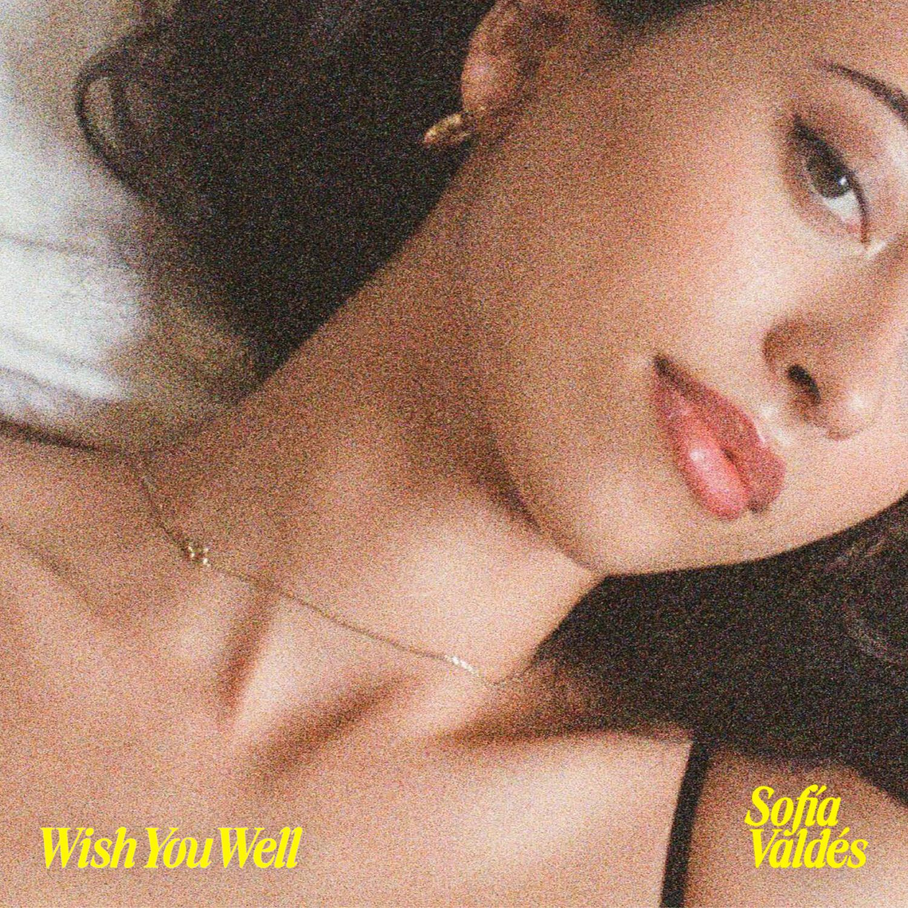

LISTEN TO EP VENTURA
https://sofiavaldes.lnk.to/venturaextended

BUY TICKETS TO BOY PABLO TOUR
https://www.boypablo.com/
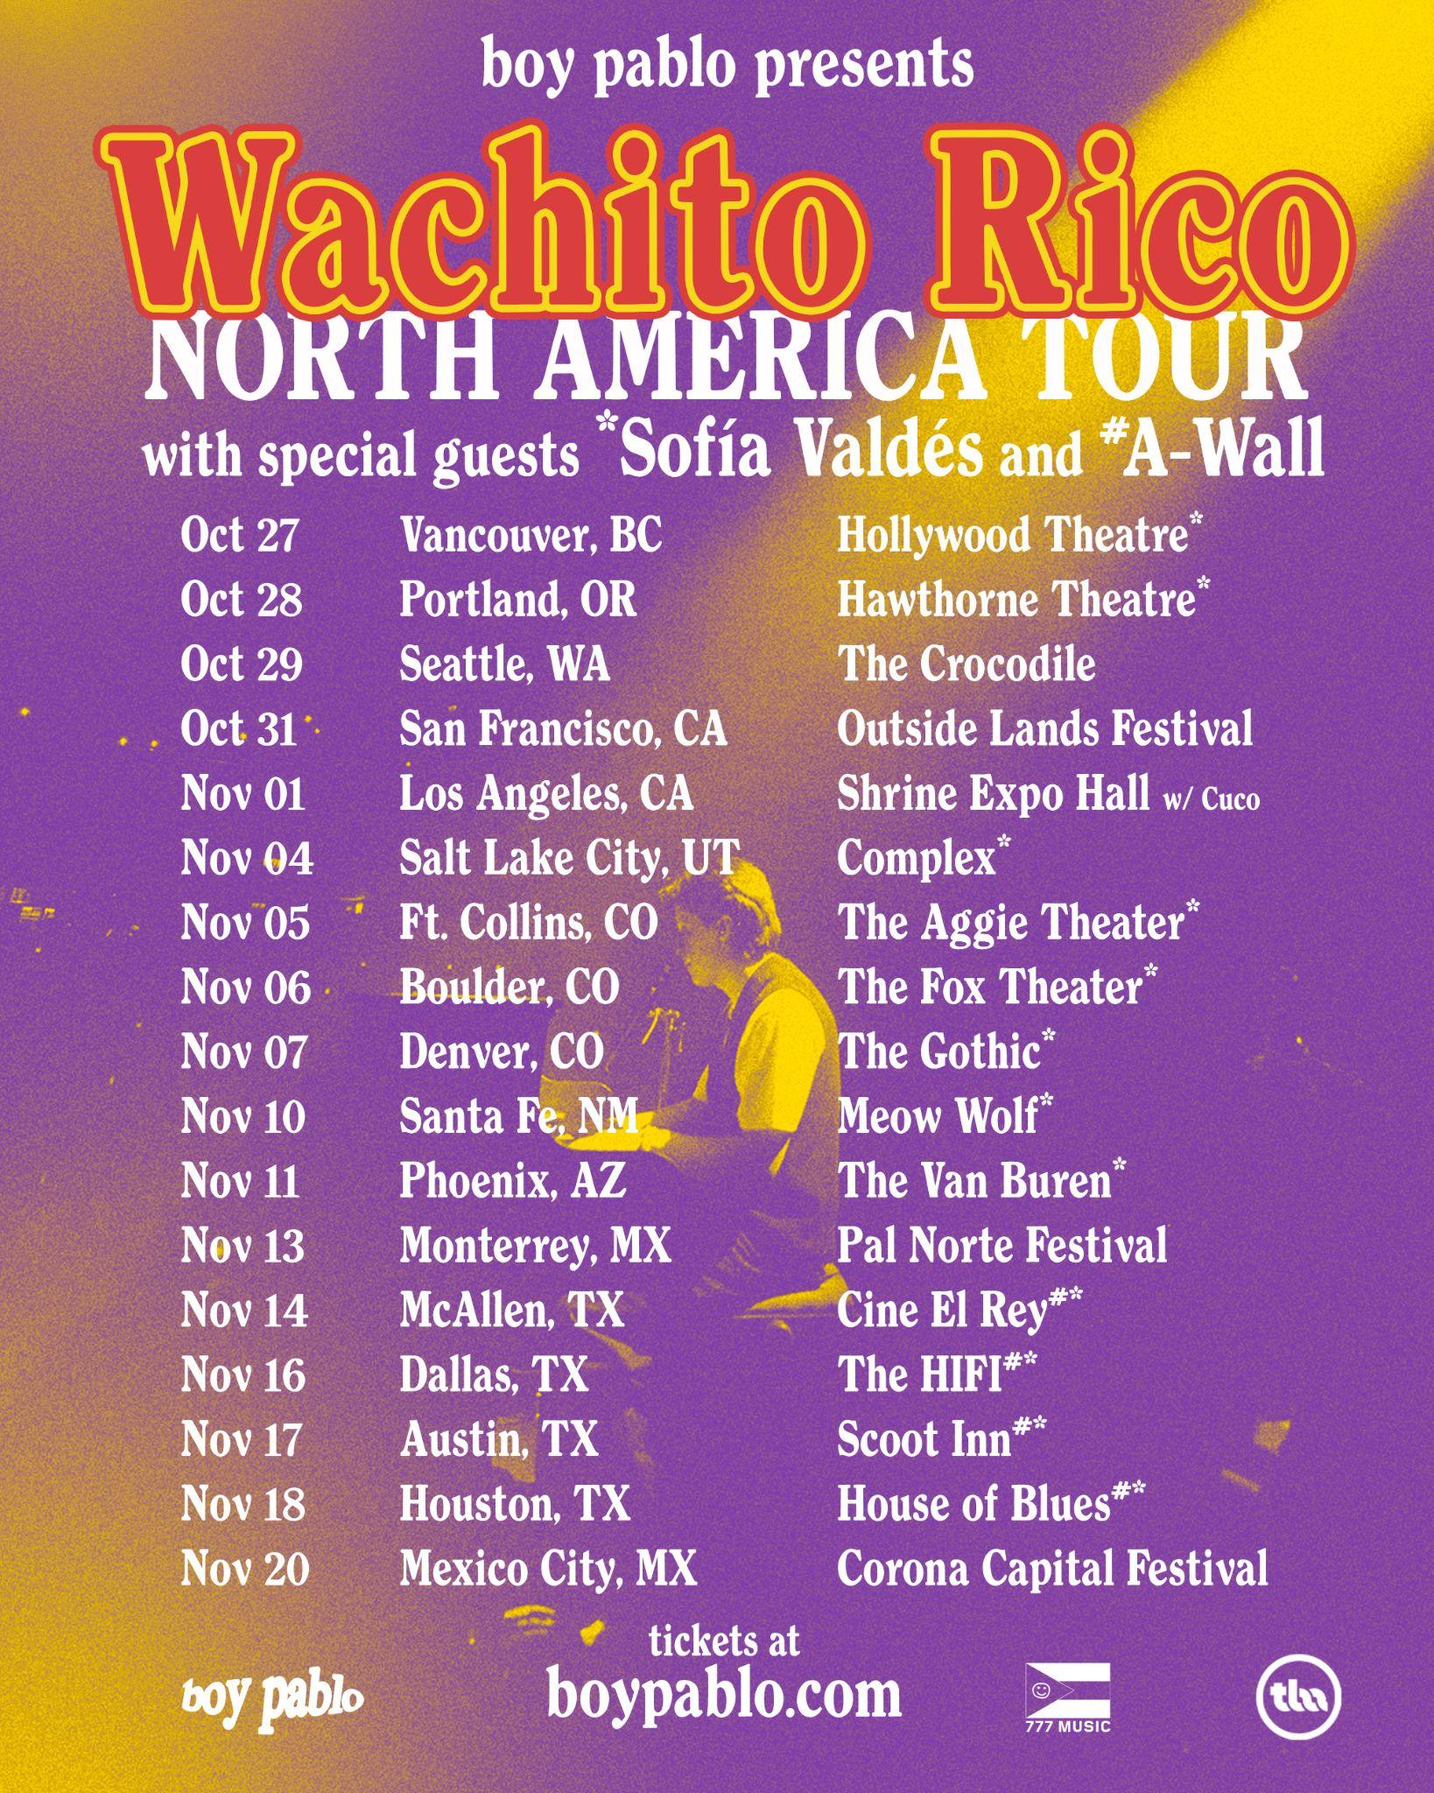
BOY PABLO W/ SOFIA VALDES TOUR DATES
October 27 - Vancouver, BC @ Hollywood Theatre
October 28 - Portland, OR @ Hawthorne Theatre
October 29 - Seattle, WA @ The Crocodile
October 31 - San Francisco, CA @ Outside Lands Festival
November 1 - Los Angeles, CA @ Shrine Expo Hall (w/ Cuco)
November 4 - Salt Lake City, UT @ Complex
November 5 - Ft. Collins, CO @ The Aggie Theater
November 6 - Boulder, CO @ The Fox Theater
November 7 - Denver, CO @ The Gothic
November 10 - Santa Fe, NM @ Meow Wolf
November 11 - Phoenix, AZ @ The Van Buren
November 13 - Monterrey, MX @ Pal Norte Festival
November 14 - McAllen, TX @ Cine El Rey
November 16 - Dallas, TX @ The HIFI
November 17 - Austin, TX @ Scoot Inn
November 18 - Houston, TX @ House of Blues
November 20 - Mexico City, MX @ Corona Capital Festival

FOLLOW SOFÍA VALDÉS
INSTAGRAM | TWITTER | WEBSITE

FOR PRESS INQUIRIES
Tori Johnson / Biz 3 tori@biz3.net
Dana Meyerson / Biz 3 dana@biz3.net
Jaime Rosenberg / Warner Records jaime.rosenberg@warnerrecords.com
Patrice Compere / Warner Records patrice.compere@warnerrecords.com

